Mineral Titles Act
NOTICE OF LAND CEASING TO BE A MINERAL TITLE
Title Type and Number: | Mineral Lease 30864
Area ceased on: | 13 July 2018
Area: | 19.00 Hectare
Locality: | SHORT RANGE
Name of Applicants(s)Holder(s): | 100% SANTEXCO PTY LTD [ACN. 002 910 296]
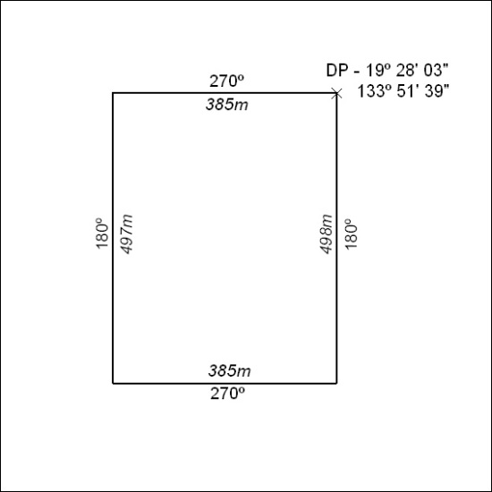

299/18

Mineral Titles Act
NOTICE OF LAND CEASING TO BE A MINERAL TITLE
Title Type and Number: | Mineral Lease 30865
Area ceased on: | 13 July 2018
Area: | 20.00 Hectare
Locality: | TENNANT CREEK
Name of Applicants(s)Holder(s): | 100% SANTEXCO PTY LTD [ACN. 002 910 296]
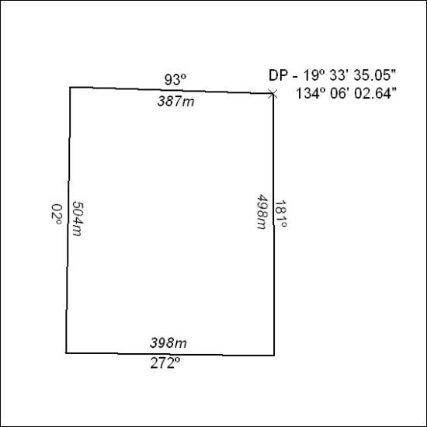

300/18

Mineral Titles Act
NOTICE OF LAND CEASING TO BE A MINERAL TITLE
Title Type and Number: | Mineral Lease 30867
Area ceased on: | 13 July 2018
Area: | 21.00 Hectare
Locality: | TENNANT CREEK
Name of Applicants(s)Holder(s): | 100% SANTEXCO PTY LTD [ACN. 002 910 296]
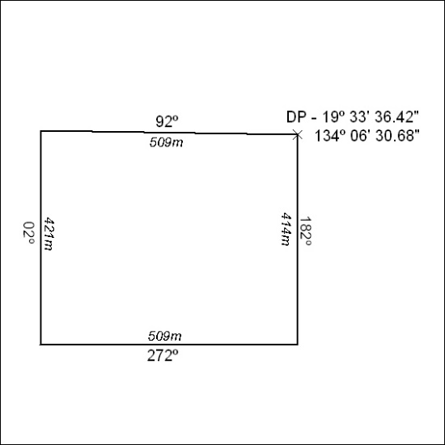

301/18

Mineral Titles Act
NOTICE OF LAND CEASING TO BE A MINERAL TITLE
Title Type and Number: | Mineral Lease 30871
Area ceased on: | 13 July 2018
Area: | 38.00 Hectare
Locality: | TENNANT CREEK
Name of Applicants(s)Holder(s): | 100% SANTEXCO PTY LTD [ACN. 002 910 296]
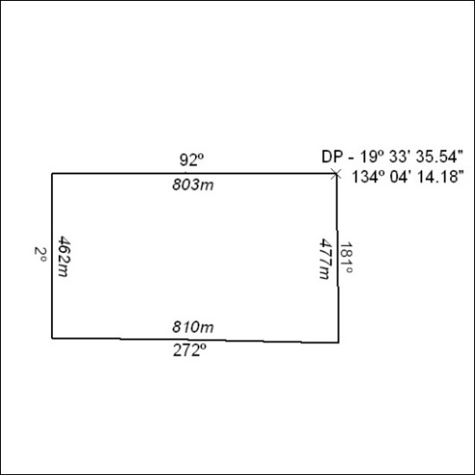

302/18

Mineral Titles Act
NOTICE OF LAND CEASING TO BE A MINERAL TITLE
Title Type and Number: | Mineral Lease 30875
Area ceased on: | 13 July 2018
Area: | 18.00 Hectare
Locality: | TENNANT CREEK
Name of Applicants(s)Holder(s): | 100% SANTEXCO PTY LTD [ACN. 002 910 296]
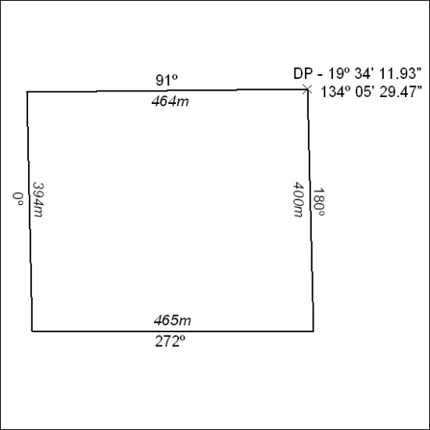

303/18

Mineral Titles Act
NOTICE OF LAND CEASING TO BE A MINERAL TITLE
Title Type and Number: | Mineral Lease 30885
Area ceased on: | 13 July 2018
Area: | 17.00 Hectare
Locality: | TENNANT CREEK
Name of Applicants(s)Holder(s): | 100% SANTEXCO PTY LTD [ACN. 002 910 296]
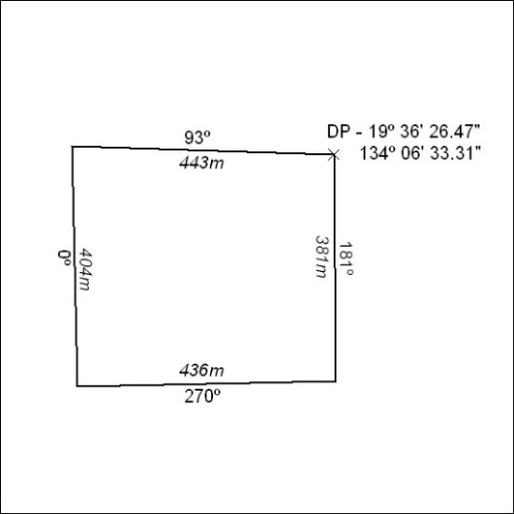

304/18

Mineral Titles Act
NOTICE OF LAND CEASING TO BE A MINERAL TITLE
Title Type and Number: | Mineral Lease 30886
Area ceased on: | 13 July 2018
Area: | 12.00 Hectare
Locality: | TENNANT CREEK
Name of Applicants(s)Holder(s): | 100% SANTEXCO PTY LTD [ACN. 002 910 296]
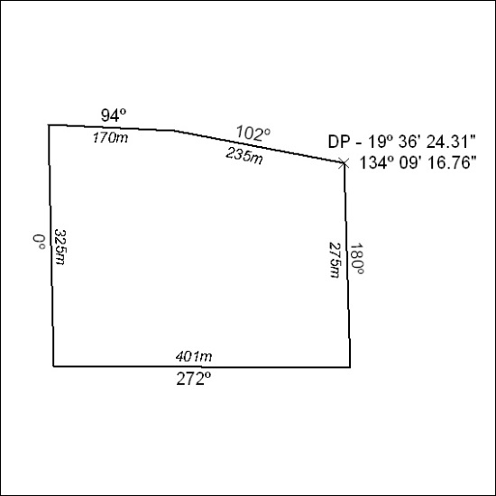

305/18

Mineral Titles Act
NOTICE OF LAND CEASING TO BE A MINERAL TITLE
Title Type and Number: | Mineral Lease 30937
Area ceased on: | 13 July 2018
Area: | 18.00 Hectare
Locality: | TENNANT CREEK
Name of Applicants(s)Holder(s): | 100% SANTEXCO PTY LTD [ACN. 002 910 296]
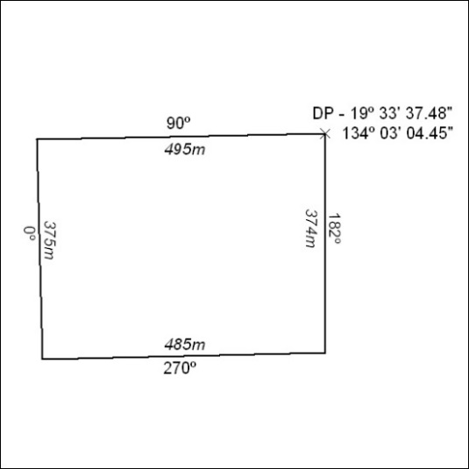

306/18

Mineral Titles Act
NOTICE OF LAND CEASING TO BE A MINERAL TITLE AREA
Title Type and Number: | Exploration Licence 27136
Area Ceased on: | 13 July 2018
Area: | 24 Blocks, 69.07 km²
Locality: | SHORT RANGE
Name of Applicant(s)/Holder(s): | 100% GIANTS REEF EXPLORATION PTY LTD* [ACN. 009 200 346]
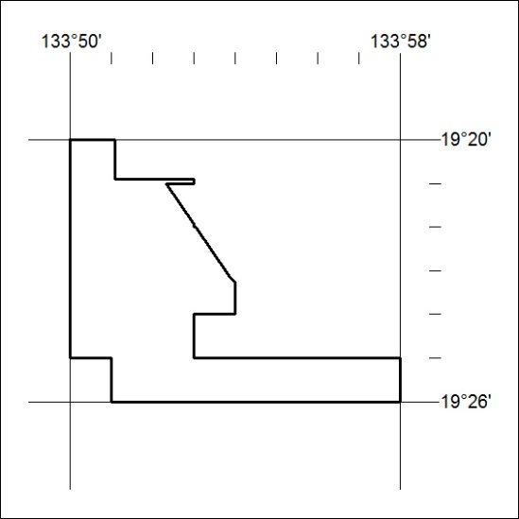

307/18

