Mineral Titles Act
NOTICE OF LAND CEASING TO BE A MINERAL TITLE AREA
Title Type and Number: | Exploration Licence 28694
Area Ceased on: | 01 March 2018
Area: | 24 Blocks, 76.36 km²
Locality: | DOREEN
Name of Applicant(s)/Holder(s): | 100% TODD RIVER METALS PTY LTD [ACN. 600 314 038]
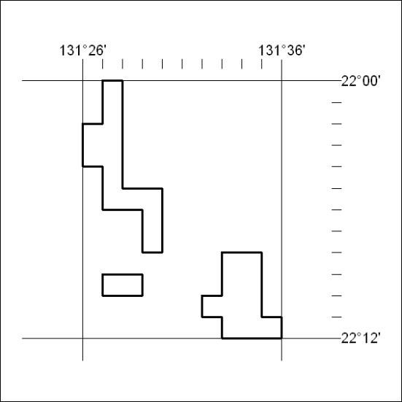

84/18

Mineral Titles Act
NOTICE OF LAND CEASING TO BE A MINERAL TITLE AREA
Title Type and Number: | Exploration Licence 28948
Area Ceased on: | 01 March 2018
Area: | 3 Blocks, 7.00 km²
Locality: | JERVOIS RANGE
Name of Applicant(s)/Holder(s): | 100% MOLYHIL MINING PTY LTD [ACN. 112 922 497]
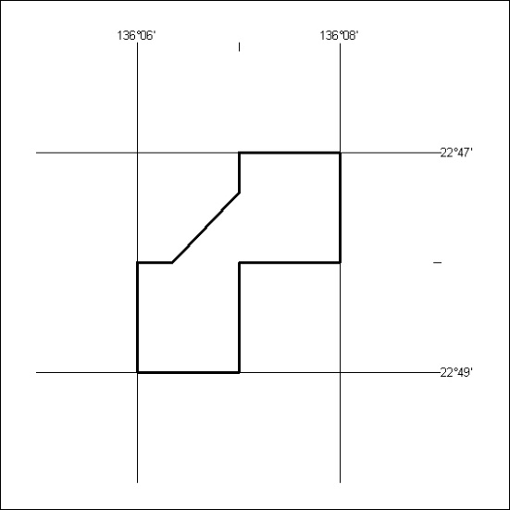

85/18

