Mineral Titles Act 2010
NOTICE OF LAND CEASING TO BE A MINERAL TITLE APPLICATION AREA
Title Type and Number: | Exploration Licence 33311
Area Ceased on: | 23 November 2022
Area: | 110 Blocks, 340.92 km²
Locality: | McDILLS
Name of Applicant(s)/Holder(s): | 100% MCCLEARY Norman Sydney
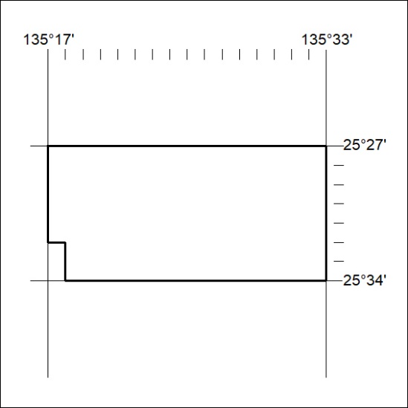

409/22

Mineral Titles Act 2010
NOTICE OF LAND CEASING TO BE A MINERAL TITLE AREA
Title Type and Number: | Extractive Mineral Permit 25441
Area ceased on: | 24 November 2022
Area: | 22.00 Hectare
Locality: | KOOLPINYAH
Name of Applicants(s)Holder(s): | 100% SJT TRAINING ABORIGINAL CORPORATION
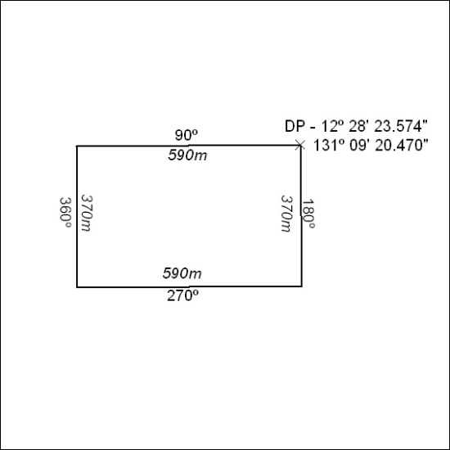

410/22

Mineral Titles Act 2010
NOTICE OF LAND CEASING TO BE A MINERAL TITLE AREA
Title Type and Number: | Extractive Mineral Permit 28800
Area ceased on: | 24 November 2022
Area: | 14.00 Hectare
Locality: | KOOLPINYAH
Name of Applicants(s)Holder(s): | 100% SJT TRAINING ABORIGINAL CORPORATION
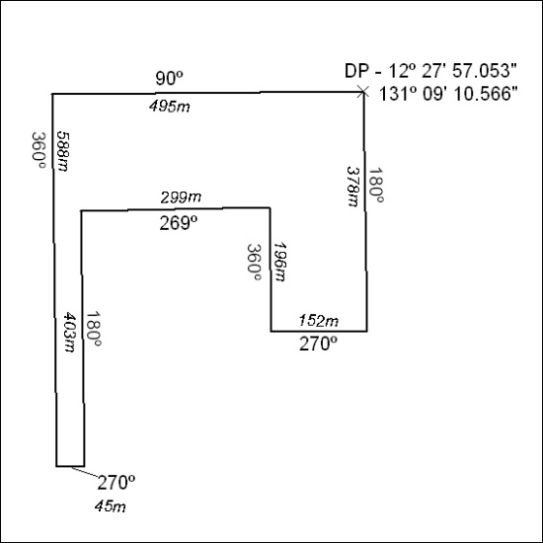

411/22

