Mineral Titles Act 2010
NOTICE OF LAND CEASING TO BE A MINERAL TITLE APPLICATION AREA
Title Type and Number: | Exploration Licence 31422
Area Ceased on: | 15 November 2022
Area: | 59 Blocks, 185.00 km²
Locality: | JINDUCKIN
Name of Applicant(s)/Holder(s): | 100% COPPEROZ PTY LTD [ACN. 603 957 124]
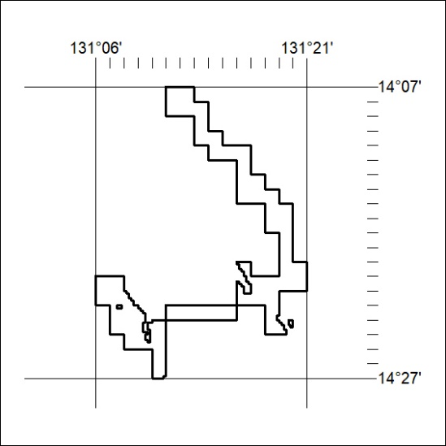

396/22

Mineral Titles Act
NOTICE OF GRANT OF A MINERAL TITLE
Title Type and Number: | Exploration Licence 33192
Granted: | 15 November 2022, for a period of 6 Years
Area: | 151 Blocks, 462.53 km²
Locality: | JOILDUNG
Name of Holder/s: | 100% MINEMAKERS AUSTRALIA PTY LTD* [ACN. 081 911 917]
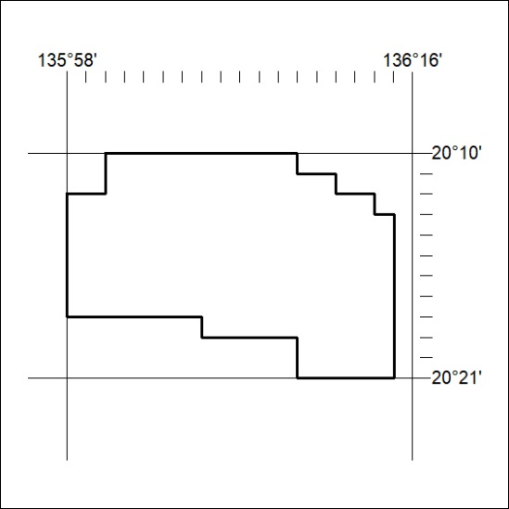
Area granted is indicated above. The titleholder is not permitted to exercise occupational rights on any land that is subject to a development title, or an application for a development title. Any land the subject of a Reserved Land gazettal under the Mineral Titles Act and all land vested in the Commonwealth of Australia is also excluded by description but not excised from the grant area.

397/22

Mineral Titles Act
NOTICE OF GRANT OF A MINERAL TITLE
Title Type and Number: | Exploration Licence 33198
Granted: | 14 November 2022, for a period of 6 Years
Area: | 242 Blocks, 800.57 km²
Locality: | THROSBY
Name of Holder/s: | 100% DALY TENEMENTS PTY LTD [ACN. 658 845 786]
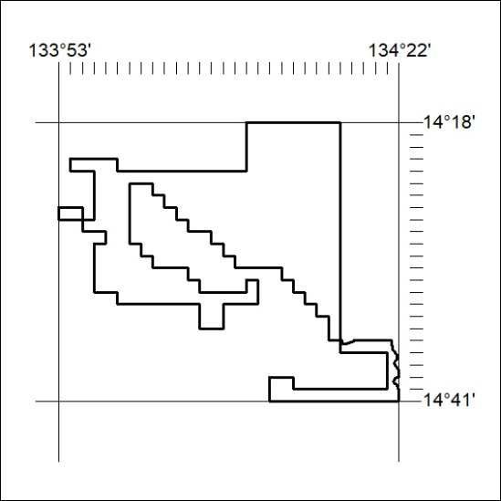
Area granted is indicated above. The titleholder is not permitted to exercise occupational rights on any land that is subject to a development title, or an application for a development title. Any land the subject of a Reserved Land gazettal under the Mineral Titles Act and all land vested in the Commonwealth of Australia is also excluded by description but not excised from the grant area.
398/22

Mineral Titles Act
NOTICE OF GRANT OF A MINERAL TITLE
Title Type and Number: | Exploration Licence 33199
Granted: | 14 November 2022, for a period of 6 Years
Area: | 250 Blocks, 830.41 km²
Locality: | MOROAK
Name of Holder/s: | 100% DALY TENEMENTS PTY LTD [ACN. 658 845 786]
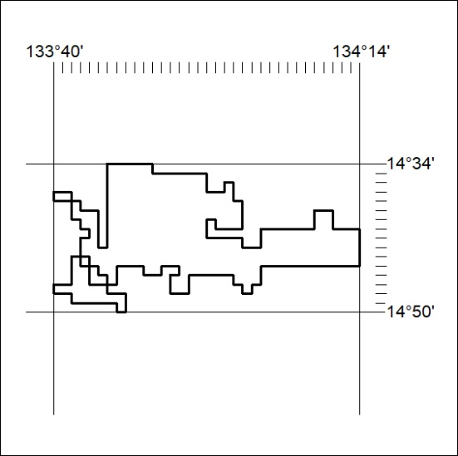
Area granted is indicated above. The titleholder is not permitted to exercise occupational rights on any land that is subject to a development title, or an application for a development title. Any land the subject of a Reserved Land gazettal under the Mineral Titles Act and all land vested in the Commonwealth of Australia is also excluded by description but not excised from the grant area.
399/22

Mineral Titles Act
NOTICE OF GRANT OF A MINERAL TITLE
Title Type and Number: | Extractive Mineral Permit 33127
Granted: | 15 November 2022, for a period of 5 Years
Area: | 13.00 Hectares
Locality: | NOONAMAH
Name of Holder/s: | 100% CHAMBERS Kenneth John
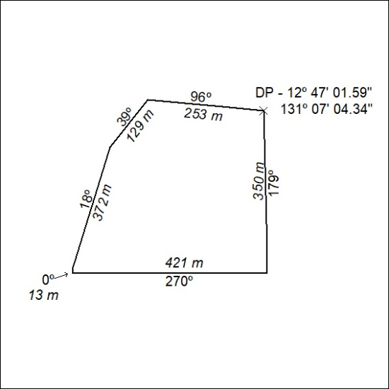

400/22

