Mineral Titles Act
NOTICE OF GRANT OF A MINERAL TITLE
Title Type and Number: | Extractive Mineral Permit 31601
Granted: | 15 September 2022, for a period of 5 Years
Area: | 62.37 Hectares
Locality: | KOOLPINYAH
Name of Holder/s: | 100% BANDIAS Leo John
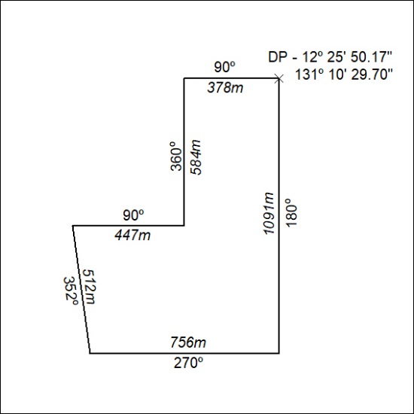

327/22

Mineral Titles Act
NOTICE OF GRANT OF A MINERAL TITLE
Title Type and Number: | Extractive Mineral Permit 31602
Granted: | 15 September 2022, for a period of 5 Years
Area: | 64.05 Hectares
Locality: | KOOLPINYAH
Name of Holder/s: | 100% BANDIAS Leo John
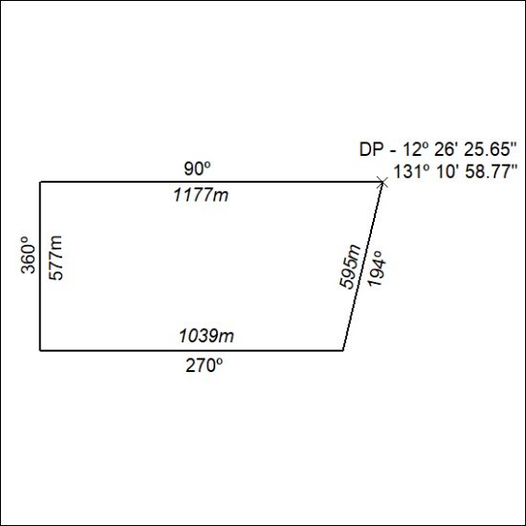

328/22

