Mineral Titles Act
NOTICE OF GRANT OF A MINERAL TITLE
Title Type and Number: | Extractive Mineral Exploration Licence 32524
Granted: | 04 July 2022, for a period of 2 Years
Area: | 3 Blocks, 4.24 km²
Locality: | KOOLPINYAH
Name of Holder/s: | 100% TRISTAR INDUSTRIES PTY LTD [ACN. 009 647 321]
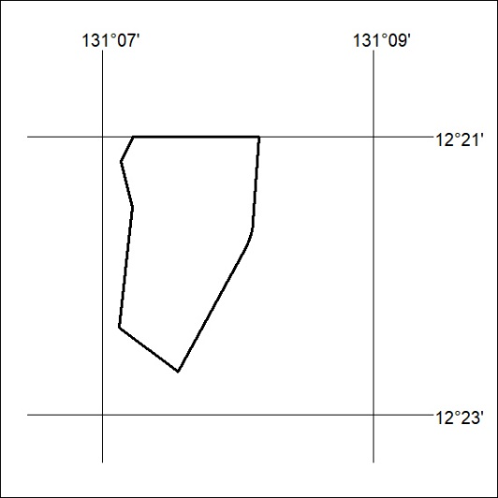
Area granted is indicated above. The titleholder is not permitted to exercise occupational rights on any land that is subject to a development title, or an application for a development title. Any land the subject of a Reserved Land gazettal under the Mineral Titles Act and all land vested in the Commonwealth of Australia is also excluded by description but not excised from the grant area.

228/22

Mineral Titles Act
NOTICE OF GRANT OF A MINERAL TITLE
Title Type and Number: | Extractive Mineral Exploration Licence 32525
Granted: | 04 July 2022, for a period of 2 Years
Area: | 4 Blocks, 2.75 km²
Locality: | KOOLPINYAH
Name of Holder/s: | 100% TRISTAR INDUSTRIES PTY LTD [ACN. 009 647 321]
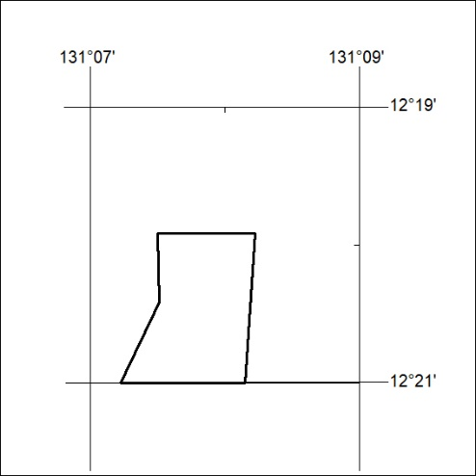
Area granted is indicated above. The titleholder is not permitted to exercise occupational rights on any land that is subject to a development title, or an application for a development title. Any land the subject of a Reserved Land gazettal under the Mineral Titles Act and all land vested in the Commonwealth of Australia is also excluded by description but not excised from the grant area.

229/22

