Mineral Titles Act
NOTICE OF GRANT OF A MINERAL TITLE
Title Type and Number: | Exploration Licence 32997
Granted: | 01 July 2022, for a period of 6 Years
Area: | 11 Blocks, 35.12 km²
Locality: | ANNINGIE
Name of Holder/s: | 100% JALEIN PTY LTD [ACN. 124 331 157]
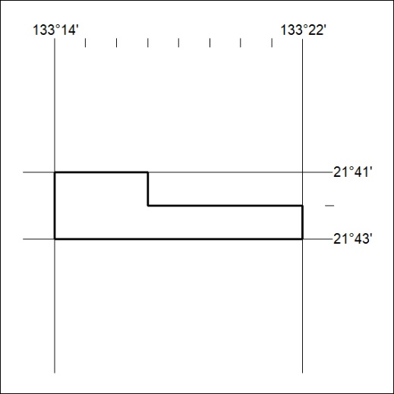
Area granted is indicated above. The titleholder is not permitted to exercise occupational rights on any land that is subject to a development title, or an application for a development title. Any land the subject of a Reserved Land gazettal under the Mineral Titles Act and all land vested in the Commonwealth of Australia is also excluded by description but not excised from the grant area.

226/22

Mineral Titles Act
NOTICE OF GRANT OF A MINERAL TITLE
Title Type and Number: | Exploration Licence 32998
Granted: | 01 July 2022, for a period of 6 Years
Area: | 6 Blocks, 19.16 km²
Locality: | ANNINGIE
Name of Holder/s: | 100% JALEIN PTY LTD [ACN. 124 331 157]
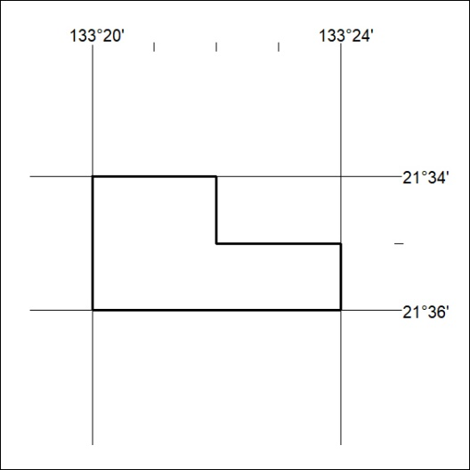
Area granted is indicated above. The titleholder is not permitted to exercise occupational rights on any land that is subject to a development title, or an application for a development title. Any land the subject of a Reserved Land gazettal under the Mineral Titles Act and all land vested in the Commonwealth of Australia is also excluded by description but not excised from the grant area.

227/22

