Mineral Titles Act
NOTICE OF GRANT OF A MINERAL TITLE
Title Type and Number: | Exploration Licence 32810
Granted: | 24 June 2022, for a period of 6 Years
Area: | 8 Blocks, 25.89 km²
Locality: | WONARAH
Name of Holder/s: | 100% NEWCREST OPERATIONS LIMITED [ACN. 009 221 505]
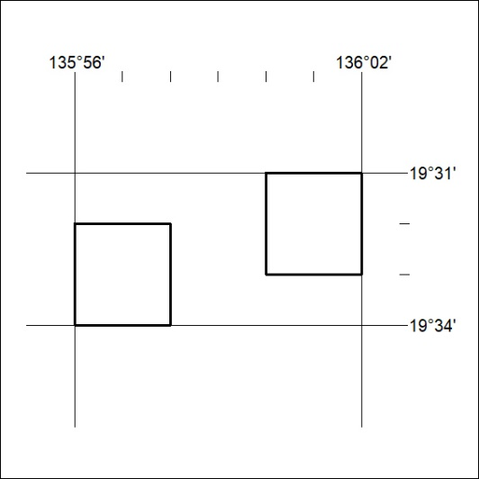
Area granted is indicated above. The titleholder is not permitted to exercise occupational rights on any land that is subject to a development title, or an application for a development title. Any land the subject of a Reserved Land gazettal under the Mineral Titles Act and all land vested in the Commonwealth of Australia is also excluded by description but not excised from the grant area.

208/22

Mineral Titles Act
NOTICE OF GRANT OF A MINERAL TITLE
Title Type and Number: | Exploration Licence 32811
Granted: | 24 June 2022, for a period of 6 Years
Area: | 12 Blocks, 38.91 km²
Locality: | ALROY
Name of Holder/s: | 100% NEWCREST OPERATIONS LIMITED [ACN. 009 221 505]
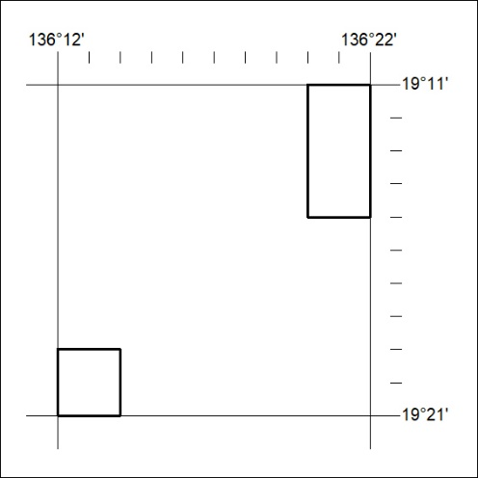
Area granted is indicated above. The titleholder is not permitted to exercise occupational rights on any land that is subject to a development title, or an application for a development title. Any land the subject of a Reserved Land gazettal under the Mineral Titles Act and all land vested in the Commonwealth of Australia is also excluded by description but not excised from the grant area.

209/22

