Mineral Titles Act 2010
NOTICE OF LAND CEASING TO BE A MINERAL TITLE APPLICATION AREA
Title Type and Number: | Exploration Licence 32960
Area Ceased on: | 09 March 2022
Area: | 7 Blocks, 22.13 km²
Locality: | RIDDOCH
Name of Applicant(s)/Holder(s): | 100% ARC MARLBOROUGH PTY LIMITED [ACN. 127 139 780]
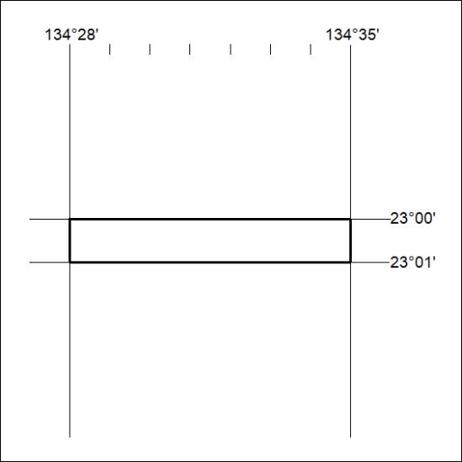

53/22

