Mineral Titles Act 2010
NOTICE OF LAND CEASING TO BE A MINERAL TITLE APPLICATION AREA
Title Type and Number: | Extractive Mineral Permit 32739
Area ceased on: | 27 January 2022
Area: | 4.00 Hectare
Locality: | UNDOOLYA
Name of Applicants(s)Holder(s): | 100% C.P. CAVANAGH NOMINEES PTY LTD [ACN. 09 7564 344]
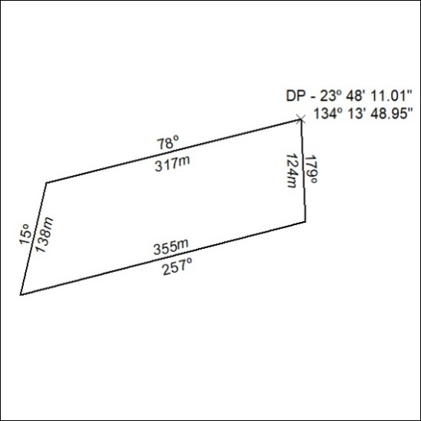

23/22

Mineral Titles Act 2010
NOTICE OF LAND CEASING TO BE A MINERAL TITLE APPLICATION AREA
Title Type and Number: | Extractive Mineral Permit 32740
Area ceased on: | 27 January 2022
Area: | 1.00 Hectare
Locality: | UNDOOLYA
Name of Applicants(s)Holder(s): | 100% C.P. CAVANAGH NOMINEES PTY LTD [ACN. 09 7564 344]
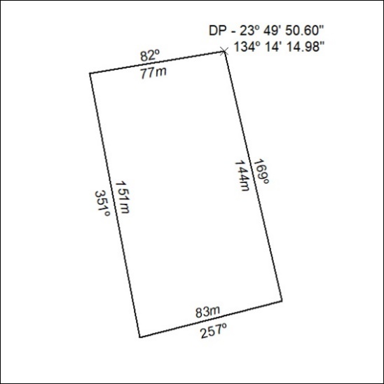

24/22

