Mineral Titles Act 2010
NOTICE OF LAND CEASING TO BE A MINERAL TITLE AREA
Title Type and Number: | Exploration Licence 29803
Area Ceased on: | 24 September 2021
Area: | 22 Blocks, 71.96 km²
Locality: | NAPIER
Name of Applicant(s)/Holder(s): | 100% MARTIN Anthony Ernest
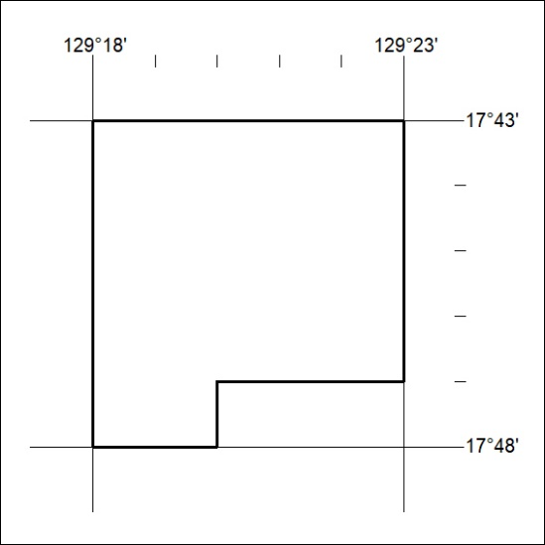

362/21

