Mineral Titles Act
NOTICE OF GRANT OF A MINERAL TITLE
Title Type and Number: | Extractive Mineral Exploration Licence 32672
Granted: | 13 May 2021, for a period of 2 Years
Area: | 4 Blocks, 12.68 km²
Locality: | AILERON
Name of Holder/s: | 100% ARAFURA RARE EARTHS PTY LTD [ACN. 118 158 900]
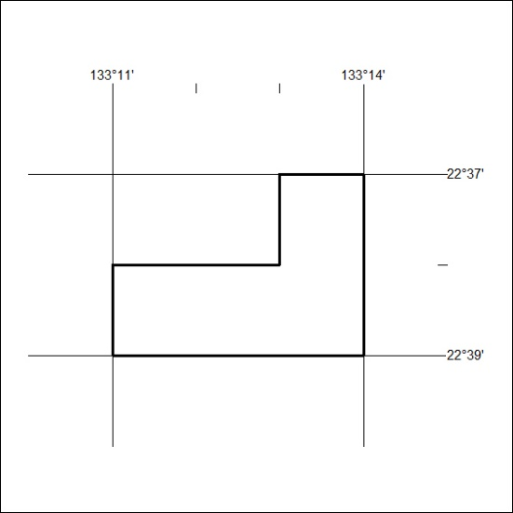
Area granted is indicated above. The titleholder is not permitted to exercise occupational rights on any land that is subject to a development title, or an application for a development title. Any land the subject of a Reserved Land gazettal under the Mineral Titles Act and all land vested in the Commonwealth of Australia is also excluded by description but not excised from the grant area.
161/21

Mineral Titles Act
NOTICE OF GRANT OF A MINERAL TITLE
Title Type and Number: | Extractive Mineral Exploration Licence 32673
Granted: | 13 May 2021, for a period of 2 Years
Area: | 4 Blocks, 12.68 km²
Locality: | AILERON
Name of Holder/s: | 100% ARAFURA RARE EARTHS PTY LTD [ACN. 118 158 900]
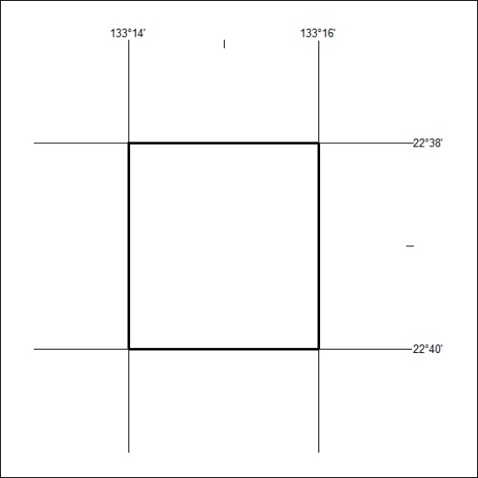
Area granted is indicated above. The titleholder is not permitted to exercise occupational rights on any land that is subject to a development title, or an application for a development title. Any land the subject of a Reserved Land gazettal under the Mineral Titles Act and all land vested in the Commonwealth of Australia is also excluded by description but not excised from the grant area.
162/21

Mineral Titles Act
NOTICE OF GRANT OF A MINERAL TITLE
Title Type and Number: | Extractive Mineral Exploration Licence 32674
Granted: | 13 May 2021, for a period of 2 Years
Area: | 4 Blocks, 12.68 km²
Locality: | AILERON
Name of Holder/s: | 100% ARAFURA RARE EARTHS PTY LTD [ACN. 118 158 900]
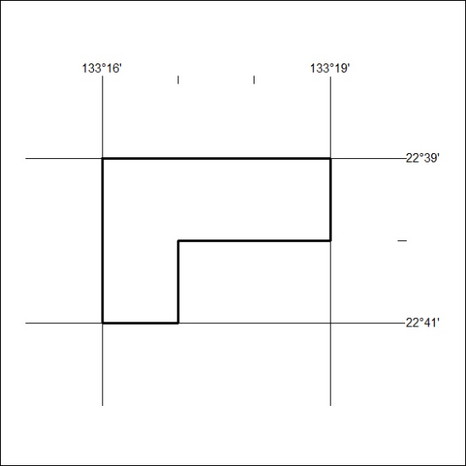
Area granted is indicated above. The titleholder is not permitted to exercise occupational rights on any land that is subject to a development title, or an application for a development title. Any land the subject of a Reserved Land gazettal under the Mineral Titles Act and all land vested in the Commonwealth of Australia is also excluded by description but not excised from the grant area.
163/21

Mineral Titles Act
NOTICE OF GRANT OF A MINERAL TITLE
Title Type and Number: | Extractive Mineral Exploration Licence 32675
Granted: | 13 May 2021, for a period of 2 Years
Area: | 4 Blocks, 12.68 km²
Locality: | AILERON
Name of Holder/s: | 100% ARAFURA RARE EARTHS PTY LTD [ACN. 118 158 900]
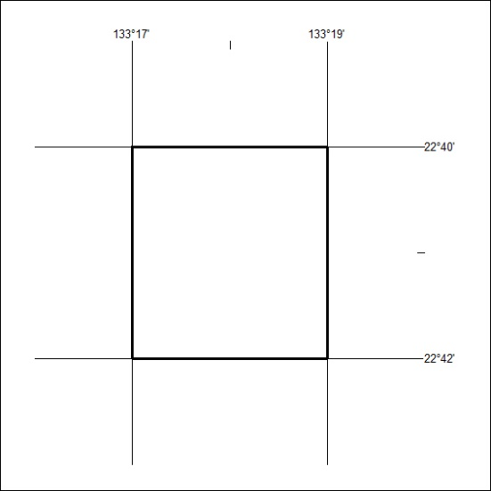
Area granted is indicated above. The titleholder is not permitted to exercise occupational rights on any land that is subject to a development title, or an application for a development title. Any land the subject of a Reserved Land gazettal under the Mineral Titles Act and all land vested in the Commonwealth of Australia is also excluded by description but not excised from the grant area.
164/21

Mineral Titles Act
NOTICE OF GRANT OF A MINERAL TITLE
Title Type and Number: | Extractive Mineral Exploration Licence 32676
Granted: | 13 May 2021, for a period of 2 Years
Area: | 4 Blocks, 12.28 km²
Locality: | AILERON
Name of Holder/s: | 100% ARAFURA RARE EARTHS PTY LTD [ACN. 118 158 900]
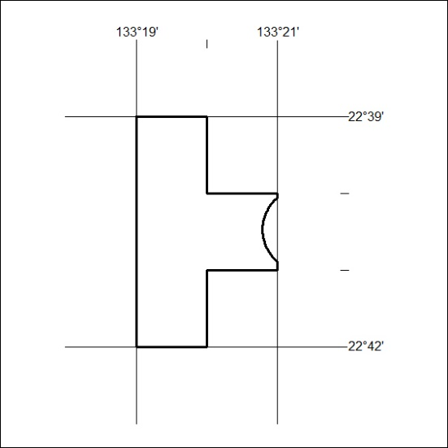
Area granted is indicated above. The titleholder is not permitted to exercise occupational rights on any land that is subject to a development title, or an application for a development title. Any land the subject of a Reserved Land gazettal under the Mineral Titles Act and all land vested in the Commonwealth of Australia is also excluded by description but not excised from the grant area.
165/21

