Mineral Titles Act 2010
NOTICE OF LAND CEASING TO BE A MINERAL TITLE APPLICATION AREA
Title Type and Number: | Mineral Lease 29540
Area ceased on: | 28 April 2021
Area: | 15.00 Hectare
Locality: | PINE CREEK
Name of Applicants(s)Holder(s): | 100% MCKINLAY RIVER MINING PTY. LTD [ACN. 059 869 224]
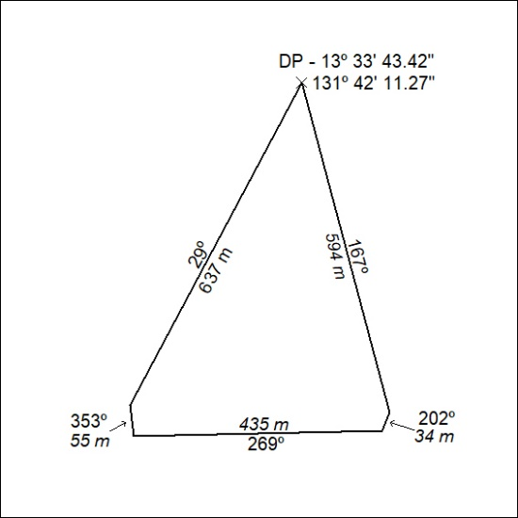

117/21

Mineral Titles Act
NOTICE OF GRANT OF A MINERAL TITLE
Title Type and Number: | Exploration Licence 32177
Granted: | 27 April 2021, for a period of 6 Years
Area: | 24 Blocks, 76.04 km²
Locality: | BATTEN
Name of Holder/s: | 100% RAWLINGS David John
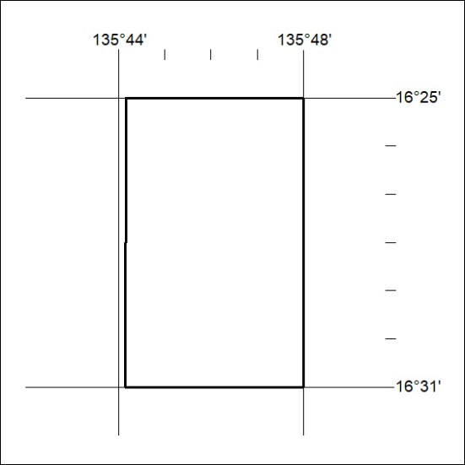
Area granted is indicated above. The titleholder is not permitted to exercise occupational rights on any land that is subject to a development title, or an application for a development title. Any land the subject of a Reserved Land gazettal under the Mineral Titles Act and all land vested in the Commonwealth of Australia is also excluded by description but not excised from the grant area.

118/21

Mineral Titles Act
NOTICE OF GRANT OF A MINERAL TITLE
Title Type and Number: | Exploration Licence 32241
Granted: | 28 April 2021, for a period of 6 Years
Area: | 104 Blocks, 330.07 km²
Locality: | MURRAY DOWNS
Name of Holder/s: | 100% KALK EXPLORATION PTY LTD [ACN. 634 749 429]
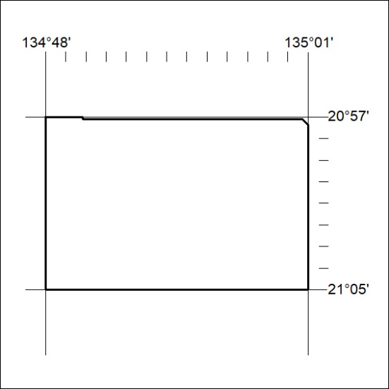
Area granted is indicated above. The titleholder is not permitted to exercise occupational rights on any land that is subject to a development title, or an application for a development title. Any land the subject of a Reserved Land gazettal under the Mineral Titles Act and all land vested in the Commonwealth of Australia is also excluded by description but not excised from the grant area.

119/21

