Mineral Titles Act
NOTICE OF GRANT OF A MINERAL TITLE
Title Type and Number: | Exploration Licence 32290
Granted: | 22 April 2021, for a period of 6 Years
Area: | 75 Blocks, 235.08 km²
Locality: | TENNANT CREEK
Name of Holder/s: | 100% BARKLY OPERATIONS PTY LTD [ACN. 641 856 706]
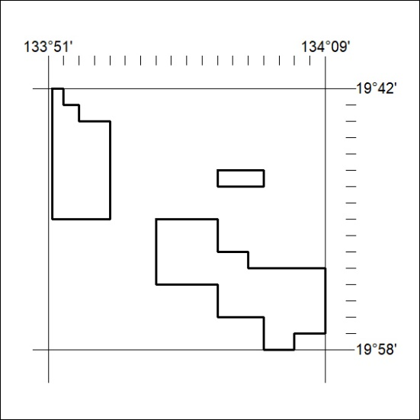
Area granted is indicated above. The titleholder is not permitted to exercise occupational rights on any land that is subject to a development title, or an application for a development title. Any land the subject of a Reserved Land gazettal under the Mineral Titles Act and all land vested in the Commonwealth of Australia is also excluded by description but not excised from the grant area.
111/21

Mineral Titles Act
NOTICE OF GRANT OF A MINERAL TITLE
Title Type and Number: | Exploration Licence 32291
Granted: | 22 April 2021, for a period of 6 Years
Area: | 250 Blocks, 809.54 km²
Locality: | FLYNN
Name of Holder/s: | 100% BARKLY OPERATIONS PTY LTD [ACN. 641 856 706]
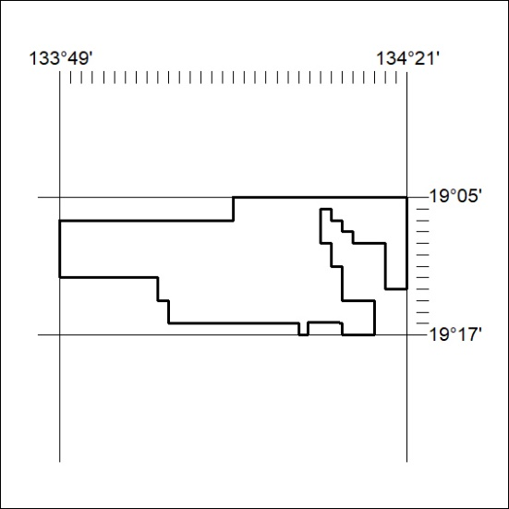
Area granted is indicated above. The titleholder is not permitted to exercise occupational rights on any land that is subject to a development title, or an application for a development title. Any land the subject of a Reserved Land gazettal under the Mineral Titles Act and all land vested in the Commonwealth of Australia is also excluded by description but not excised from the grant area.
112/21

Mineral Titles Act
NOTICE OF GRANT OF A MINERAL TITLE
Title Type and Number: | Exploration Licence 32292
Granted: | 22 April 2021, for a period of 6 Years
Area: | 7 Blocks, 22.64 km²
Locality: | LIGNUM
Name of Holder/s: | 100% BARKLY OPERATIONS PTY LTD [ACN. 641 856 706]
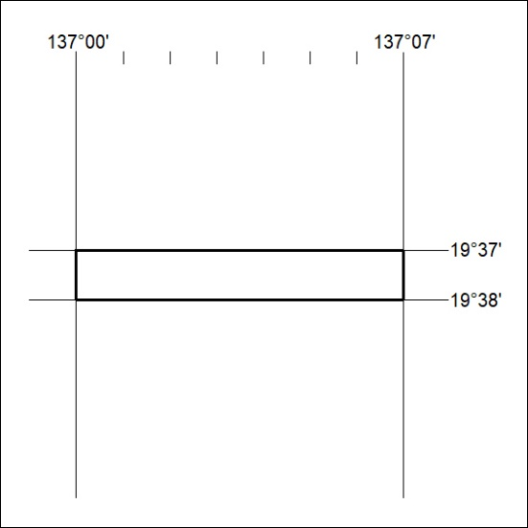
Area granted is indicated above. The titleholder is not permitted to exercise occupational rights on any land that is subject to a development title, or an application for a development title. Any land the subject of a Reserved Land gazettal under the Mineral Titles Act and all land vested in the Commonwealth of Australia is also excluded by description but not excised from the grant area.
113/21

Mineral Titles Act
NOTICE OF GRANT OF A MINERAL TITLE
Title Type and Number: | Exploration Licence 32304
Granted: | 22 April 2021, for a period of 6 Years
Area: | 21 Blocks, 67.80 km²
Locality: | FAVENC
Name of Holder/s: | 100% BARKLY OPERATIONS PTY LTD [ACN. 641 856 706]
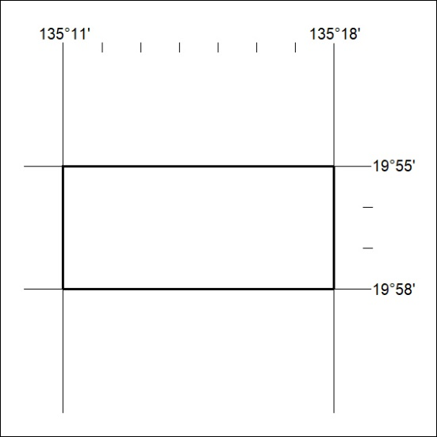
Area granted is indicated above. The titleholder is not permitted to exercise occupational rights on any land that is subject to a development title, or an application for a development title. Any land the subject of a Reserved Land gazettal under the Mineral Titles Act and all land vested in the Commonwealth of Australia is also excluded by description but not excised from the grant area.
114/21

Mineral Titles Act
NOTICE OF GRANT OF A MINERAL TITLE
Title Type and Number: | Exploration Licence 32305
Granted: | 22 April 2021, for a period of 6 Years
Area: | 24 Blocks, 75.38 km²
Locality: | COOLIBAH
Name of Holder/s: | 100% BARKLY OPERATIONS PTY LTD [ACN. 641 856 706]
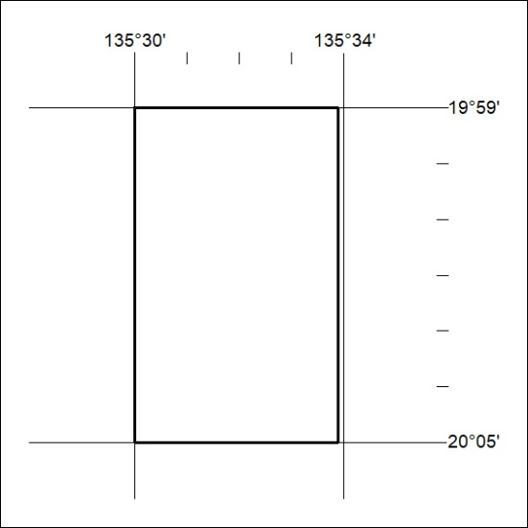
Area granted is indicated above. The titleholder is not permitted to exercise occupational rights on any land that is subject to a development title, or an application for a development title. Any land the subject of a Reserved Land gazettal under the Mineral Titles Act and all land vested in the Commonwealth of Australia is also excluded by description but not excised from the grant area.
115/21

