Mineral Titles Act 2010
NOTICE OF LAND CEASING TO BE A MINERAL TITLE APPLICATION AREA
Title Type and Number: | Exploration Licence 32448
Area Ceased on: | 04 March 2021
Area: | 252 Blocks, 721.93 km²
Locality: | HATCHES
Name of Applicant(s)/Holder(s): | 100% FUTURE MINERALS PTY LTD [ACN. 625 372 661]
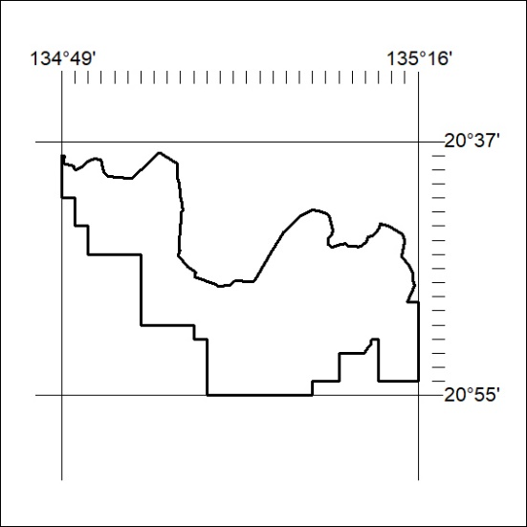

43/21

Mineral Titles Act 2010
NOTICE OF LAND CEASING TO BE A MINERAL TITLE APPLICATION AREA
Title Type and Number: | Exploration Licence 32449
Area Ceased on: | 04 March 2021
Area: | 26 Blocks, 45.87 km²
Locality: | DAVENPORT RANGE
Name of Applicant(s)/Holder(s): | 100% FUTURE MINERALS PTY LTD [ACN. 625 372 661]
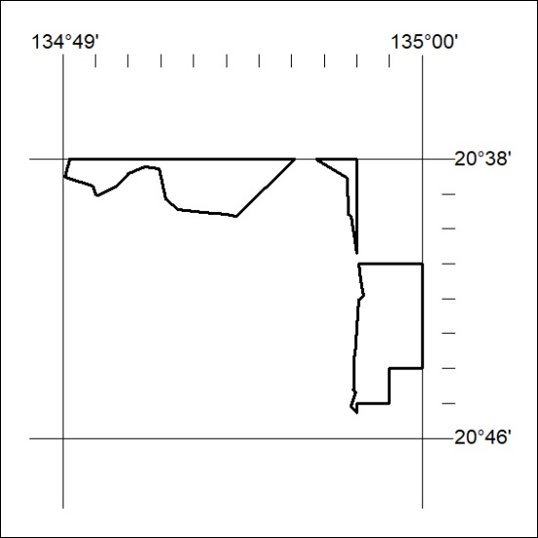

44/21

