Mineral Titles Act 2010
NOTICE OF LAND CEASING TO BE A MINERAL TITLE AREA
Title Type and Number: | Exploration Licence 26628
Area Ceased on: | 01 March 2021
Area: | 19 Blocks, 61.20 km²
Locality: | McFARLANE
Name of Applicant(s)/Holder(s): | 90% PRODIGY GOLD NL* [ACN. 009 127 020], 10% ALTURA LITHIUM OPERATIONS PTY LTD* [ACN. 095 384 491]
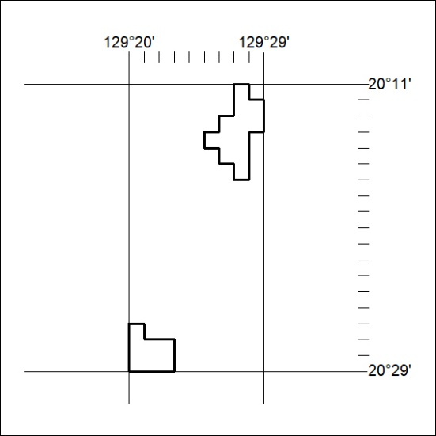

39/21

Mineral Titles Act 2010
NOTICE OF LAND CEASING TO BE A MINERAL TITLE AREA
Title Type and Number: | Exploration Licence 29828
Area Ceased on: | 01 March 2021
Area: | 40 Blocks, 128.74 km²
Locality: | McFARLANE
Name of Applicant(s)/Holder(s): | 90% PRODIGY GOLD NL* [ACN. 009 127 020], 10% ALTURA LITHIUM OPERATIONS PTY LTD* [ACN. 095 384 491]
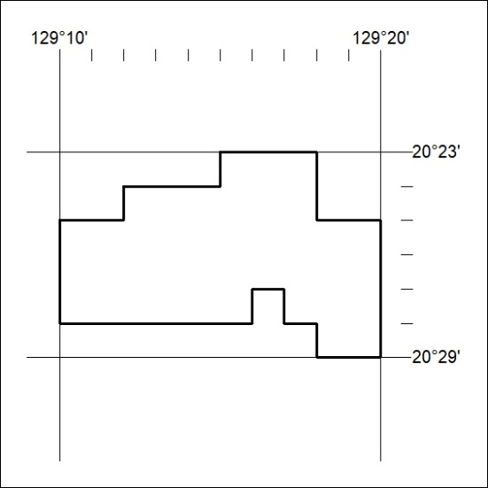

40/21

