Mineral Titles Act 2010
NOTICE OF LAND CEASING TO BE A MINERAL TITLE APPLICATION AREA
Title Type and Number: | Exploration Licence 32334
Area Ceased on: | 11 February 2021
Area: | 86 Blocks, 258.87 km²
Locality: | MT WEDGE
Name of Applicant(s)/Holder(s): | 100% SANDFIRE RESOURCES LIMITED* [ACN. 105 154 185]
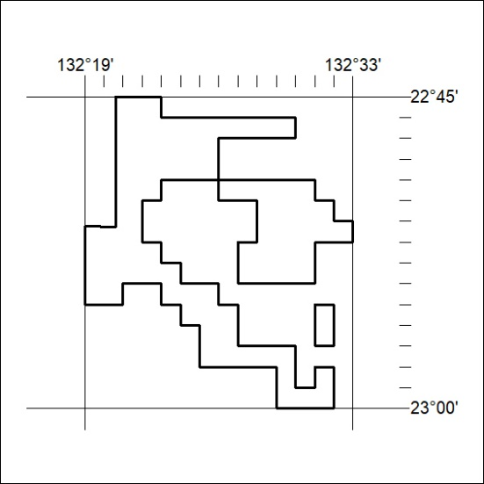

35/21

