Mineral Titles Act
NOTICE OF GRANT OF A MINERAL TITLE
Title Type and Number: | Exploration Licence 32287
Granted: | 28 January 2021, for a period of 6 Years
Area: | 44 Blocks, 142.21 km²
Locality: | FAVENC
Name of Holder/s: | 90% INCA MINERALS LIMITED [ACN. 128 512 907], 5% MRG RESOURCES PTY LTD [ACN. 614 946 164], 5% WEST Jonathan
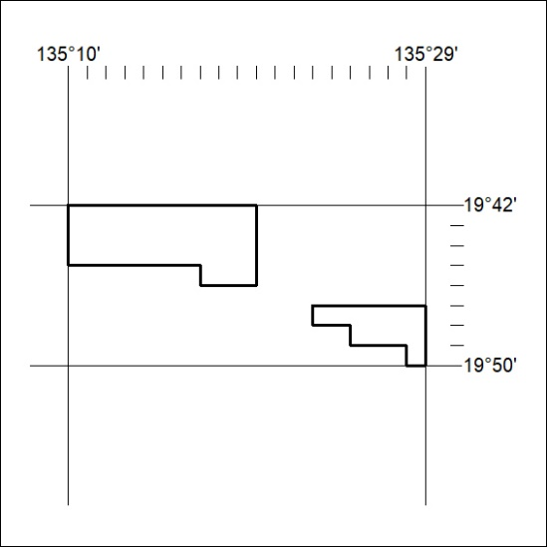
Area granted is indicated above. The titleholder is not permitted to exercise occupational rights on any land that is subject to a development title, or an application for a development title. Any land the subject of a Reserved Land gazettal under the Mineral Titles Act and all land vested in the Commonwealth of Australia is also excluded by description but not excised from the grant area.
18/21

Mineral Titles Act
NOTICE OF GRANT OF A MINERAL TITLE
Title Type and Number: | Exploration Licence 32289
Granted: | 28 January 2021, for a period of 6 Years
Area: | 26 Blocks, 84.06 km²
Locality: | DALMORE
Name of Holder/s: | 90% INCA MINERALS LIMITED [ACN. 128 512 907], 5% MRG RESOURCES PTY LTD [ACN. 614 946 164], 5% WEST Jonathan
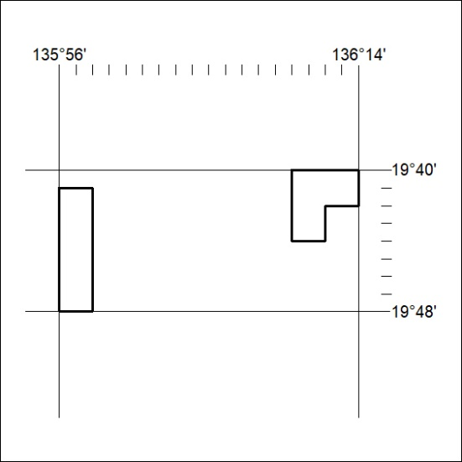
Area granted is indicated above. The titleholder is not permitted to exercise occupational rights on any land that is subject to a development title, or an application for a development title. Any land the subject of a Reserved Land gazettal under the Mineral Titles Act and all land vested in the Commonwealth of Australia is also excluded by description but not excised from the grant area.
19/21

Mineral Titles Act
NOTICE OF GRANT OF A MINERAL TITLE
Title Type and Number: | Exploration Licence 32293
Granted: | 28 January 2021, for a period of 6 Years
Area: | 240 Blocks, 776.78 km²
Locality: | WONARAH
Name of Holder/s: | 90% INCA MINERALS LIMITED [ACN. 128 512 907], 5% MRG RESOURCES PTY LTD [ACN. 614 946 164], 5% WEST Jonathan
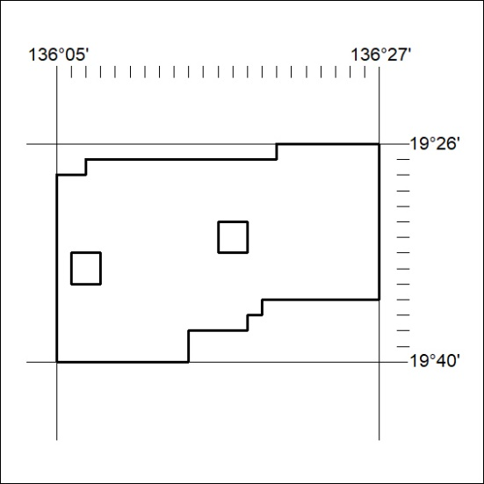
Area granted is indicated above. The titleholder is not permitted to exercise occupational rights on any land that is subject to a development title, or an application for a development title. Any land the subject of a Reserved Land gazettal under the Mineral Titles Act and all land vested in the Commonwealth of Australia is also excluded by description but not excised from the grant area.
20/21

