NTEM Priority Reform Program: Reliability priority changes
  - Consultation Paper: Design of the capacity mechanism
  - January 2021

Published by the Northern Territory Government. Apart from any use permitted under the Copyright Act, no part of this document may be reproduced without prior written permission from the Northern Territory Government through the Department of Treasury and Finance and the Department of Industry, Tourism and Trade.

Contents
1. Introduction 4
2. Reliability standard and assessment framework 4
2.1. Form and level of the reliability standard 5
2.2. The Reliability Manager 5
3. Approaches to achieving the reliability standard 6
3.1. Options for ensuring capacity adequacy 6
3.2. Capacity procurement approach for the NTEM Priority Reform 7
4. Detailed design elements of the reliability framework 8
4.1. Determining the forecast of required accredited capacity 12
4.2. Allocating capacity requirements to retailers 13
4.3. Ex-post review and reconciliation 13
4.4. Capacity price 14
5. Accreditation of capacity 15
5.1. Controllable capacity 16
5.2. Intermittent generation and storage 17
5.3. New entrant impact on accreditation 18
6. Management of maintenance via capacity out-of-balance 20
6.1. Reserve factor 20
6.2. Capping of reserve factors 21
6.3. Paying for capacity in excess of accredited capacity 22
7. Transition 22
8. Implementation and next steps 24
8.1. Legislative change 24
8.2. Next steps 24
9. Making a submission 25
Appendix A: Illustrative overview of capacity mechanism 26

Introduction
The Northern Territory Government has identified the need to undertake reform to support reliability as part of its Northern Territory Electricity Market (NTEM) Priority Reform Program. The NTEM Priority Reform Program, announced in June 2020, is a package of coordinated priority reforms to market arrangements in the Darwin-Katherine Interconnected System (DKIS) to facilitate an increased number of market participants and accommodate emerging technologies. The reforms will ensure efficient, secure and reliable electricity supply and support government’s renewable energy target. Components of the Priority Reform Program relate to reliability, dispatch, essential system services and settlement arrangements. More information can be found on each component in the Northern Territory Electricity Market Priority Reform Program: Introductory Notes on scope and work program which is on the Department of Industry, Tourism and Trade’s website.
This consultation paper focusses on the area of reliability where priority reforms identified by the Territory Government will ensure achievement of a system-wide standard for reliability of supply (reliability standard). A critical element of the reliability framework is ensuring there is sufficient capacity available (capacity adequacy) to meet the reliability standard.
The purpose of this consultation paper is to seek stakeholder input on the design considerations in respect to the reliability priority reforms, and more specifically, a proposed draft design of the reliability framework to ensure achievement of the reliability standard. The paper includes a series of consultation questions to elicit feedback to inform a final design of priority reliability reforms.
The paper is structured as follows: Section 2 summarises the proposed NTEM Priority Reform Program reliability standard and assessment framework; Section 3 discusses electricity market designs and the need for specific mechanisms to ensure capacity adequacy; Section 4 outlines the processes required under a capacity mechanism and provides a draft design for the mechanism; Sections 5 and 6 provide detail on the accreditation of generation and storage and management of the provision of actual and accredited capacity; and finally, Sections 7 and 8 discuss matters relating to transition and the legislative changes required to implement the capacity mechanism. Section 9 details how stakeholders can provide feedback on this consultation paper.

Reliability standard and assessment framework
The Priority Reform Program for reliability in the DKIS will result in the establishment of a formal reliability standard informed by detailed reliability analysis modelling and the design and implementation of a fit-for-purpose framework to ensure achievement of the reliability standard. The form and level of the reliability standard are not the subject of this paper. This paper focuses on how the reliability standard will be translated into a forecast physical capacity requirement and implemented to ensure effective capacity is present to satisfy the reliability standard in any given year. Notwithstanding this, the following paragraphs provide a brief summary of arrangements for the reliability standard and responsibility for the management of reliability in the DKIS.

Form and level of the reliability standard
Following public consultation in early 2019, it has been determined that the reliability standard for the DKIS will be a customer-focused standard. A customer-focussed standard directly addresses the reliability experienced by customers, in contrast to generator standards, which focus on the status of generators. The reliability standard is to be measured in terms of hours at risk of shortfall per year, termed Loss of Load Hours (LoLH). LoLH will limit the number of hours the available generation capacity may, under rare circumstances, fall short of customer demand (that is, interruption to electricity supply resulting from inadequate generating capacity). This is distinct from interruptions due to inadequate network capacity or instability in operation which can also cause interruptions. LoLH is considered the most appropriate form of standard due to the relatively flat demand profile of demand in the DKIS.
The level of the LOLH reliability standard will be determined through detailed reliability analysis modelling. Expert assistance will be sought to undertake modelling of the impact on the supply of electricity delivered to customers (for different levels of reliability) and the associated capital and operating cost implications. Following completion of the work, the form and level of the reliability standard will be formally established by government through regulatory instruments.

The Reliability Manager
The framework for ensuring there is sufficient capacity to meet the reliability standard will be administered by a new function, the Reliability Manager. The Reliability Manager function is proposed to be assigned to the System Controller. Section 4 outlines in more detail the responsibilities of the role. The System Controller has been determined as the most suitable party to perform the Reliability Manager function because it already has whole-of-power system responsibilities and functions. It is also well placed to be able to source the information required for the management of reliability in the DKIS and have the necessary technical expertise to perform the role.
Consultation question:
- What other matters need to be considered in determining who should undertake the Reliability Manager function for the DKIS?

Approaches to achieving the reliability standard

Options for ensuring capacity adequacy
A key market design element of the NTEM Priority Reform Program is the choice of approach for ensuring there is adequate capacity to achieve the reliability standard. Internationally, there are a number of approaches ranging from market-based mechanisms through to more administrative structures. The approaches differ from each other in terms of:
- structure – administrative/centralised mechanisms or market-based/decentralised mechanisms
- products – actual capacity guaranteed to be available (firm capacity), backup (reserve) capacity or call option (the holder of the option has the right [but not obligation] to buy/sell a specified amount of electricity during a particular time period in the future and at a fixed price)
- purchaser – retailer or central body/Reliability Manager; and
- target – volume-based amount of capacity or price-based (where the price is set and the market determines volume of capacity supplied).
The most decentralised mechanism is an energy-only wholesale market, so called because generators are only paid from the market when electricity is supplied. The price paid is the only source of market revenue to cover both capital and operating costs of generators. In this form of market, generators and retailers often arrange financial contracts between themselves to manage the risk of extreme prices and these contracts can dominate the commercial transactions in the market. Alternative commercial arrangements are increasingly being used, for example Power Purchase Agreements (PPA) where generators sell directly to a retailer for a negotiated price and various forms of financial instruments with prices referenced off a market price.
Energy-only markets create commercial incentives for investment, but do not guarantee enough capacity will be available to meet a desired standard of reliability. As a result, energy only markets often include a ‘back stop’ arrangement that can be activated by a central authority or regulator if forecasts of supply and demand indicate sufficient capacity is unlikely to be available. More generally, backstop arrangements are commonly included in market designs that rely on incentives, rather than obligations on market participants to make or contract for investments. The rules for these markets must set out criteria for triggering the backstop.
Other electricity markets use a different approach and have linked, but separate, capacity and energy arrangements. Capacity and energy markets are designed to incentivise efficient dispatch and have separate arrangements to administer capacity investment. In these markets, a central body typically sets a reliability standard and depending on the market design, the central body may:
- set a quantity of capacity that it will procure or require retailers to procure; or
- set a price, a price formula or mechanism such as an auction to determine a price that it will pay for capacity and let the market response decide the amount of capacity.
The purchasing mechanisms used internationally vary from direct bilateral contracts (e.g. PPAs) to centrally administered auctions and sophisticated financial instruments such as reliability options. Reliability options and reverse auctions create financial incentives for capacity to be made available and are used in a number of markets, but require a reference market price in order to function, highlighting the need for close linkage between the design of energy market and capacity procurement in these models.
In all designs, there is a benchmark for reliability (the reliability standard), arrangements for dispatch and pricing of energy and essential system services and arrangements for procurement of capacity, or alternatively, an incentive for market participants to invest in capacity. Where needed a backstop mechanism is also included.
The Australian National Electricity Market (NEM) is an example of an energy-only market and includes a Retailer Reliability Obligation as a backstop (note: the Energy Security Board is currently reviewing and consulting on possible amendments to the design of the Retailer Reliability Obligation). The Western Australian Wholesale Electricity Market (WEM) is a capacity and energy market and includes a capacity price set by the Australian Energy Market Operator (the System and Market Operator of both the eastern/southern seaboard NEM and the WEM) who stands in the market at a published price and includes provision for a backstop auction for capacity if needed.

Capacity procurement approach for the NTEM Priority Reform
The arrangements for ensuring sufficient capacity in a market should recognise the particular conditions and circumstances of the market in question. The DKIS customer base, which ultimately must fund market costs, is relatively small compared to other competitive markets and this means the costs to build and operate the market should be kept to a minimum.
In addition, the number of market participants is currently very low and dominated by one player on the supply side and one on the demand side; however, one aim of electricity market reform is to increase the number and diversity of participants on both sides of the market to deliver efficiency and improved performance to the benefit of consumers and taxpayers. Further, like many other power systems around the world, the technology mix in the DKIS is expected to change rapidly over the next decade, not only due to the introduction of renewable energy and storage, but also potentially with demand side and diverse suppliers of essential system services connecting for management of power system security.
Given these circumstances, reliability of supply in the DKIS is to be managed with a centrally administered reliability standard and obligations placed on retailers to be accountable for bringing sufficient capacity to market in order to meet the standard.
In this consultation paper, it is proposed that retailers may meet their obligations by contracting with generators (or other capacity providers) directly – a continuation of PPA style contracts – or retailers may leave the Reliability Manager to contract for capacity with relevant retailers paying a pro rata share of the costs incurred by the Reliability Manager.
The proposed arrangement is intended to keep barriers to entry for small retailers low by allowing the Reliability Manager to contract on their behalf if they choose. Additionally, the proposed arrangement does not require a separate backstop as it assigns obligations to parties to either acquire capacity in their own right or pay for capacity acquired by the Reliability Manager. This administered approach is considered preferable to alternatives of the Reliability Manager standing in the market at a declared price or requiring market responses to determine the price for capacity and designing and operating backstop arrangements. These alternative options would be more complex and costly to administer and are not compatible with the PPA form of many existing arrangements in the DKIS. The proposed approach is designed to strike a balance between minimising market costs to be paid by customers, economic efficiency by facilitating as much competition as circumstances allow and relatively close supervision of the level of capacity, which is central to ensuring reliability of supply.
The proposed reliability arrangements will require that a reference price for capacity be calculated. This reference price will be published as a benchmark to assist bilateral contracting between generators and retailers seeking to meet their obligation to bring capacity to market and also provide a price that will be used to create incentives for the planning and timing of generator maintenance activity. A key point is that the design of the reliability framework and energy and essential service markets need to be compatible (refer to section 7). Additionally, should government desire, the capacity mechanism described in this paper may provide a mechanism to implement any government policy relating to a percentage of capacity that is required to be sourced from renewable energy. This is an approach that could be used to manage renewable energy investment to support government’s renewable energy target, while ensuring sufficient reliability is maintained for customers.
The proposed arrangement whereby retailers have the choice of directly contracting with capacity providers to meet their obligation or leaving the acquisition of capacity to the Reliability Manger is expected to see most retailers and capacity providers contract directly with one another in the early stages of the capacity mechanism’s implementation. This reflects a continuation of existing contracting and a process that is familiar to existing players. However, the capacity mechanism design opens up the possibility that over time more capacity sources may enter the market by the actions of the Reliability Manager if retailers choose this particular path.
The Reliability Manager’s function is to ensure there is sufficient capacity and if the Reliability Manager acts to acquire capacity, it is for that purpose only. The capacity mechanism, and any procurement by the Reliability Manager, will not acquire energy or generator acquisition. Retailers will need to rely on contracts or the energy settlement for out-of-balance when energy is produced. Arrangements for energy are described in government’s policy position paper on dispatch and settlement priority reforms.
Consultation question:
- Are the proposed arrangements for acquiring capacity an appropriate balance between cost to administer, certainty and flexibility for retailers in choosing how to procure capacity?

Detailed design elements of the reliability framework
This section provides a more detailed description of the proposed arrangements for managing reliability of supply for the DKIS. It describes arrangements for:
- forecasting of capacity requirements
- inclusion of renewable energy requirements
- how much capacity each capacity provider can offer to a retailer seeking to acquit its obligation for capacity (accredited capacity)
- the detailed timeframe for the procurement process
- incentives for capacity providers to manage the amount and timing of capacity outages for maintenance; and
- after the event true up of retailer obligations for capacity.
As noted earlier, the form and level of the reliability standard are not the subject of this paper and are to be determined by government separately. Therefore, for the purpose of this paper on the draft design of the capacity mechanism, the reliability standard can be assumed as set.
The Reliability Manager will manage an accreditation process for provision of capacity to the DKIS. The approach to accreditation will be technology neutral, although for convenience plant with intermittent technology and fully controllable technology will be assessed through slightly different processes, with the process for assessing intermittent technology including additional steps. The accreditation assessment process covers thermal and renewable generation units, storage facilities (batteries) or demand side response resources. The determination of accredited capacity will account for failure rate, fuel certainty (including solar/wind variability) and any network constraints that affect the effective capacity of a type of technology or generation units in a particular location. The proposed process of determining accredited capacity is described in further detail in section 5.
The Reliability Manager will calculate how much accredited capacity will be needed to satisfy the reliability standard for a given year and announce each retailer’s capacity obligations (in megawatts [MW]). If there is a policy mandate for a certain level of investment in a specific technology to support government’s renewable energy target, the Reliability Manager will define a requirement for different classes of capacity. This is discussed further in section 4.1.
Each retailer’s share of the required accredited capacity that they will be accountable for will be related to their expected customer demand, which is detailed in section 4.2. An appropriate timeline will be established to ensure that contracting for capacity occurs well ahead of time in order to reduce the risks of a potential shortfall. In other markets, this typically occurs on a rolling three or four year cycle. Stakeholder feedback is sought on the proposed timeline outlined in Figure 1. The Reliability Manager will monitor whether enough accredited capacity is in the market and, if not, seek to enter into contracts in its own right and pass the cost through to those retailers who fall short in procuring their capacity obligations.
The Reliability Manager will also calculate a reference capacity price (refer to section 4.4). This price will be a published price that the Reliability Manager expects to pay if it is required to contract for capacity (that is, if a retailer fails to do so or chooses not to). Publication of the reference capacity price will also act as a benchmark price for retailers and generators (or other capacity providers) to refer to in negotiations of bilateral contracts. The capacity price will also form the basis for incentives or penalties related to the timing of reductions in capacity during a year, for example, to incentivise maintenance activity at times of high reserve capacity, or to impose a charge where there has been a failure to provide capacity, as accredited, without approval such as an unapproved maintenance outage. These matters and the use of the capacity price in calculations for ‘capacity out-of-balance’ are detailed further in section 6.
Under the proposed reliability framework, ensuring sufficient capacity will be present in the DKIS to meet the reliability standard involves the following steps. The proposed timing associated with each step is illustrated in Figure 1.
The framework involves:
- A rolling four-year planning period with a new fourth year added each year during an annual reset
- Forecasting of system demand across the planning period resulting in review and amendment (resetting) of the first three years and developing a new projection of demand for the fourth year
- The Reliability Manager:
  - Assessing the ability of each capacity source to contribute to meeting the reliability standard (accredited capacity)
  - Determining the amount of accredited capacity needed to meet the reliability standard and setting a new obligation for the new fourth year
  - Allocating accountability to each retailer for a share of the required accredited capacity (their capacity obligation)
- Retailers contracting with capacity sources for their capacity obligation or advising the Reliability Manager they wish the Reliability Manager to acquire their share and be charged accordingly
- Ex-post review by the Reliability Manager of the adequacy of the amount of capacity each retailer presented to market. Any retailer holding a surplus will be obligated to sell that surplus to any retailer holding a deficit
  - If retailers fail to reconcile their ex-post surplus and deficit positions after two months, they will be required to buy and sell at the capacity price to reconcile their positions
  - Reconciliation of surplus and deficit between retailers does not affect the trade between retailers and capacity providers who may trade bilaterally at any time during a planning period
    - Mandated ex-post sales will not expose capacity providers to credit risk as payment will have already been made for the period in question.
In the unusual event that the ex-post review determines that there was a net deficit in contracted capacity, the reliability standard would not have been met. In this circumstance, any retailer in deficit will pay the Reliability Manager for the amount of shortfall at the capacity price plus a 10 per cent premium. Proceeds will be used to offset any additional costs incurred by the Reliability Manager and potentially reimburse customers who will have experienced an unacceptable level of reliability.
Appendix A provides an illustrative overview of the proposed capacity mechanism, with a focus on contractual arrangements and cash flows between relevant parties under the mechanism.
Consultation question:
- Do the proposed timeframes in Figure 1 allow sufficient time between the Reliability Manager advising capacity obligations for Year 4 and retailers notifying the Reliability Manager of their purchasing intentions (that is, either the retailer will procure for itself or the retailer requests the Reliability Manager to purchase on its behalf)?
If no, please explain your answer.
- What issues and constraints need to be considered in adjusting contracts in response to capacity obligation resets in earlier years (Years 1 to 3), noting the rolling nature of the capacity mechanism should mean these are relatively minor?

Figure 1 Summary of key tasks and timing for the proposed capacity mechanism
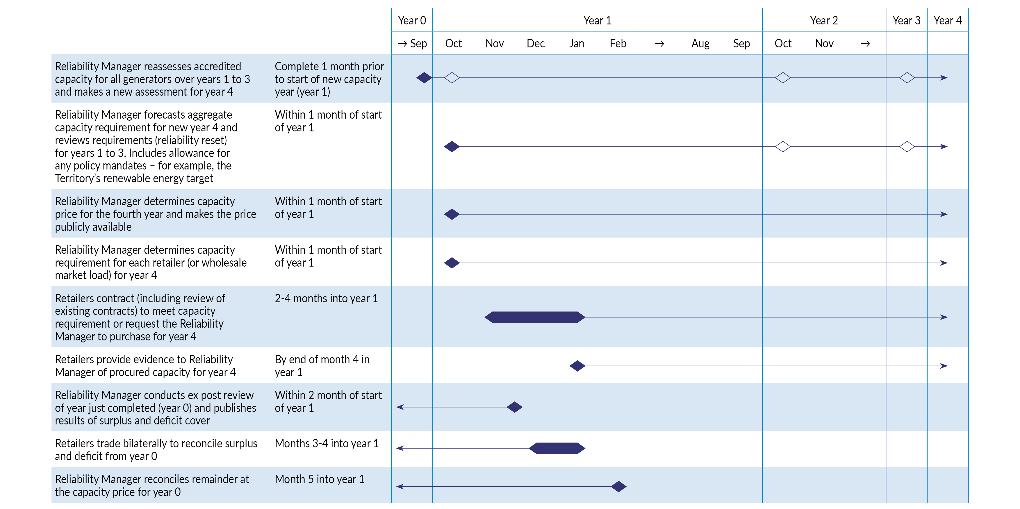

Determining the forecast of required accredited capacity
A key responsibility of the Reliability Manager function will be to translate the reliability standard into a forecast physical capacity requirement. The requirement reflects the accredited capacity, not nameplate or other measures of capacity. The accreditation of capacity is discussed in Section 5.
The proposed four-year planning period means that the Reliability Manager will be required to publish the forecast of accredited capacity requirement annually, for four years in advance. This will provide a statement to retailers on their obligations to contract for capacity as well as inform prospective capacity providers of emerging opportunities for investment. Typically, there may be small changes in forecasts across the first three years as these will have been assessed in previous years to adjust for any minor changes in demand and/or supply that are expected to impact those years.
The Reliability Manager will be responsible for developing the methodology for the calculation of the forecast and should use one of the well-established industry modelling tools. Once finalised, the methodology will be published. The Reliability Manager will perform the calculation once a year as part of the process of planning for the four-year period. The calculated aggregate accredited capacity requirement will also be published in accordance with the timeframes in Figure 1.
The Reliability Manager function will draw on information held by the System Controller as well as source input from industry participants in order to forecast demand and the aggregate accredited capacity requirement. Key inputs for the modelling include:
- Projected system-wide demand
- Projected available capacity of existing and planned generating units including solar generation and battery storage resources
- Fuel cost, heat-rate, fixed and variable operating costs for existing and planned generating units
- Potential new entrant generating plant including capital cost, fuel cost, heat-rate, fixed and variable operating costs
- Forecast forced outage rates of existing and planned generating units to calculate capacity needed to manage security
- The size of units or generation blocks that can be interrupted due to a single credible event
- Transmission network details including transfer limits and losses; and
- Investment and operating policies, for example, the reliability standard, essential system services constraints, emissions limits and renewable energy targets.
Key outputs of the analysis will include the following, which will be published.
- A statistical report of instances of shortfall in capacity at different times of the day and season; and
- The capacity required to ensure the shortfall is no more than the reliability standard – this level of capacity will define the capacity requirement.
The Reliability Manager will need to develop assessments of the contribution of different facilities – their accredited capacity – and then specify how much accredited capacity needs to be present.
In determining the aggregate forecast accredited capacity requirement to meet the reliability standard, the Reliability Manager will be agnostic to the source of accredited capacity. However, it is noted that should government utilise the option to require a certain percentage of capacity to be sourced from renewable sources, the Reliability Manager would need to specify the percentage of accredited capacity that must be contracted from a renewable source.

Allocating capacity requirements to retailers
Once the total accredited capacity requirement has been determined, the Reliability Manager will need to allocate each retailer a share of the requirement for which they will be accountable or obligated to provide. Retailers can meet their capacity obligation directly through contracting with accredited capacity providers or by paying the Reliability Manager to procure accredited capacity or a combination of these two methods.
If retailers are required to meet a percentage of their demand from renewable technology (if government utilises the policy option to require a percentage of capacity to be from renewable sources), retailers will also need to contract for that amount of accredited renewable capacity at a minimum within their allocated obligations. If this option is not utilised by government, the accredited capacity requirement will be technology neutral and retailers will be able to meet their obligation using any form of accredited capacity.
In order to determine each retailer’s allocation or share of the total requirement for accredited capacity, the Reliability Manager will assign accountability for that capacity between retailers, expressed in terms of a MW obligation to each retailer for each year:
- Assess each retailer’s demand in the at-risk hours in the system as a whole
- Find the average of each retailer’s demand in Step 1 across all at risk hours
- Set each retailer’s share of accredited capacity in proportion to their share of total average demand across all retailers (from Step 2)

The Reliability Manager will advise each retailer of its allocation of the forecast accredited capacity requirement it must meet (at a minimum). Each retailer will need to meet its capacity obligation by entering into contract(s) for or building its own capacity or requesting that the Reliability Manager procure capacity on their behalf. Although the choice of how retailers might meet their obligation may evolve over time, initially most retailers are expected to choose to contract directly with capacity providers and typically through PPAs or similar contractual arrangements. It is also expected that initially retailers may contract with new entrant generation including intermittent generation, but they will also need to contract with controllable plant to firm supply and cover times of low intermittent energy input (in the absence of very large scale storage). Retailers are likely to need to have a range of contracts in order to meet their customers’ energy needs and their obligation for accredited capacity.
Retailers will be required to provide sufficient detail on their procured capacity to enable the Reliability Manager to validate that they have met their obligation. This should be provided by the end of the three month window for undertaking procurement (refer to Figure 1).

Ex-post review and reconciliation
The proposed design intends to create a balance between incentives to contract accurately in advance, but also to facilitate efficient use of existing plant. Accordingly, each year the Reliability Manager will review whether sufficient actual physical capacity (MW) was in place and whether each retailer met their capacity obligation. This review is not intended to be a punitive review; rather it is designed to ensure each retailer has, in practice, carried their allocated share of costs of bringing capacity to market. Any retailer holding more accredited capacity than required will be obligated to offer it for sale to any retailer that is holding less than its requirement who will be obligated to buy it.
This ex-post mechanism is designed to reduce the risk of hoarding surplus capacity and to provide assurance to large and small retailers that each will be paying their ‘fair’ share of the cost of bringing capacity to market. It is also intended to be an incentive to avoid under providing which would amount to free-riding (that is, relying on others to bear the cost of contracting capacity).
If there is a net surplus and no retailers are in deficit there will be no adjustment required and each retailer will carry the cost of its own surplus (providing an incentive to provide information required by the Reliability Manager to facilitate accurate demand forecasting as discussed in section 4.1).
It is noted that if there is a net surplus (for example, because retailers have contracted more accredited capacity than needed), the capacity price that will be used for ex-post transfers and capacity out-of-balance payments will be low, but not necessarily zero. This is because additional capacity will have delivered higher reliability than the reliability standard, providing an economic benefit to customers. Retailers will bear the additional cost for contracting higher levels of capacity and will ultimately seek to recover this cost from customers, subject to competitive pressures in the retail market. There will be no direct recovery of these additional costs in the wholesale market.
As noted in section 4.1, in the unusual event that the ex-post review determines that there was a net deficit in contracted capacity, retailers in deficit will pay the Reliability Manager for the amount of their individual shortfall(s) at the capacity price plus a 10 per cent premium.
The Reliability Manager will publish its assessment two months after the end of each capacity year. Retailers will have a further two months to trade on a bilateral basis and notify the Reliability Manager of adjusted entitlements to accredited capacity. Retailers can, however, trade between themselves at whatever price they agree at any time prior to the review if surplus and deficit positions are apparent.
After four months, the Reliability Manager will reassess the holding of ex-post accredited capacity by retailers and where positions have not been reconciled, publish a notice of mandatory adjustments which will be added to relevant party’s next settlement statement (facilitated through a centralised Market Operator settlement arrangement). Mandatory adjustments will be processed using the published capacity price. These transactions will be cost neutral to the Market Operator as buyers and sellers will be balanced and the capacity price set by a calculation under the market rules.

Capacity price
The majority of capacity costs in the DKIS are expected to be recovered through contracts between retailers and capacity providers; however, each year the Reliability Manager function will set a capacity price for the fourth year.
The capacity price will be:
- The price the Reliability Manager will pay for any capacity it must acquire (i.e., where retailers fail to contract to meet their capacity obligations);
- Published as a benchmark price to inform negotiations between generators and retailers;
- The basis for mandatory adjustments where retailers remain deficit in during an ex-post review (see previous section);
- An input to capacity out-of-balance settlement; and
- An incentive for timing of maintenance activities.
The level of capacity required and the impact of the existing PPAs and other contracts will determine the level of capacity present in the system. Analysis of the marginal cost of existing capacity will be used to determine the capacity price in the short term.
In the long term, the capacity price will be derived from market studies of forecast demand compared to the forecast availability of capacity. This will be done by examining the change in cost to deliver the same level of reliability under the reliability standard if forecast demand was 1 MW different to the prevailing forecast (that is, what is the extra (or lesser) cost likely to be if demand was marginally more (or less)). The capacity price can also be set by benchmarking against the price set for deficit capacity obligation procured by the Reliability Manager through a central process (such as an auction or tender). Other markets base their capacity price on the size of a typical new entrant of the technology expected and this could also be done in the DKIS, but this requires that the technology of the new entrant be selected in advance. The small increment of capacity (1MW) proposed in this paper reflects the purposes of the capacity price under the NTEM Priority Reform Program. For example, the price is intended to be used to create incentives for timing of maintenance and be the basis of trading capacity in the ex-post reconciliation. The proposed approach allows the modelling to identify the technology on the basis of costs, noting that although the 1 MW increment is artificial (and may be below the minimum size of a new (greenfield) investment in some technologies) it will be suitable for the role of the capacity price under the NTEM Priority Reform Program.
Rules regarding the methodology that the Reliability Manager is to use for setting the capacity price will be established.
In the analysis by the Reliability Manager, consideration will need to be given to the impact of the diurnal change in output from intermittent plant as the lowest reserve may occur late in the day or early evening. This will have implications for the type of generation required to be purchased. The Reliability Manager will also need to consider whether there is a need to adjust a declared capacity price. The need for such adjustments has arisen in a number of capacity markets including in the WEM and may also be needed in the DKIS.
Typically, capacity prices are in the order of $10 to $15 per MW per hour per year when incremental capacity is sourced from gas fired generation plant. However, a capacity price for the DKIS will only be available from detailed analysis relating to the DKIS including consideration of what capacity sources, including storage or demand energy response, might contribute.

Accreditation of capacity
The assessment of reliability in any power system needs an understanding of the capability and performance of individual generation units and other forms of capacity (e.g. battery storage and demand response) and how their combined performance meets customer demand for energy and essential system services. The process to assess the contribution of various plant to reliability is termed accreditation. As different plant may be owned by separate businesses and the performance of each unit will in general differ, it is necessary to identify the contribution of each unit to reliability of the system so that owners can be appropriately remunerated and retailers can construct a portfolio of accredited capacity providers to suit their customer base.
The degree to which different capacity sources are capable of contributing to reliability varies due to location, technology type and a range of other factors, which impact on the availability of the plant. For example, a solar photovoltaic installation that is intermittent in nature cannot contribute to reliability after the sun sets and its contribution can also be reduced due to cloud cover, but if coupled with battery storage or other firming arrangements, it may contribute more than the size of the solar capability. A gas fired generating unit can contribute throughout the day, but the contribution is dependent on fuel supply, temperature and risk of breakdown. Thus, accreditation will vary by plant.
The following sections describe the proposed process for accrediting capacity for the NTEM Priority Reform Program. The concept of the Effective Load Carrying Capacity (ELCC) will be used to determine accreditation for controllable and intermittent generators and storage. The ELCC concept is used in a number of international markets and also in Western Australia. In simple terms, ELCC is a measure of the capacity contribution of a particular capacity source based on the additional load that the capacity source can supply when it is introduced to the system, without changing the level of reliability of the system. For controllable generators, which have relatively small variation in availability, the ELCC of a generator is likely to be similar to the installed capacity of that generator. Accordingly, for convenience, a short form of the process to determine ELCC may be used for controllable generators (see section 5.1). For intermittent plant, where availability is relatively more variable, calculation of the ELCC is more challenging and requires a modelling exercise to be undertaken (see section 5.2).
Section 5.3 discusses the implications on new entrants for the accreditation of existing plant (incumbent or early movers) and whether protection of the accreditation of existing plant in order to de-risk investment is likely to impede or facilitate efficient investment in capacity.
While all plant may be given accreditation, it does not automatically mean that all plant receives a payment for capacity in the same way that not all plant that responds to a traditional PPA tender would be awarded a contract. Sources of capacity will only receive payment for that capacity when it is accredited and contracted by a retailer for the purposes of fulfilling its capacity obligation or acquired by the Reliability Manager. The total amount of contracted accredited plant necessary to meet the reliability standard is determined by the Reliability Manager. Retailers’ procurement choices will determine what accredited plant actually receives capacity payments (which may be set out within contracts between retailers and capacity sources).

Controllable capacity
In the Territory, current controllable plant is primarily gas fired thermal plant. These plant typically have substantial flexibility and a controllable fuel supply allowing them to be called on at any time. As a result, the contribution of thermal units to reliability is most likely limited by factors such as planned and unplanned maintenance, and for plant that is regularly stopped and started, there is the probability of ‘fail to start’ when instructed.
Accreditation of each controllable unit is proposed to be through a discount factor on installed capacity. The factor will be set based on unplanned loss of availability over the previous 12 month period.
Unplanned loss of availability includes:
- instances of unavailable capacity that were not pre-approved by the System Controller 48 hours in advance (although discretion may be given where a shorter period of advice was given and the System Controller expected that sufficient capacity would be available); and
- failures to start within 30 minutes of the time indicated in a generator’s submission which the System Controller has used to make a decision to call a unit into service.
As noted above, this is a short form of the ELCC approach process. While it would be possible to apply the long form of the ELCC process, it is not necessary for controllable plant, and this simpler approach remains consistent with the ELCC concept.
Consultation question:
- Is a more complex process warranted for determining accreditation of controllable units? If so, please explain why, and describe your proposed process.
- Are the proposed timeframes (previous 12 month performance; 48 hour pre-approval; 30 minute start window) suitable for deriving the discount factor?

Intermittent generation and storage
Intermittent generation and storage is proposed to be accredited using the concept of the ELCC using the longer form of the process due to the relatively greater variability of availability of such plant. Under the approach, the ELCC will identify how much additional customer demand, over a base case, a single plant or group of plant of the same technology (technology group) can provide. This becomes the accredited capacity for the plant or in the case of a technology group, the amount that is to be distributed across plant within the group.
The following process is proposed for determining the ELCC and deriving an accredited capacity value for intermittent plant and storage:
- Prepare a base case of reliability in a half hourly study using a projection of customer demand (including allowance for variations in behind the meter solar) with all intermittent plant that is to be accredited excluded at this stage
- Increase or decrease controllable plant until the reliability standard is met with no surplus or deficit
- Add intermittent plant to be assessed. This will result in an improved level of reliability that exceeds the standard
- Increase demand uniformly to retain the load shape until the level of reliability returns to the standard and note the amount of demand at-risk in each half hour
- The increase in demand in step 4 is the ELCC. In the case of assessment of a single intermittent generation unit, the accredited capacity would be the ELCC. In case where there are multiple existing generators in a technology group (e.g. all solar generators), the ELCC is the total amount of capacity that can be accredited. The total amount must be divided among members (e.g. individual solar generators) of the group
  - Dividing the ELCC across a group can be based on the average output of each plant or other criteria relating to the size and performance of plant.
  - The accreditation of individual intermittent plant will change if:
    - the performance of the plant varies over time; or
    - external factors such as a change in the demand profile or a constraint affecting the ELCC.
It is noted that (in respect to step 5.a. above) while the contribution of a group of intermittent plant will progressively increase the ELCC for the group, as the group grows in size (e.g. additional participants that are of the same technology in the group) there can be diminishing returns for further additions of the same technology. This is because hours and energy previously at risk will progressively reduce resulting in a different profile of risk and reducing the average benefit. When this occurs, the share of the ELCC for each plant in the group will be less. Or in other words, this may mean that as more plant of the same technology are accredited, the accreditation of existing (incumbent) plant of the same technology may decrease, due to the ELCC being shared by additional plant. The impact on accreditation of new intermittent plant entering the market, and situations where power system constraints affect capacity investment, is discussed in section 5.3
Storage that is physically or contractually linked with the operation of an intermittent plant should be assessed as a hybrid facility where the availability is representative of the expected availability of the combination of technologies including allowance for cloud cover. Stand alone storage (e.g. batteries) operated as an independent market participant will be assessed in a similar way to intermittent plant. The time periods where storage will be guaranteed to be at full charge will define the profile of availability of storage capacity for the ELCC calculation.
The capacity of the 132kV line between Darwin and Katherine may at times be a constraint on the operation of plant south of Channel Island grid. This means intermittent plant to the north and south of Channel Island may need to be assessed separately. These two groups are also likely to show different degrees of reduced output due to cloud with plant further south less likely to be impacted. Whether separate assessment of the northern and southern regions is needed will only be determined from practical experience (evaluated by the Reliability Manager) and may evolve in conjunction with the growth in solar.

New entrant impact on accreditation
Directly or indirectly through contracts the capacity mechanism provides a steady revenue stream for providers of accredited (and contracted) capacity to support achievement of the reliability standard. Although the characteristics exhibited by controllable generation (discussed in section 5.1) mean this type of generation is suited to contributing to the capacity needs of a power system, intermittent generation and storage are also expected to contribute to capacity and also earn capacity revenue. However, production of energy is expected to be the primary source of income for intermittent generators. It should also be noted that accreditation (for any capacity provider) does not afford any priority for dispatch. Dispatch order will be determined on the basis of least cost economic principles (with tie breaking for equal priced energy as well as meeting other security and network constraints).
Given the Territory Government’s renewable energy target, it is anticipated that many new entrants will be intermittent generators and storage. Without a decision to the contrary, the accreditation process in section 5.2 for these technologies means that as the number of market participants increases, the ELCC would be divided over an increasing number of generation units, as explained above. Accordingly, the initial accreditation value assigned to an intermittent plant (and therefore the capacity revenue it could potentially earn) will generally be highest at commissioning then decline over time as other plant enters the market. This has a number of advantages and disadvantages detailed in Table 1.
Table 1 Advantages and disadvantages of variable accreditation
 | Analysis
Advantages | Reduces barriers to future competition (and more efficient technology) by facilitating equal access to capacity revenue stream.  Avoids possible distortions where two (or more) generators may have significantly different accreditation (and thus levels of capacity revenue) simply due to the order in which they connect to the network.  Preserves the relationship between accreditation and the capability or characteristics of the generation plant (as accreditation is regularly reviewed).  The impact on ELCC from changes in customer demand (positive or negative) are equally shared across generators.  This analysis assumes energy is the primary source of revenue. (Intermittent solar plant are likely to be only accredited a small proportion of their installed capacity and thus, capacity related payments will be a minor part of their revenue.) The addition of storage coupled with an intermittent technology (such as solar PV) would change this analysis unless the storage and solar are assessed separately.
Disadvantages | Creates uncertainty about the level of capacity revenue, which may result in investors requiring a price premium to accommodate revenue risk.  Weakens capacity investment signals when there are network or other constraints at particular locations within the network. Preserving the accreditation of incumbents (or early movers) in those areas would send a stronger signal (as new entrants only receive any residual associated with an increase in the ELCC) that further supply would not be beneficial and investors should consider other locations within the power system.  There is less incentive for early movers (relative to a regime where the accreditation and the associated stream of capacity revenue of incumbents was protected).

Consultation question:
- How important is certainty in the level of capacity accreditation granted to intermittent plant, noting generators have access to capacity and energy streams of income?
- What indicators provide the effective signals to prospective entrants about the benefits of connecting to the network including in areas where access is likely to be constrained?
- What approach – a variable accreditation approach or an approach that preserves the accreditation of incumbents or early movers – is likely to result in long term efficient outcomes and best serve the interests of consumers? Why would that approach best achieve those outcomes?

Management of maintenance via capacity out-of-balance
From time to time, sources of capacity may suffer outages and/or not have the capacity or performance available that was expected. Planned outages also occur for maintenance purposes. These situations may result in what is referred to as ‘capacity out-of-balance’, that is, a failure (planned or unplanned) to provide the capacity for which a generation unit is accredited and contracted for, in accordance with the requirements to meet the reliability standard.
Proposed capacity out-of-balance arrangements are intended to create incentives to manage the timing of outages to avoid times when there is low reserve capacity available, and to plan and coordinate maintenance. These incentives, together with the System Controller’s management of planned maintenance, will ensure poor performing generation plant are exposed to incentives to improve performance.
It is proposed that capacity providers pay or receive payment if they present less or more capacity than their accredited capacity, for each half hour. The payment (facilitated through a centralised Market Operator settlement arrangement) will reflect the difference between actual availability for dispatch, regardless of whether the unit is dispatched at the time and accredited capacity, termed a capacity out-of-balance.
The payment is proposed to be calculated from the capacity price for the year, a reserve scaling factor related to actual total system reserve and a cap related to whether the capacity reductions had been pre-approved by the System Controller.
The arrangement would apply to all accredited capacity that is part of retailers’ obligations, regardless of whether it is contracted by retailers or the Reliability Manager on behalf of retailer(s). Where capacity is procured by the Reliability Manager on a retailer’s behalf, the relevant retailer will pay or receive capacity out-of-balance payments relating to the proportion of capacity the Reliability Manager procured on its behalf.

Reserve factor
The reserve factor is intended to align the capacity out-of-balance charge with the incremental value of capacity to customers at the time. It will also create an incentive to manage the timing of inevitable reductions in capacity.
The reserve factor follows the shape of the relationship between the level of reserve capacity and the economic value at risk from a shortfall in supply. The incremental value of capacity to customers is the value of a small increase or decrease in the available capacity. This value increases as reserve falls and the risk of shortfall rises. The value decreases when reserve is higher and the impact of a small increase or decrease in available capacity has less impact on risk of shortfall.
Figure 2 illustrates a typical profile of a reserve factor. The profile is an approximation of the incremental value of reserve and economic cost to the customer of a shortfall in supply. Values and steps are chosen to balance incentives for generators to ensure capacity is available at the times it is needed, while also ensuring the scaling factor for low reserve does not result in a detrimental financial impact. The overall effect is designed to be a pragmatic incentive that is directionally correct but unavoidably contains a number of judgemental design choices.
Figure 2 Illustrative reserve factor compared to reserve capacity
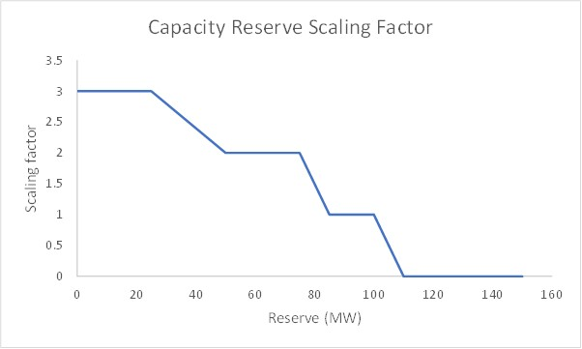
The following provides an example of application of reserve factors before applying the proposed cap that incentivises sources of capacity to plan timing of maintenance through the System Controller for when reliability will be less impacted (which is discussed in section 6.2). In this example, if a plant that is accredited for 40MW of capacity is unavailable, and the declared capacity price is $10/MWh:
- at times when reserve is at a minimum (peak time): the reserve factor would be 3 which would be applied to the capacity price giving rise to a $30/MW charge resulting in a charge of $1200/hour
- at times when reserve is moderate: the reserve factor would be 1 and the charge would be 1 times $10/MWh so the charge for a 40MW shortfall would be $400/hour; and
- at times when reserve is high (e.g. off peak and during dry season periods): the reserve factor would be zero, reflecting the low value of additional capacity under those conditions. Note: these periods may also be times of significant scheduled maintenance which will reduce the reserve. As a result an outage in these times may still result in only moderate levels of reserve.

The next section describes the incentive for planning and managing the timing of reductions in capacity.

Capping of reserve factors
The System Control Technical Code (SCTC) includes a number of requirements related to seeking approval and notice periods before undertaking maintenance that reduces the availability for dispatch.
The reserve factor described in the previous section is to be capped in a way that creates an incentive to forward plan the timing of reductions in capacity. This incentive is to be delivered by capping the reserve factor to be applied to capacity out-of-balance payments according to whether the reductions have been pre-approved by the System Controller in accordance with the SCTC.
Table 2 lists the reserve factors (introduced in the previous section) and the capped factors to create an incentive for capacity sources to manage the timing of any reductions in available capacity to match system conditions.
Unplanned reductions incur the full reserve factor of between 0 and 3. Planned reductions result in a lower factor (minimum 0) depending on the actual reserve.
Table 2 Capped capacity charge scaling factors
Scenario | Reserve factor | Capped Scaling Factor
Lower reserve and unplanned reduction | 3 | 3
Moderate reserve and unplanned reduction | 1 | 1
Moderate-high reserve and unplanned reduction | 0.5 | 0.5
High reserve and unplanned reduction | 0 | 0
Approved planning reduction with notice period as per SCTC (all reserve levels) | 0 to 3 according to reserve | 0
Approved planning reduction with less than SCTC notice period (but nevertheless approved) | 0 to 3 according to reserve | Reserve factor minus 1 (minimum 0)

Paying for capacity in excess of accredited capacity
When one capacity source is available for less than its accredited capacity it will often be the case that other capacity sources will have capacity that exceeds their accredited capacity, therefore enhancing system reserve. This may be particularly relevant to intermittent plant which are likely to have relatively low accredited capacity relative to their peak generation capability.
It is proposed that a payment will be made to capacity sources that provide capacity in excess of their accredited capacity from (and limited by) funds received from capacity sources with availability below their accredited capacity. This payment will be calculated by apportioning the total payment received from units below accredited capacity in proportion to the amount each capacity source is above its accredited capacity in each half hour.
This approach will recognise that although intermittent plant may not have a high accreditation for longer term planning of system capacity, this plant can at times provide valuable short term, albeit intermittent, support to reliability. This contribution should be recognised as and when it occurs and when it adds to reliability. It should be noted, however, that as the amount of intermittent (or other) generation in the DKIS increases, the likely capacity out-of-balance charge to off-line controllable (or other) generators will decrease. This is because overall reserve levels will often be quite high which will result in lower charges.
Consultation question:
- Do the arrangements described in section 6 create a satisfactory balance of risk and reward for managing the timing of presentation of capacity? Please explain your response.

Transition
Both the reliability and essential system services components of the NTEM Priority Reform Program are expected to be implemented in late 2021, noting that commencement of the capacity mechanism will depend on transitional arrangements determined through consultation. The review of the competitive provision of essential system services is being undertaken concurrently to the development of, and consultation on, the proposed capacity mechanism. Alignment in timing of these reforms is important, as arrangements for the essential system services need to be fully functional before the capacity mechanism can operate effectively to ensure the priority reforms are implemented in a coordinated and integrated manner.
On this basis, it is anticipated that the first year that capacity requirements will be calculated is 2022-23; however, there will be a transition before the mechanism is fully functional. For the early years in the four-year rolling period, there may be insufficient time to seek contracts or additional capacity (if required) so total capacity may need to be set to what is currently available. Equally, there could be surplus capacity in which case a method of transition will be developed to reach a point where the total capacity requirement to achieve the reliability standard and physical capacity align, and the capacity mechanism can operate as designed. These will be issues that will need to be addressed once the necessary modelling has been conducted in respect to the level of the reliability standard and it is possible to compare actual and required capacity.
To assist market participants familiarise themselves with concepts, roles and procedures, it is proposed to operate the capacity mechanism on a virtual basis until 2025-26. At that point, retailers would become fully accountable for their capacity obligations. This transition period would involve:
- setting capacity requirements in 2022-23 to apply in 2025-26
- continuing current arrangements for 2023-24 and 2024-25
- creating an information package to show what the financial outcomes would have been in 2022-25 if the capacity market had been live; and
- modifying the virtual capacity requirements informed by timetables for retirement of existing plant and introduction of the essential system services framework.
Consultation question:
- Will the proposal to operate a virtual capacity mechanism and the associated timeframes be helpful in assisting participants to understand and prepare for full operation? Please explain your response.
- What other information or initiatives would be helpful to inform participants on capacity mechanism operations in order to prepare for live operation of the mechanism in 2025-26?
- Alternatively, rather than applying a virtual capacity mechanism until 2025-26, do you consider that an earlier commencement of a full operational mechanism is possible and preferred? Please explain your response.

Implementation and next steps

Legislative change
Introduction of the reliability framework will be a substantial change to the current regulatory framework for the Territory’s electricity sector. The framework will guide future investment in capacity in the sector. Accordingly, there needs to be clear and transparent rules underpinning the framework to ensure industry participant and investor confidence. Legislative and regulatory change (amendments to Acts and regulations) will be required to implement the reliability framework because:
- a legislative basis is required to support new powers and responsibilities proposed for the Reliability Manager and retailers; and
- the reliability standard will be set by government and implemented through regulations.
While the capacity mechanism could be established through code changes (such as the Power and Water Corporation’s SCTC), this option is not preferred as it does not represent best practice and may not provide the same level of confidence to industry as if it was established through legislative instruments. Additionally, while the reliability reforms are intended to be implemented as quickly as possible, it is appropriate for transition as discussed in section 7 in recognition that a capacity mechanism is a substantial change for market participants to prepare for.
It is proposed that that detailed rules governing the capacity mechanism will be established through legislation and regulations. At this stage, it is anticipated that amendments to the Electricity Reform Act 2000 and subordinate regulations will be required to implement the reliability framework.
In the longer term, once the framework is well established, including any refinements needed to improve the efficiency and effectiveness of design elements, consideration could be given to transferring rules to the Northern Territory National Electricity Rules and/or expanding the scope of independent rule making in the Territory’s electricity industry. These longer term options may provide for more appropriate and independent governance of the Territory’s electricity industry, noting that consideration of governance arrangements beyond those applicable to reliability arrangements are outside the scope of this review.
Consultation question:
- Do stakeholders have an alternative preferred option to implementation through legislative and regulatory change? If so, please describe the approach and provide reasoning for why it is preferred.

Next steps
Implementation of the reliability standard and capacity mechanism is a priority reform identified by the Territory Government and stakeholder feedback and engagement is important to ensure the design is robust and fit-for-purpose.
Following the release of this consultation paper, a Stakeholder Working Group workshop on the proposed reliability design will be held to provide the opportunity for stakeholders to provide feedback outside of (and in addition to) providing written submissions on this paper. The workshop will be held in early February 2021 with further details on the workshop to be provided to the Stakeholder Working Group. Information on how to participate in the Stakeholder Working Group are on the DITT website.
Depending on the nature of feedback received, supplementary targeted consultation may be undertaken if necessary. The intention is to consider feedback to inform the finalisation of the design of the capacity mechanism and publish a final review report in April 2021. Following the publication of the final review report, work will commence on preparation of the legislative changes required to implement the NTEM Priority Reform Program reliability framework. Commencement timeframes will be determined through consultation (refer to section 7). The expected timeframes are set out in Table 3.
Table 3 Timetable for legislative changes to implement the reliability framework
Action | Expected timing
Stakeholder workshop to be held on this consultation paper | Early February 2021
Publish final review report setting out detailed policy positions | April 2021
Implementation of legislative and regulatory changes | Late 2021
Implementation of required procedures and systems | To be determined through consultation
Commencement of reliability changes | To be determined through consultation

Making a submission
Interested parties are invited to email submissions on this consultation paper to the Design Development Team at electricityreform@nt.gov.au by Close of Business Friday 12 March 2021.
Submissions should be provided in Adobe Acrobat or Microsoft Word format. On receipt of a submission a confirmation of receipt email will be provided, however, it is the submitter’s responsibility to ensure successful delivery of their submission.
The Design Development Team will publish submissions. Public submissions are preferred, however, if the submitter includes confidential information, it must be clearly identified and a version of the submission suitable for publication with confidential information removed should also be provided. The Design Development Team may also exercise its discretion not to publish any submission based on content, such as submissions containing material that is offensive of defamatory.
Please contact the Design Development Team regarding any questions on the consultation by emailing electricityreform@nt.gov.au.

Appendix A: Illustrative overview of capacity mechanism: Contractual arrangements and cash flows
The figures below provide a diagrammatic summary of the proposed capacity mechanism, with a focus on illustrating the contracting and cash flow relationships between relevant parties.
Figure A1 Contractual arrangements and cash flows – capacity and energy
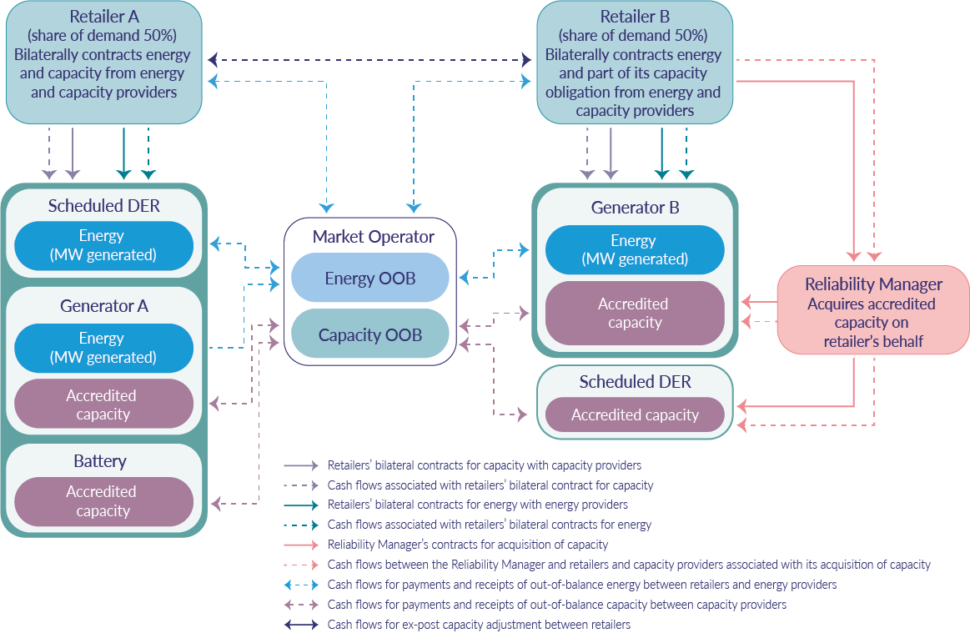
In addition to capacity contractual arrangements and cash flows, Figure A1 also illustrates energy settlement arrangements, being bilateral contracts for energy and associated cash flows, and cash flows for settlement of out-of-balance energy. Note that for simplicity, cash flows associated with settlement of startup/shutdown cycle costs are not shown.
This is a simplified example, with a hypothetical market with two retailers. Retailers A and B both bilateral contracts for energy and capacity (often using the same providers for both). The capacity obligation of each retailer is based on their share of demand. The Reliability Manager has partially acquired Retailer B’s capacity obligation. This could be because Retailer B requested that the Reliability Manager partially acquire capacity on its behalf, or because when Retailer B presented evidence of procured capacity, there was a shortfall requiring the Reliability Manager to step in and acquire capacity. A retailer could also request the Reliability Manager to contract for all of its obligation, although this is not the case in this example. Noting the Reliability Manager may acquire capacity through a range of means, this figure shows a bilateral contract and associated cash flows.
At the end of each capacity year, the ex-post review of the adequacy of the amount of capacity each retailer presented to the market, may result in ex-post trading between Retailer A and B. While not shown in Figure A1 for simplicity, in the event there is a net deficit where retailers, in aggregate, do not procure sufficient capacity, there may also be a payment (cash flow) from retailers to the Reliability Manager.
Throughout each capacity year, capacity providers may receive and pay capacity out-of-balance reflecting that from time to time they may present more or less capacity than expected, such as due to unplanned maintenance/breakdown (with the rate to depend on level of reserve at the time).
Figure A2 shows contractual arrangements and cash flows for the capacity mechanism only (and ‘greys out’ arrangements for energy). Similarly, Figure A3 shows contractual arrangements and cash flows for only energy settlement (noting that startup/shutdown cycle cost settlement cash flows are not shown).
Figure A2 Contractual arrangements and cash flows – capacity only
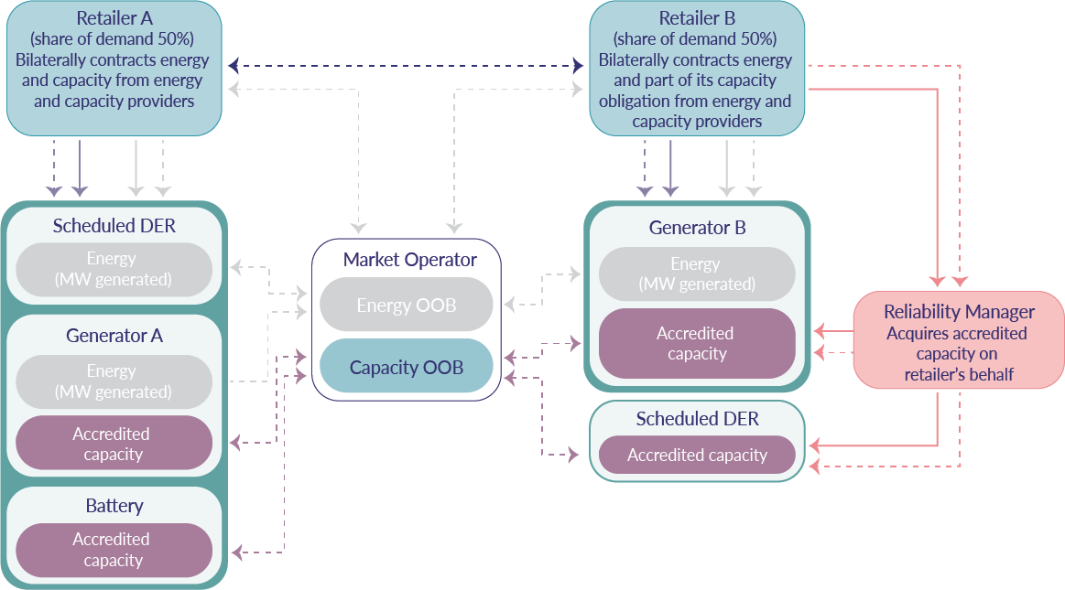
Figure A3 Contractual arrangements and cash flows – energy only
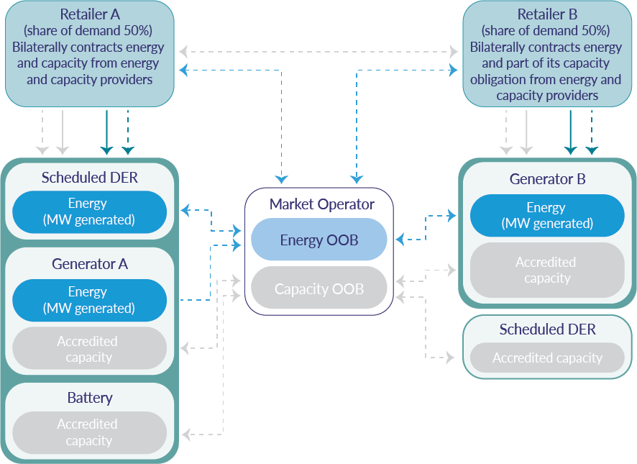

At https://industry.nt.gov.au/__data/assets/pdf_file/0012/889563/ntemprp-introductory-notes-scope-work-program.pdf
Further detail on reliability standards and the issues considered during the consultation can be found at https://treasury.nt.gov.au/__data/assets/pdf_file/0005/646475/Consultation-Paper-Reliability-Standard-Form-Final-Jan-2018.pdf.
Or other capacity sources recognised under the mechanism, such as battery storage or schedulable distributed resources.
The Power and Water Corporation holds the System Control licence for the Territory’s three regulated power systems (DKIS, Tennant Creek and Alice Springs power systems). System Control is responsible for real time operations, operations planning, power system technical assessments, incident reviews, and operational and technical regulatory reporting for the three power systems.
CIGRE. Capacity mechanisms: needs, solutions and state of affairs, Working Group C5.17, February 2016. Available at https://e-cigre.org/publication/647-capacity-mechanisms-needs-solutions-and-state-of-affairs.
For example, jurisdictions including the Australian Capital Territory (ACT) have used reverse auctions to achieve renewable energy targets, with auctions using the NEM market price in NSW as the reference price (the ACT is within the NSW region).
The Policy Position Paper on dispatch and settlement can be found at: https://industry.nt.gov.au/electricityreforms
The inputs listed are for typical industry models and can be amended in light of the final choice of model used by the Reliability Manager. Most industry models require input costs, although technically costs are not required for this modelling exercise. Therefore, input cost information could be estimates or indicative.
In small system as such the DKIS allowance for security can dominate capacity requirements.
The choice of how to allocate capacity obligations varies widely between markets with capacity mechanisms. The proposed process has been chosen to be simple, transparent and low cost to administer.
Although the concept is used in a number of markets, it should be noted that the detailed design varies.
The concept is similar to the dynamic refund regime in the WA WEM and rising prices in the NEM when reserve reduces.
The capacity mechanism will ensure sufficient capacity is contracted to meet the Reliability Standard and capacity providers will be paid through that mechanism. However, in the absence of revised essential system services arrangements, if a provider of essential system services was not contracted for provision of capacity, an alternative means would be required to ensure it was able to recover any costs associated with being available to provide essential system services.
Even if the rules for the capacity mechanism were to be implemented via code changes, they would likely require supporting legislative and/or regulatory changes.
This is also subject to further legal advice and the views of the Northern Territory Office of Parliamentary Counsel.
Registration details for the Stakeholder Working Group are at: https://industry.nt.gov.au/electricityreforms
Refer to the Policy Position Paper on dispatch and settlement at: https://industry.nt.gov.au/electricityreforms

