Mineral Titles Act 2010
NOTICE OF LAND CEASING TO BE A MINERAL TITLE APPLICATION AREA
Title Type and Number: | Exploration Licence 29252
Area Ceased on: | 09 December 2020
Area: | 212 Blocks, 645.22 km²
Locality: | ALCOOTA
Name of Applicant(s)/Holder(s): | 100% TODD RIVER METALS PTY LTD [ACN. 600 314 038]
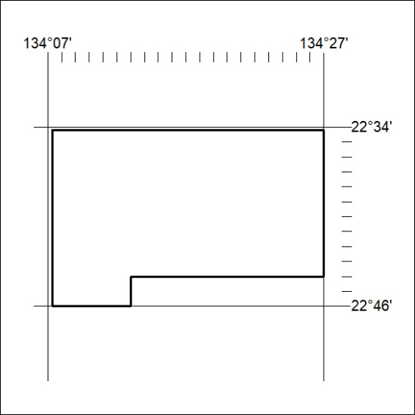

406/20

Mineral Titles Act 2010
NOTICE OF LAND CEASING TO BE A MINERAL TITLE APPLICATION AREA
Title Type and Number: | Exploration Licence 29253
Area Ceased on: | 09 December 2020
Area: | 71 Blocks, 224.29 km²
Locality: | DELNY
Name of Applicant(s)/Holder(s): | 100% TODD RIVER METALS PTY LTD [ACN. 600 314 038]
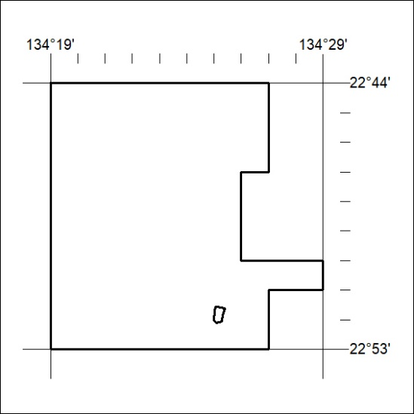

407/20

