Mineral Titles Act 2010
NOTICE OF LAND CEASING TO BE A MINERAL TITLE AREA
Title Type and Number: | Exploration Licence 29831
Area Ceased on: | 17 March 2020
Area: | 4 Blocks, 13.10 km²
Locality: | COANJULA
Name of Applicant(s)/Holder(s): | 100% OZ URANIUM (NT) PTY LTD [ACN. 161 904 847]
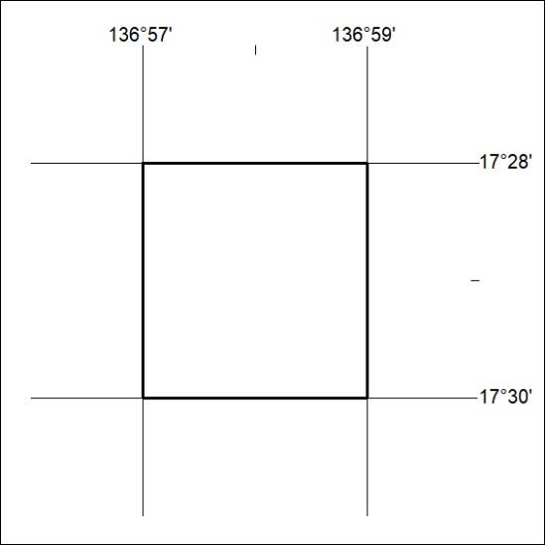

142/20

