Mineral Titles Act 2010
NOTICE OF LAND CEASING TO BE A MINERAL TITLE AREA
Title Type and Number: | Extractive Mineral Exploration Licence 31663
Area Ceased on: | 07 March 2020
Area: | 2 Blocks, 3.32 km²
Locality: | NOONAMAH
Name of Applicant(s)/Holder(s): | 100% BERNO BROS. PTY. LIMITED [ACN. 009 592 741]
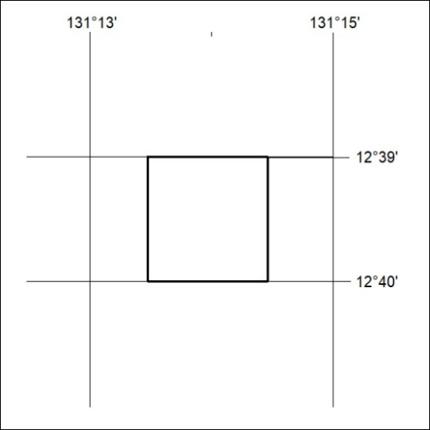

135/20

Mineral Titles Act 2010
NOTICE OF LAND CEASING TO BE A MINERAL TITLE AREA
Title Type and Number: | Exploration Licence 31591
Area Ceased on: | 07 March 2020
Area: | 218 Blocks, 682.42 km²
Locality: | PINE CREEK
Name of Applicant(s)/Holder(s): | 100% WOODLEIGH NOMINEES PTY LIMITED [ACN. 050 120 057]
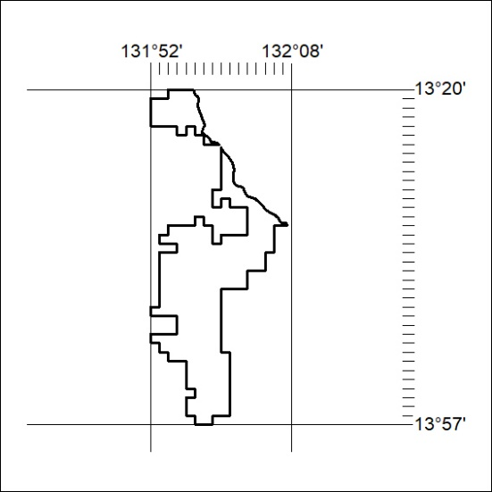

136/20
Mineral Titles Act 2010
NOTICE OF LAND CEASING TO BE A MINERAL TITLE AREA
Title Type and Number: | Exploration Licence 28940
Area Ceased on: | 06 March 2020
Area: | 26 Blocks, 81.94 km²
Locality: | LAUGHLEN
Name of Applicant(s)/Holder(s): | 100% DBL BLUES PTY LTD [ACN. 140 024 442]
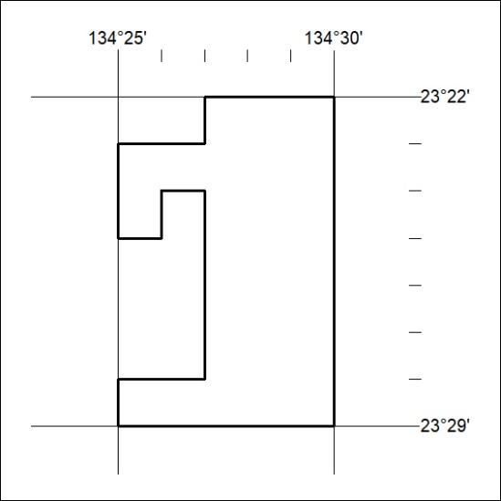

137/20

