Mineral Titles Act
NOTICE OF GRANT OF A MINERAL TITLE
Title Type and Number: | Exploration Licence 32133
Granted: | 04 March 2020, for a period of 6 Years
Area: | 52 Blocks, 170.55 km²
Locality: | MARUMBA
Name of Holder/s: | 100% ROPER ILMENITE PTY LTD [ACN. 609 843 978]
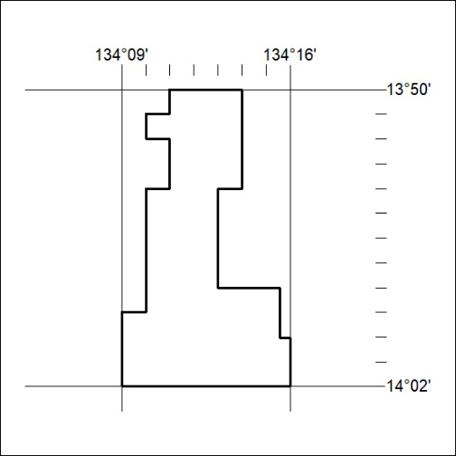
Area granted is indicated above. The titleholder is not permitted to exercise occupational rights on any land that is subject to a development title, or an application for a development title. Any land the subject of a Reserved Land gazettal under the Mineral Titles Act and all land vested in the Commonwealth of Australia is also excluded by description but not excised from the grant area.

128/20

Mineral Titles Act
NOTICE OF GRANT OF A MINERAL TITLE
Title Type and Number: | Exploration Licence 32134
Granted: | 04 March 2020, for a period of 6 Years
Area: | 22 Blocks, 73.33 km²
Locality: | MARUMBA
Name of Holder/s: | 100% ROPER ILMENITE PTY LTD [ACN. 609 843 978]
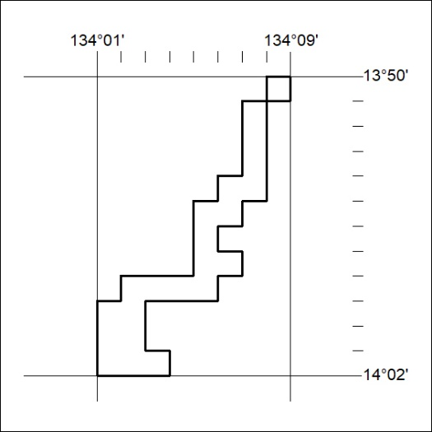
Area granted is indicated above. The titleholder is not permitted to exercise occupational rights on any land that is subject to a development title, or an application for a development title. Any land the subject of a Reserved Land gazettal under the Mineral Titles Act and all land vested in the Commonwealth of Australia is also excluded by description but not excised from the grant area.

129/20

Mineral Titles Act
NOTICE OF GRANT OF A MINERAL TITLE
Title Type and Number: | Exploration Licence 32135
Granted: | 04 March 2020, for a period of 6 Years
Area: | 14 Blocks, 46.63 km²
Locality: | FLYING FOX
Name of Holder/s: | 100% ROPER ILMENITE PTY LTD [ACN. 609 843 978]
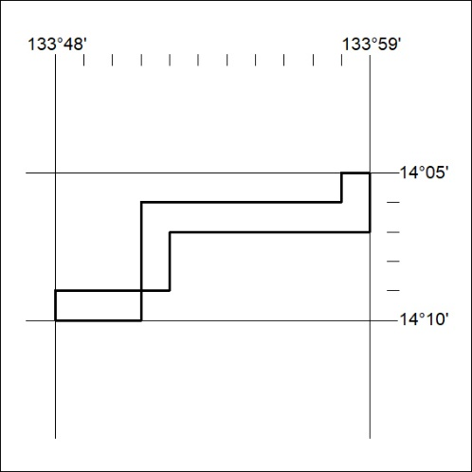
Area granted is indicated above. The titleholder is not permitted to exercise occupational rights on any land that is subject to a development title, or an application for a development title. Any land the subject of a Reserved Land gazettal under the Mineral Titles Act and all land vested in the Commonwealth of Australia is also excluded by description but not excised from the grant area.

130/20

Mineral Titles Act
NOTICE OF GRANT OF A MINERAL TITLE
Title Type and Number: | Exploration Licence 32136
Granted: | 04 March 2020, for a period of 6 Years
Area: | 96 Blocks, 319.68 km²
Locality: | FLYING FOX
Name of Holder/s: | 100% ROPER ILMENITE PTY LTD [ACN. 609 843 978]
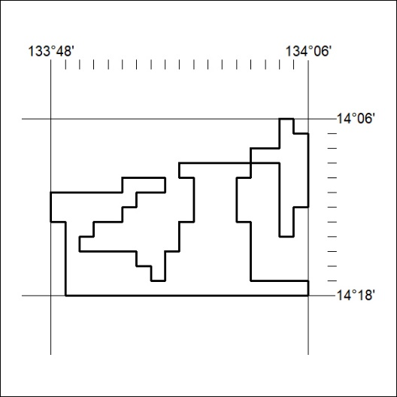
Area granted is indicated above. The titleholder is not permitted to exercise occupational rights on any land that is subject to a development title, or an application for a development title. Any land the subject of a Reserved Land gazettal under the Mineral Titles Act and all land vested in the Commonwealth of Australia is also excluded by description but not excised from the grant area.

131/20

Mineral Titles Act
NOTICE OF GRANT OF A MINERAL TITLE
Title Type and Number: | Exploration Licence 32137
Granted: | 04 March 2020, for a period of 6 Years
Area: | 41 Blocks, 107.26 km²
Locality: | THROSBY
Name of Holder/s: | 100% ROPER ILMENITE PTY LTD [ACN. 609 843 978]
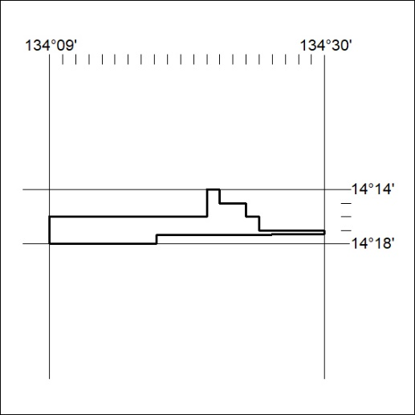
Area granted is indicated above. The titleholder is not permitted to exercise occupational rights on any land that is subject to a development title, or an application for a development title. Any land the subject of a Reserved Land gazettal under the Mineral Titles Act and all land vested in the Commonwealth of Australia is also excluded by description but not excised from the grant area.

132/20

Mineral Titles Act
NOTICE OF GRANT OF A MINERAL TITLE
Title Type and Number: | Exploration Licence 32138
Granted: | 04 March 2020, for a period of 6 Years
Area: | 245 Blocks, 741.20 km²
Locality: | THROSBY
Name of Holder/s: | 100% ROPER ILMENITE PTY LTD [ACN. 609 843 978]
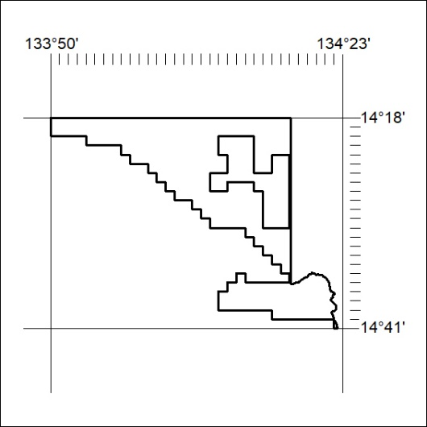
Area granted is indicated above. The titleholder is not permitted to exercise occupational rights on any land that is subject to a development title, or an application for a development title. Any land the subject of a Reserved Land gazettal under the Mineral Titles Act and all land vested in the Commonwealth of Australia is also excluded by description but not excised from the grant area.

133/20

Mineral Titles Act
NOTICE OF GRANT OF A MINERAL TITLE
Title Type and Number: | Exploration Licence 32144
Granted: | 04 March 2020, for a period of 6 Years
Area: | 15 Blocks, 46.46 km²
Locality: | CHAPMAN
Name of Holder/s: | 100% ROPER ILMENITE PTY LTD [ACN. 609 843 978]
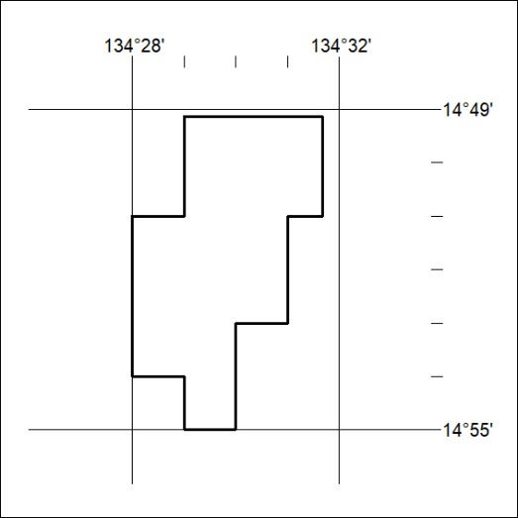
Area granted is indicated above. The titleholder is not permitted to exercise occupational rights on any land that is subject to a development title, or an application for a development title. Any land the subject of a Reserved Land gazettal under the Mineral Titles Act and all land vested in the Commonwealth of Australia is also excluded by description but not excised from the grant area.

134/20

