Mineral Titles Act 2010
NOTICE OF LAND CEASING TO BE A MINERAL TITLE APPLICATION AREA
Title Type and Number: | Extractive Mineral Permit 31681
Area ceased on: | 05 February 2020
Area: | 71.00 Hectare
Locality: | KOOLPINYAH
Name of Applicants(s)Holder(s): | 100% ALLAN KING & SONS CONSTRUCTION PTY LTD [ACN. 068 688 148]
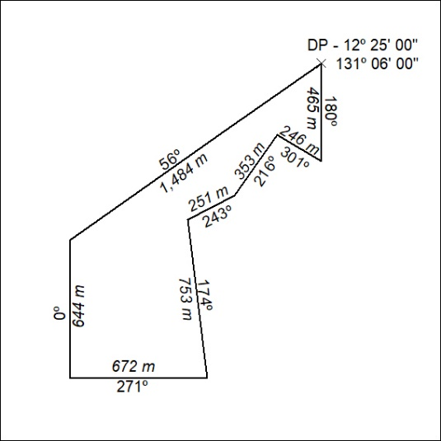

63/20

Mineral Titles Act 2010
NOTICE OF LAND CEASING TO BE A MINERAL TITLE APPLICATION AREA
Title Type and Number: | Extractive Mineral Permit 31682
Area ceased on: | 05 February 2020
Area: | 87.00 Hectare
Locality: | KOOLPINYAH
Name of Applicants(s)Holder(s): | 100% ALLAN KING & SONS CONSTRUCTION PTY LTD [ACN. 068 688 148]
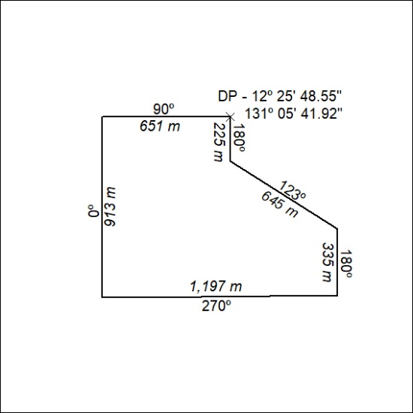

64/20
Mineral Titles Act 2010
NOTICE OF LAND CEASING TO BE A MINERAL TITLE AREA
Title Type and Number: | Exploration Licence 24451
Area Ceased on: | 06 February 2020
Area: | 10 Blocks, 31.69 km²
Locality: | MT WEDGE
Name of Applicant(s)/Holder(s): | 100% ENERGY METALS LTD [ACN. 111 306 533]
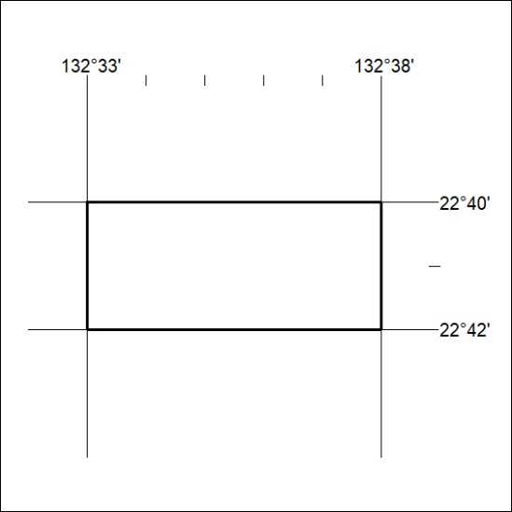

65/20

Mineral Titles Act 2010
NOTICE OF LAND CEASING TO BE A MINERAL TITLE AREA
Title Type and Number: | Exploration Licence 28434
Area Ceased on: | 06 February 2020
Area: | 47 Blocks, 136.02 km²
Locality: | MACDONNELL RANGES
Name of Applicant(s)/Holder(s): | 56.28% CROSSLAND NICKEL PTY LTD* [ACN. 099 477 915], 43.72% ESSENTIAL MINING RESOURCES PTY LTD [ACN. 601 655 725]
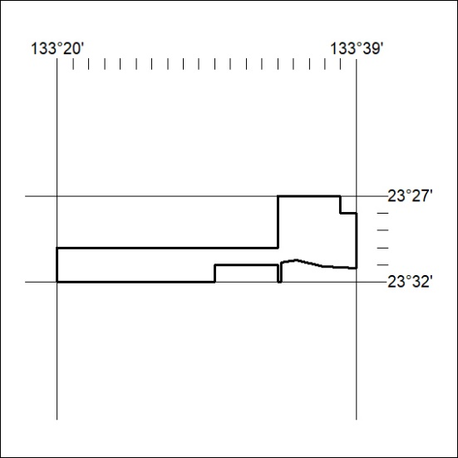

66/20

