Mineral Titles Act 2010
NOTICE OF LAND CEASING TO BE A MINERAL TITLE AREA
Title Type and Number: | Mineral Lease (Northern) 286
Area ceased on: | 27 November 2019
Area: | 12.00 Hectare
Locality: | BYNOE
Name of Applicants(s)Holder(s): | 100% OSTOJIC GROUP PTY LTD* [ACN. 009 629 805]
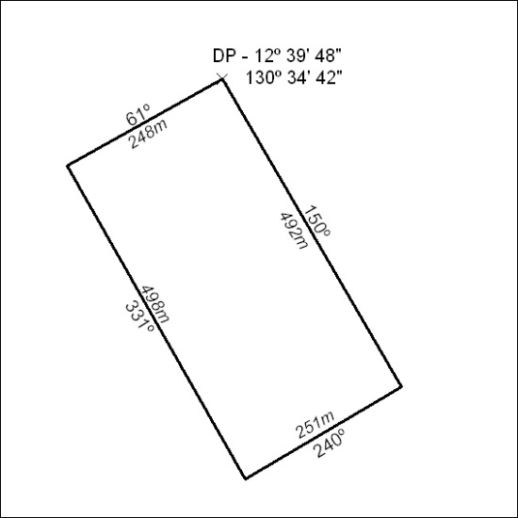

502/19

Mineral Titles Act 2010
NOTICE OF LAND CEASING TO BE A MINERAL TITLE AREA
Title Type and Number: | Mineral Lease (Northern) 287
Area ceased on: | 27 November 2019
Area: | 12.00 Hectare
Locality: | BYNOE
Name of Applicants(s)Holder(s): | 100% OSTOJIC GROUP PTY LTD* [ACN. 009 629 805]
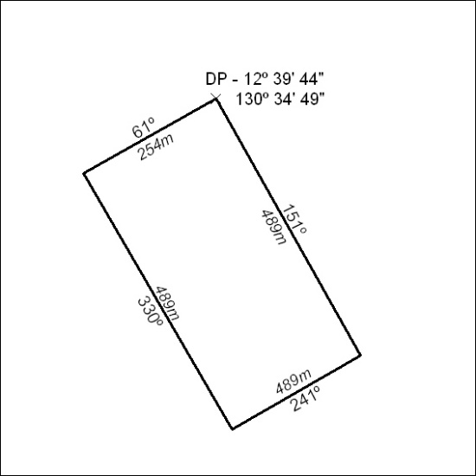

503/19

Mineral Titles Act 2010
NOTICE OF LAND CEASING TO BE A MINERAL TITLE AREA
Title Type and Number: | Mineral Lease (Northern) 289
Area ceased on: | 27 November 2019
Area: | 12.00 Hectare
Locality: | BYNOE
Name of Applicants(s)Holder(s): | 100% OSTOJIC GROUP PTY LTD* [ACN. 009 629 805]
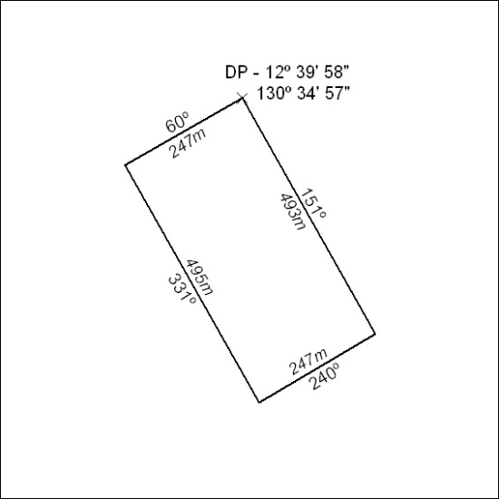

504/19

Mineral Titles Act 2010
NOTICE OF LAND CEASING TO BE A MINERAL TITLE AREA
Title Type and Number: | Mineral Lease (Northern) 291
Area ceased on: | 27 November 2019
Area: | 3.00 Hectare
Locality: | BYNOE
Name of Applicants(s)Holder(s): | 100% OSTOJIC GROUP PTY LTD* [ACN. 009 629 805]
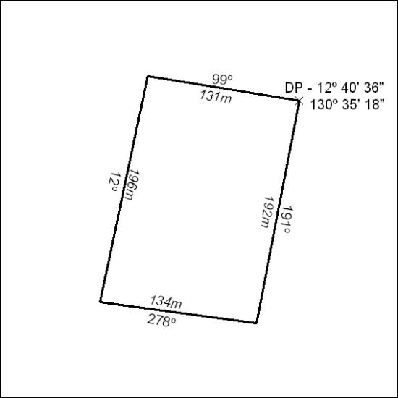

505/19

Mineral Titles Act 2010
NOTICE OF LAND CEASING TO BE A MINERAL TITLE AREA
Title Type and Number: | Mineral Lease (Northern) 292
Area ceased on: | 27 November 2019
Area: | 6.00 Hectare
Locality: | BYNOE
Name of Applicants(s)Holder(s): | 100% OSTOJIC GROUP PTY LTD* [ACN. 009 629 805]
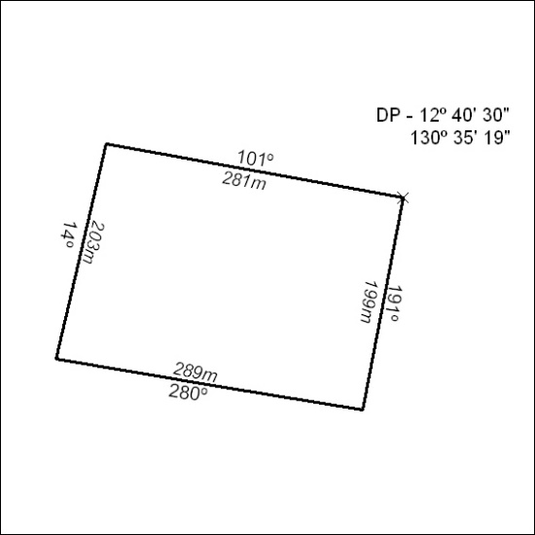

506/19

Mineral Titles Act 2010
NOTICE OF LAND CEASING TO BE A MINERAL TITLE AREA
Title Type and Number: | Mineral Lease (Northern) 297
Area ceased on: | 27 November 2019
Area: | 1.00 Hectare
Locality: | BYNOE
Name of Applicants(s)Holder(s): | 100% PASPALEY PEARLING COMPANY PTY. LIMITED [ACN. 009 591 708]
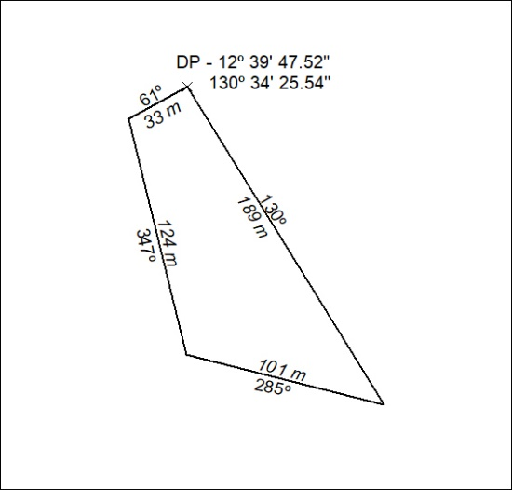

507/19

Mineral Titles Act 2010
NOTICE OF LAND CEASING TO BE A MINERAL TITLE AREA
Title Type and Number: | Mineral Lease (Northern) 298
Area ceased on: | 27 November 2019
Area: | 2.00 Hectare
Locality: | BYNOE
Name of Applicants(s)Holder(s): | 100% PASPALEY PEARLING COMPANY PTY. LIMITED [ACN. 009 591 708]
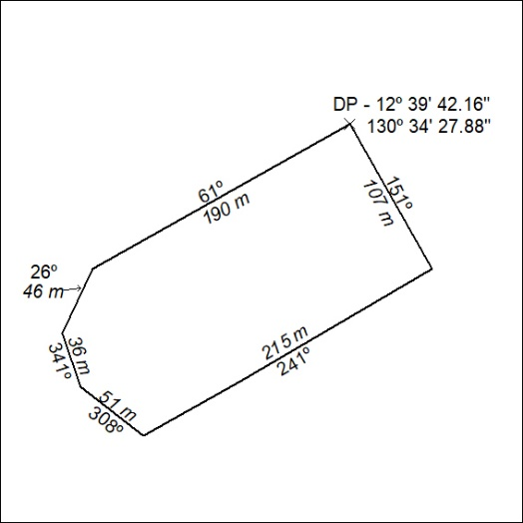

508/19

Mineral Titles Act 2010
NOTICE OF LAND CEASING TO BE A MINERAL TITLE AREA
Title Type and Number: | Mineral Lease (Northern) 299
Area ceased on: | 27 November 2019
Area: | 4.00 Hectare
Locality: | BYNOE
Name of Applicants(s)Holder(s): | 100% OSTOJIC GROUP PTY LTD* [ACN. 009 629 805]
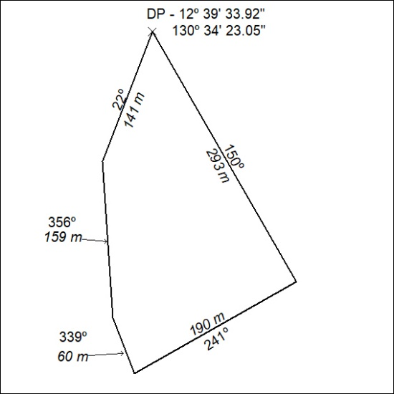

509/19

Mineral Titles Act 2010
NOTICE OF LAND CEASING TO BE A MINERAL TITLE AREA
Title Type and Number: | Mineral Lease (Northern) 300
Area ceased on: | 27 November 2019
Area: | 10.00 Hectare
Locality: | BYNOE
Name of Applicants(s)Holder(s): | 100% OSTOJIC GROUP PTY LTD* [ACN. 009 629 805]
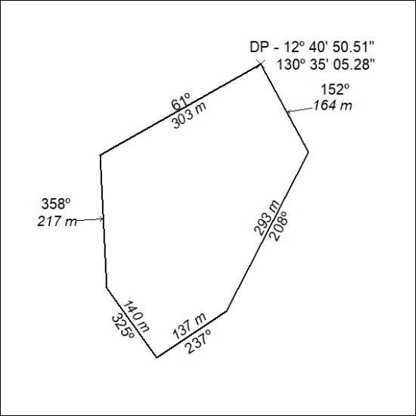

510/19

Mineral Titles Act 2010
NOTICE OF LAND CEASING TO BE A MINERAL TITLE AREA
Title Type and Number: | Mineral Lease (Northern) 301
Area ceased on: | 27 November 2019
Area: | 2.00 Hectare
Locality: | BYNOE
Name of Applicants(s)Holder(s): | 100% OSTOJIC GROUP PTY LTD* [ACN. 009 629 805]
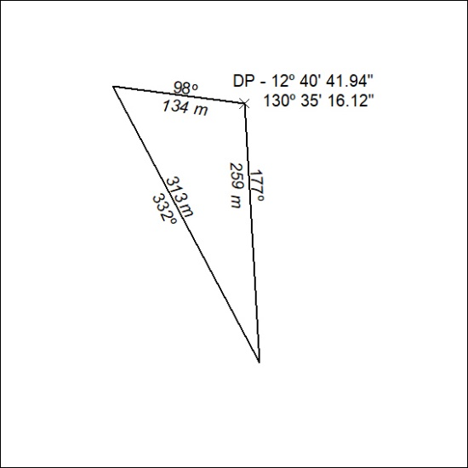

511/19

Mineral Titles Act 2010
NOTICE OF LAND CEASING TO BE A MINERAL TITLE AREA
Title Type and Number: | Mineral Lease (Northern) 302
Area ceased on: | 27 November 2019
Area: | 2.00 Hectare
Locality: | BYNOE
Name of Applicants(s)Holder(s): | 100% OSTOJIC GROUP PTY LTD* [ACN. 009 629 805]
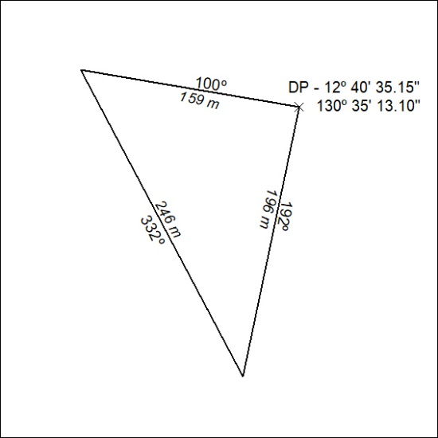

512/19

Mineral Titles Act 2010
NOTICE OF LAND CEASING TO BE A MINERAL TITLE AREA
Title Type and Number: | Mineral Lease (Northern) 303
Area ceased on: | 27 November 2019
Area: | 13.00 Hectare
Locality: | BYNOE
Name of Applicants(s)Holder(s): | 100% OSTOJIC GROUP PTY LTD* [ACN. 009 629 805]
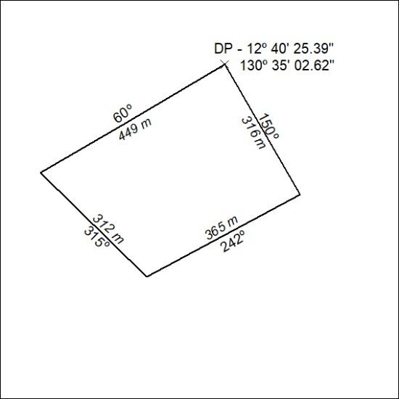

513/19

Mineral Titles Act 2010
NOTICE OF LAND CEASING TO BE A MINERAL TITLE AREA
Title Type and Number: | Mineral Lease (Northern) 304
Area ceased on: | 27 November 2019
Area: | 9.00 Hectare
Locality: | BYNOE
Name of Applicants(s)Holder(s): | 100% OSTOJIC GROUP PTY LTD* [ACN. 009 629 805]
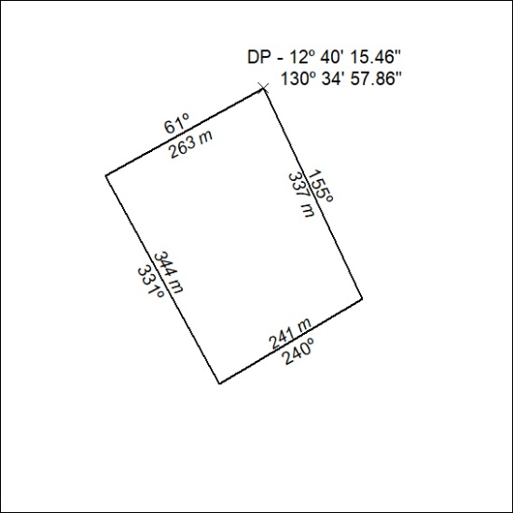

514/19

Mineral Titles Act
NOTICE OF GRANT OF A MINERAL TITLE
Title Type and Number: | Exploration Licence 32020
Granted: | 27 November 2019, for a period of 6 Years
Area: | 240 Blocks, 791.35 km²
Locality: | DALY WATERS
Name of Holder/s: | 100% FIDDLER'S CREEK MINING COMPANY PTY LTD * [ACN. 099 215 648]
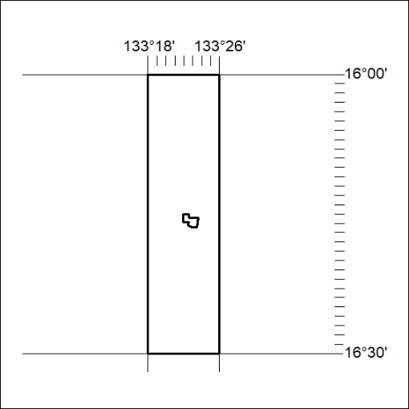
Area granted is indicated above. The titleholder is not permitted to exercise occupational rights on any land that is subject to a development title, or an application for a development title. Any land the subject of a Reserved Land gazettal under the Mineral Titles Act and all land vested in the Commonwealth of Australia is also excluded by description but not excised from the grant area.

515/19

Mineral Titles Act
NOTICE OF GRANT OF A MINERAL TITLE
Title Type and Number: | Exploration Licence 32111
Granted: | 27 November 2019, for a period of 6 Years
Area: | 24 Blocks, 77.71 km²
Locality: | TENNANT CREEK
Name of Holder/s: | 100% TRUSCOTT MINING CORPORATION LTD [ACN. 116 420 378]
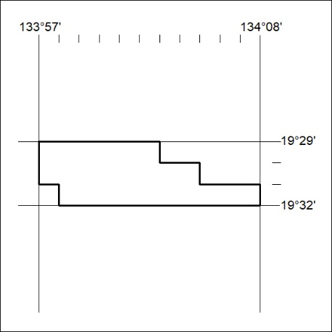
Area granted is indicated above. The titleholder is not permitted to exercise occupational rights on any land that is subject to a development title, or an application for a development title. Any land the subject of a Reserved Land gazettal under the Mineral Titles Act and all land vested in the Commonwealth of Australia is also excluded by description but not excised from the grant area.

516/19

