Mineral Titles Act 2010
NOTICE OF LAND CEASING TO BE A MINERAL TITLE AREA
Title Type and Number: | Exploration Licence 28658
Area Ceased on: | 27 October 2019
Area: | 62 Blocks, 137.60 km²
Locality: | BATTEN
Name of Applicant(s)/Holder(s): | 100% SANDFIRE RESOURCES NL [ACN. 105 154 185]
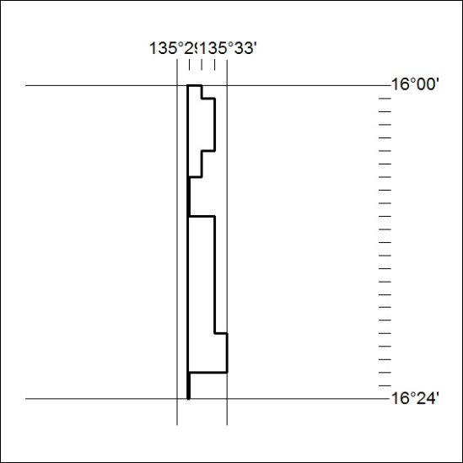

461/19

Mineral Titles Act 2010
NOTICE OF LAND CEASING TO BE A MINERAL TITLE AREA
Title Type and Number: | Extractive Mineral Exploration Licence 31555
Area Ceased on: | 25 October 2019
Area: | 4 Blocks, 9.08 km²
Locality: | MANBULLOO
Name of Applicant(s)/Holder(s): | 100% RELKETY PTY. LIMITED [ACN. 009 647 296]
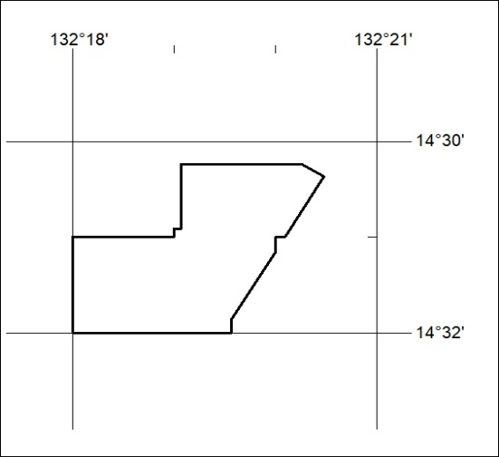

462/19

Mineral Titles Act
NOTICE OF GRANT OF A MINERAL TITLE
Title Type and Number: | Extractive Mineral Permit 31458
Granted: | 25 October 2019, for a period of 5 Years
Area: | 4.48 Hectares
Locality: | LANGDON
Name of Holder/s: | 100% AMINJARRINJA ENTERPRISES ABORIGINAL CORPORATION
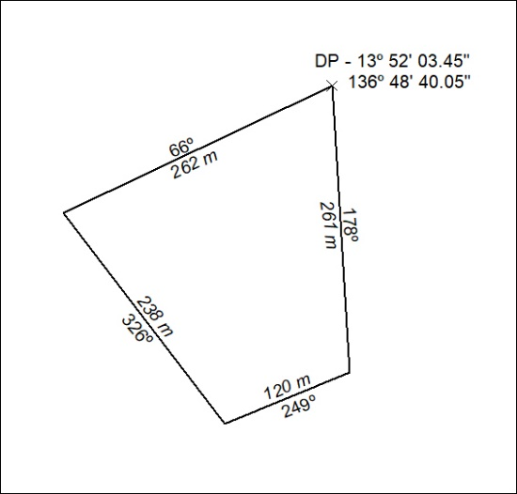

463/19

