Mineral Titles Act 2010
NOTICE OF LAND CEASING TO BE A MINERAL TITLE APPLICATION AREA
Title Type and Number: | Exploration Licence 32254
Area Ceased on: | 22 October 2019
Area: | 140 Blocks, 457.26 km²
Locality: | MONMOONA
Name of Applicant(s)/Holder(s): | 100% RIO TINTO EXPLORATION PTY LIMITED [ACN. 000 057 125]
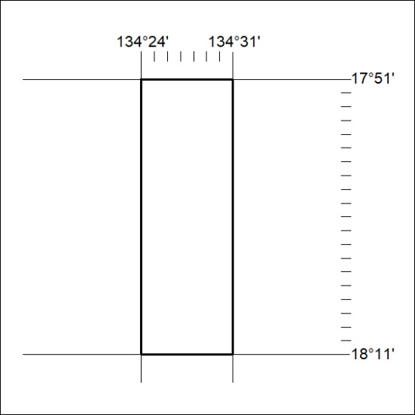

454/19

Mineral Titles Act 2010
NOTICE OF LAND CEASING TO BE A MINERAL TITLE APPLICATION AREA
Title Type and Number: | Exploration Licence 32255
Area Ceased on: | 22 October 2019
Area: | 215 Blocks, 652.71 km²
Locality: | SHANDON DOWNS
Name of Applicant(s)/Holder(s): | 100% RIO TINTO EXPLORATION PTY LIMITED [ACN. 000 057 125]
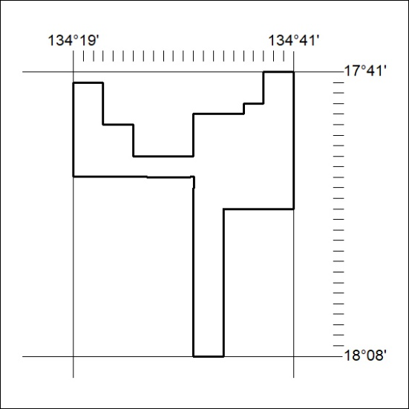

455/19
Mineral Titles Act 2010
NOTICE OF LAND CEASING TO BE A MINERAL TITLE APPLICATION AREA
Title Type and Number: | Exploration Licence 32256
Area Ceased on: | 22 October 2019
Area: | 201 Blocks, 658.00 km²
Locality: | UCHARONIDGE
Name of Applicant(s)/Holder(s): | 100% RIO TINTO EXPLORATION PTY LIMITED [ACN. 000 057 125]
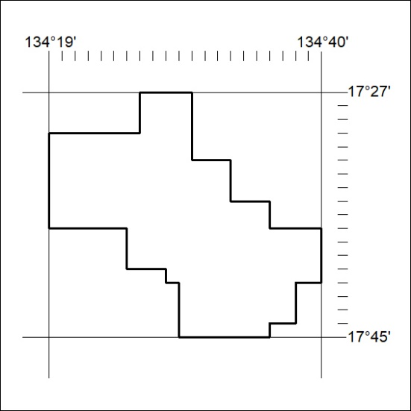

456/19

