Mineral Titles Act
NOTICE OF GRANT OF A MINERAL TITLE
Title Type and Number: | Exploration Licence 32089
Granted: | 07 October 2019, for a period of 6 Years
Area: | 250 Blocks, 789.22 km²
Locality: | QUARTZ
Name of Holder/s: | 100% TYPHON MINERALS PTY LTD [ACN. 614 887 464]
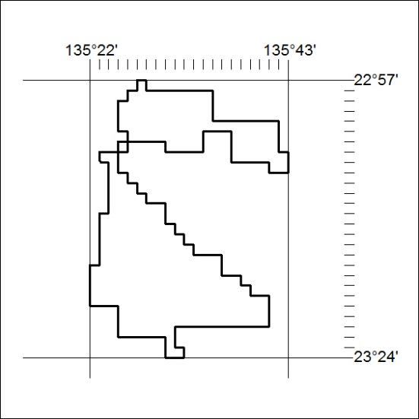
Area granted is indicated above. The titleholder is not permitted to exercise occupational rights on any land that is subject to a development title, or an application for a development title. Any land the subject of a Reserved Land gazettal under the Mineral Titles Act and all land vested in the Commonwealth of Australia is also excluded by description but not excised from the grant area.

421/19

