Mineral Titles Act 2010
NOTICE OF LAND CEASING TO BE A MINERAL TITLE AREA
Title Type and Number: | Exploration Licence 10189
Area Ceased on: | 22 July 2019
Area: | 28 Blocks, 91.95 km²
Locality: | SURPRISE CREEK
Name of Applicant(s)/Holder(s): | 100% MERLIN OPERATIONS PTY LTD* [ACN. 009 171 019]
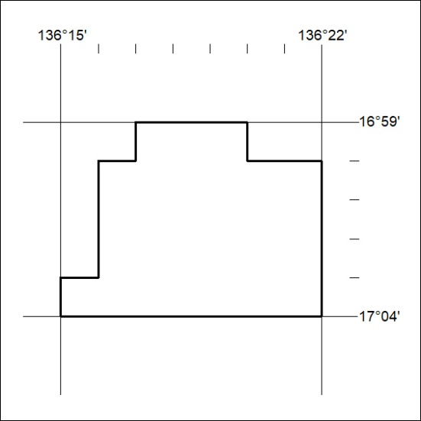

313/12

