Mineral Titles Act 2010
NOTICE OF LAND CEASING TO BE A MINERAL TITLE AREA
Title Type and Number: | Exploration Licence 28434
Area Ceased on: | 28 July 2019
Area: | 43 Blocks, 135.29 km²
Locality: | MACDONNELL RANGES
Name of Applicant(s)/Holder(s): | 56.28% CROSSLAND NICKEL PTY LTD* [ACN. 099 477 915], 43.72% ESSENTIAL MINING RESOURCES PTY LTD [ACN. 601 655 725]
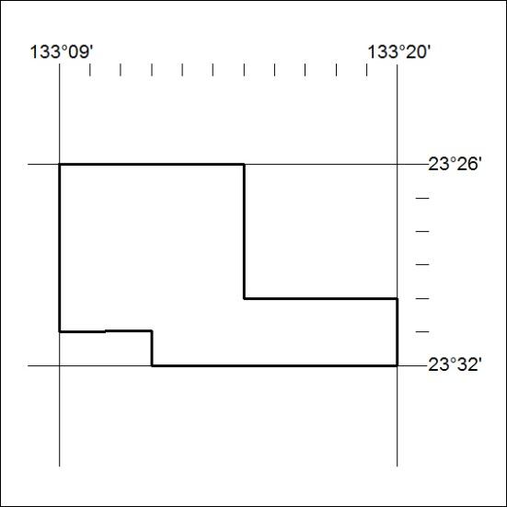

289/19

Mineral Titles Act 2010
NOTICE OF LAND CEASING TO BE A MINERAL TITLE AREA
Title Type and Number: | Exploration Licence 29789
Area Ceased on: | 25 July 2019
Area: | 2 Blocks, 6.30 km²
Locality: | NARWIETOOMA
Name of Applicant(s)/Holder(s): | 56.28% CROSSLAND NICKEL PTY LTD* [ACN. 099 477 915], 43.72% ESSENTIAL MINING RESOURCES PTY LTD [ACN. 601 655 725]
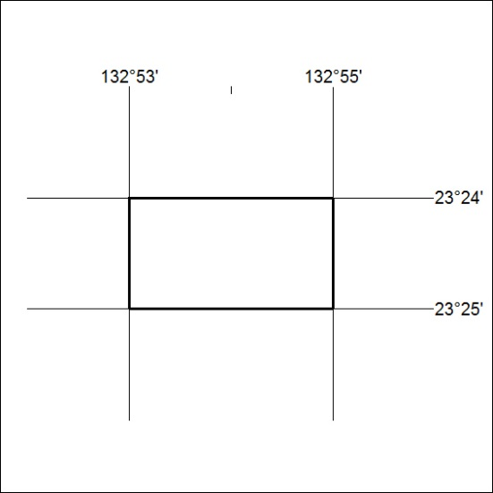

290/19

Mineral Titles Act
NOTICE OF GRANT OF A MINERAL TITLE
Title Type and Number: | Exploration Licence 31791
Granted: | 15 July 2019, for a period of 6 Years
Area: | 250 Blocks, 798.47 km²
Locality: | AMMAROO
Name of Holder/s: | 100% TERRITORY PHOSPHATE PTY LTD [ACN. 130 065 351]
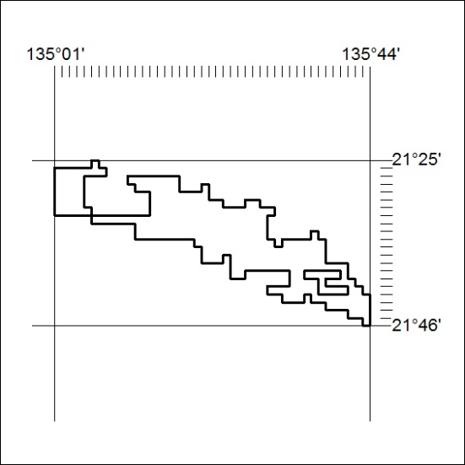
Area granted is indicated above. The titleholder is not permitted to exercise occupational rights on any land that is subject to a development title, or an application for a development title. Any land the subject of a Reserved Land gazettal under the Mineral Titles Act and all land vested in the Commonwealth of Australia is also excluded by description but not excised from the grant area.

291/19

