Mineral Titles Act
NOTICE OF GRANT OF A MINERAL TITLE
Title Type and Number: | Exploration Licence 32051
Granted: | 03 July 2019, for a period of 6 Years
Area: | 203 Blocks, 634.73 km²
Locality: | NONGRA
Name of Holder/s: | 100% OAKAJEE EXPLORATION PTY LTD [ACN. 629 544 912]
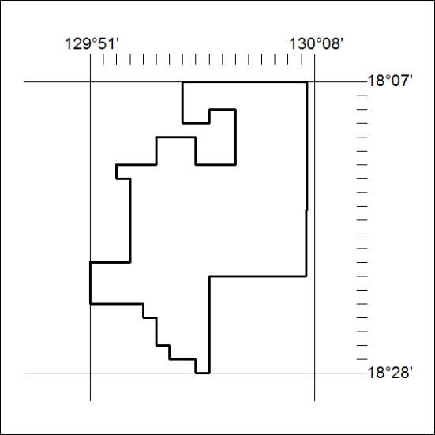
Area granted is indicated above. The titleholder is not permitted to exercise occupational rights on any land that is subject to a development title, or an application for a development title. Any land the subject of a Reserved Land gazettal under the Mineral Titles Act and all land vested in the Commonwealth of Australia is also excluded by description but not excised from the grant area.
278/19

Mineral Titles Act
NOTICE OF GRANT OF A MINERAL TITLE
Title Type and Number: | Exploration Licence 32052
Granted: | 03 July 2019, for a period of 6 Years
Area: | 160 Blocks, 481.32 km²
Locality: | MT WINNECKE
Name of Holder/s: | 100% OAKAJEE EXPLORATION PTY LTD [ACN. 629 544 912]
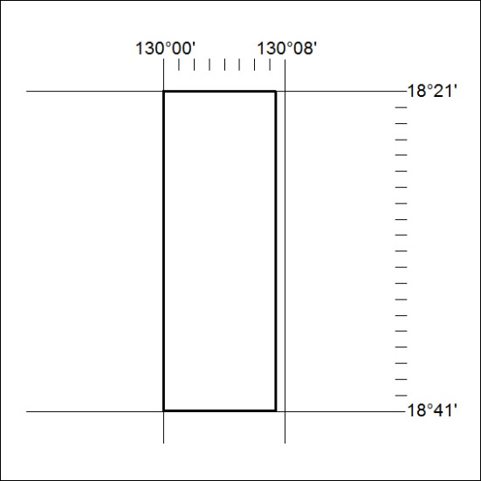
Area granted is indicated above. The titleholder is not permitted to exercise occupational rights on any land that is subject to a development title, or an application for a development title. Any land the subject of a Reserved Land gazettal under the Mineral Titles Act and all land vested in the Commonwealth of Australia is also excluded by description but not excised from the grant area.
279/19

