Mineral Titles Act 2010
NOTICE OF LAND CEASING TO BE A MINERAL TITLE AREA
Title Type and Number: | Exploration Licence 26397
Area Ceased on: | 25 March 2019
Area: | 51 Blocks, 163.93 km²
Locality: | MALLAPUNYAH
Name of Applicant(s)/Holder(s): | 100% LEGEND INTERNATIONAL HOLDINGS, INC. [ACN. 120 855 352]
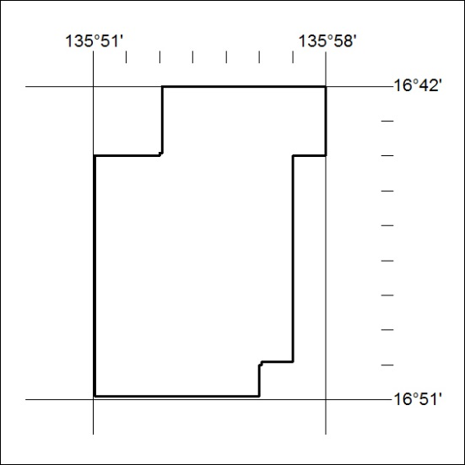

109/19

Mineral Titles Act 2010
NOTICE OF LAND CEASING TO BE A MINERAL TITLE AREA
Title Type and Number: | Exploration Licence 29840
Area Ceased on: | 26 March 2019
Area: | 12 Blocks, 38.70 km²
Locality: | JOILDUNG
Name of Applicant(s)/Holder(s): | 100% MINEMAKERS AUSTRALIA PTY LTD* [ACN. 081 911 917]
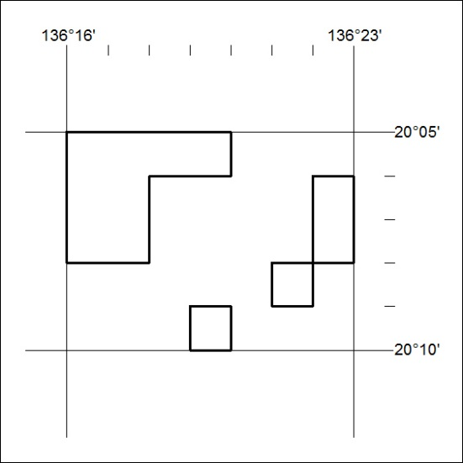

110/19
Mineral Titles Act 2010
NOTICE OF LAND CEASING TO BE A MINERAL TITLE AREA
Title Type and Number: | Exploration Licence 29841
Area Ceased on: | 26 March 2019
Area: | 13 Blocks, 39.61 km²
Locality: | WONARAH
Name of Applicant(s)/Holder(s): | 100% MINEMAKERS AUSTRALIA PTY LTD* [ACN. 081 911 917]
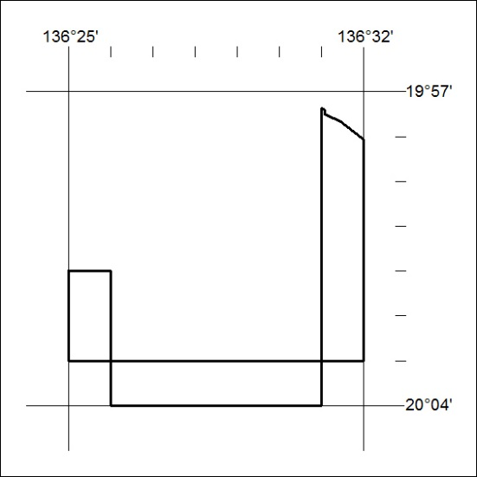

111/19

Mineral Titles Act 2010
NOTICE OF LAND CEASING TO BE A MINERAL TITLE AREA
Title Type and Number: | Exploration Licence 29849
Area Ceased on: | 26 March 2019
Area: | 6 Blocks, 17.71 km²
Locality: | WONARAH
Name of Applicant(s)/Holder(s): | 100% MINEMAKERS AUSTRALIA PTY LTD* [ACN. 081 911 917]
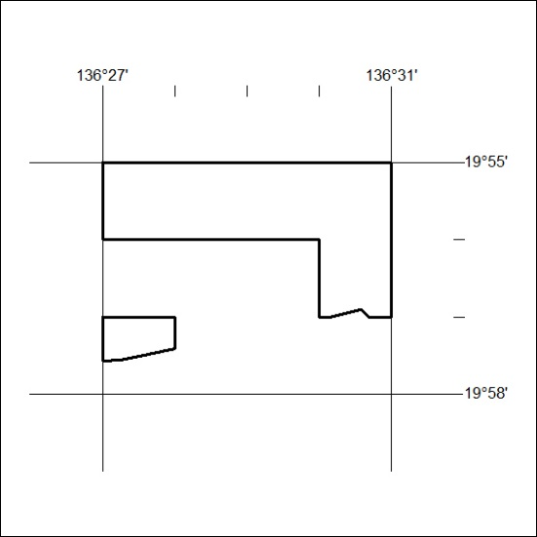

112/19

Mineral Titles Act
NOTICE OF GRANT OF A MINERAL TITLE
Title Type and Number: | Exploration Licence 31710
Granted: | 22 March 2019, for a period of 6 Years
Area: | 91 Blocks, 289.08 km²
Locality: | WINGATE MOUNTAINS
Name of Holder/s: | 100% FOCUS EXPLORATION PTY LTD [ACN. 622 437 361]
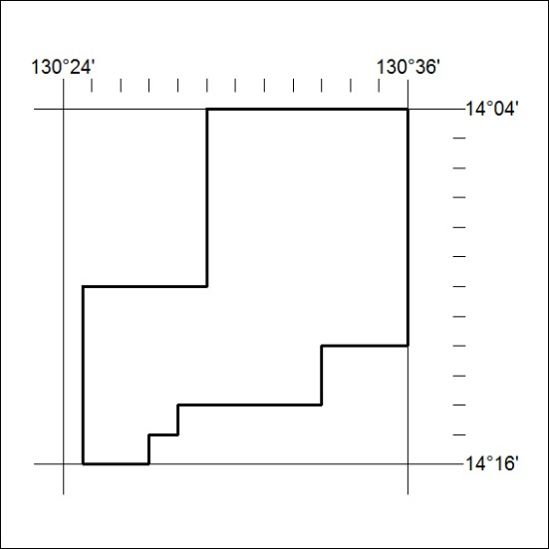
Area granted is indicated above. The titleholder is not permitted to exercise occupational rights on any land that is subject to a development title, or an application for a development title. Any land the subject of a Reserved Land gazettal under the Mineral Titles Act and all land vested in the Commonwealth of Australia is also excluded by description but not excised from the grant area.

113/19

