Mineral Titles Act
NOTICE OF LAND CEASING TO BE A MINERAL TITLE AREA
Title Type and Number: | Exploration Licence 25063
Area Ceased on: | 30 January 2019
Area: | 15 Blocks, 40.77 km²
Locality: | QUARTZ
Name of Applicant(s)/Holder(s): | 100% BARFUSS CORPORATION PTY. LTD. [ACN. 006 917 666]
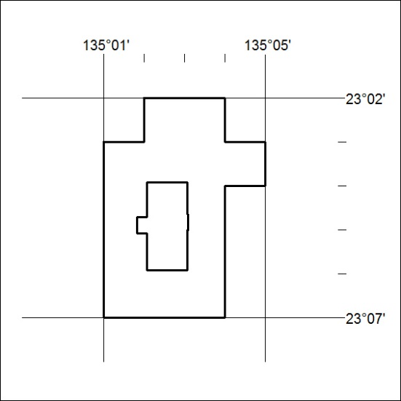
(Area now amalgamated into Exploration Licence 32046 under s102 – EL moratorium period does not apply)

33/19

Mineral Titles Act
NOTICE OF LAND CEASING TO BE A MINERAL TITLE AREA
Title Type and Number: | Exploration Licence 25764
Area Ceased on: | 30 January 2019
Area: | 6 Blocks, 6.32 km²
Locality: | QUARTZ
Name of Applicant(s)/Holder(s): | 100% BARFUSS CORPORATION PTY. LTD. [ACN. 006 917 666]
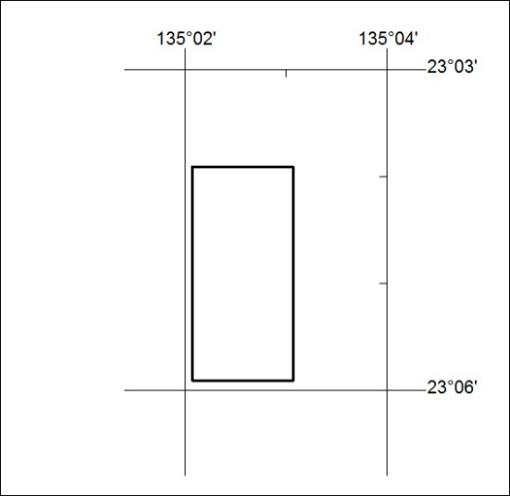
(Area now amalgamated into Exploration Licence 32046 under s102 – EL moratorium period does not apply)

34/19

Mineral Titles Act
NOTICE OF GRANT OF A MINERAL TITLE
Title Type and Number: | Exploration Licence 31947
Granted: | 29 January 2019, for a period of 6 Years
Area: | 58 Blocks, 172.75 km²
Locality: | ALICE SPRINGS
Name of Holder/s: | 100% CROSSLAND NICKEL PTY LTD* [ACN. 099 477 915]
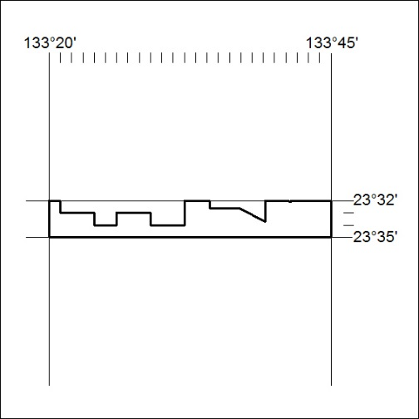
Area granted is indicated above. The titleholder is not permitted to exercise occupational rights on any land that is subject to a development title, or an application for a development title. Any land the subject of a Reserved Land gazettal under the Mineral Titles Act and all land vested in the Commonwealth of Australia is also excluded by description but not excised from the grant area.

35/19

