Mineral Titles Act
NOTICE OF LAND CEASING TO BE A MINERAL TITLE AREA
Title Type and Number: | Exploration Licence 31275
Area Ceased on: | 15 January 2019
Area: | 61 Blocks, 192.44 km²
Locality: | QUARTZ
Name of Applicant(s)/Holder(s): | 100% GBE EXPLORATION PTY LTD [ACN. 121 535 948]
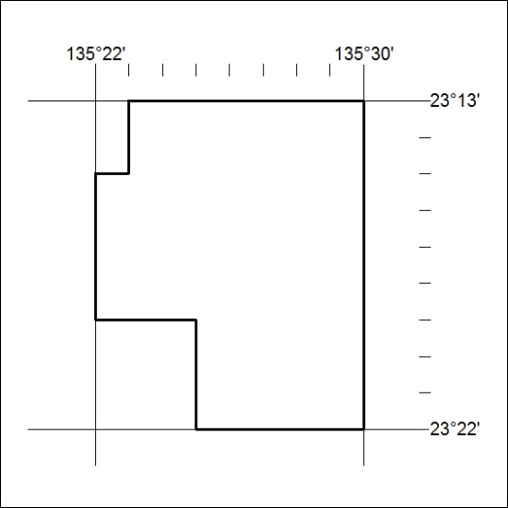

10/19

