Mineral Titles Act
NOTICE OF LAND CEASING TO BE AN EXPLORATION LICENCE IN RETENTION
Title Type and Number: | Exploration Licence in Retention 29627
Area ceased on: | 20 November 2018
Area: | 1197.00 Hectares
Locality: | ANNINGIE
Name of Applicants(s)Holder(s): | 100% ENIGMA MINING LIMITED [ACN. 009 225 558]
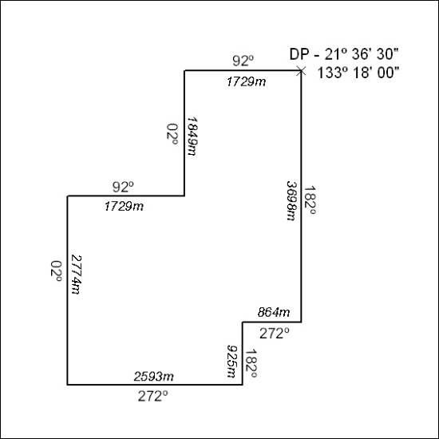

540/18

Mineral Titles Act
NOTICE OF GRANT OF A MINERAL TITLE
Title Type and Number: | Mineral Lease 28341
Granted: | 20 November 2018, for a period of 24 Years
Area: | 328.10 Hectares
Locality: | ANNINGIE
Name of Holder/s: | 100% ENIGMA MINING LIMITED [ACN. 009 225 558]
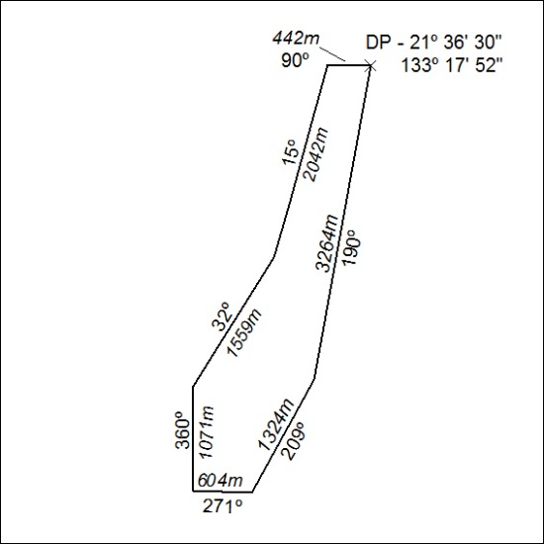

541/18

