Mineral Titles Act
NOTICE OF LAND CEASING TO BE A MINERAL TITLE AREA
Title Type and Number: | Exploration Licence 28657
Area Ceased on: | 05 November 2018
Area: | 45 Blocks, 148.29 km²
Locality: | BATTEN
Name of Applicant(s)/Holder(s): | 100% SANDFIRE RESOURCES NL [ACN. 105 154 185]
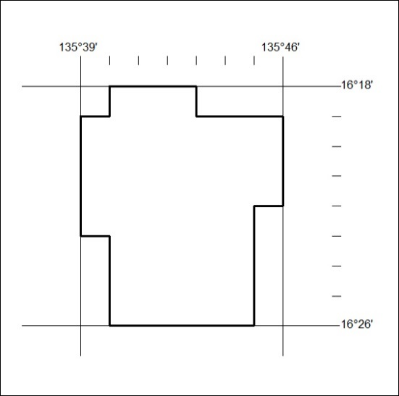

501/18

Mineral Titles Act
NOTICE OF LAND CEASING TO BE A MINERAL TITLE AREA
Title Type and Number: | Exploration Licence 28659
Area Ceased on: | 05 November 2018
Area: | 10 Blocks, 33.01 km²
Locality: | BATTEN
Name of Applicant(s)/Holder(s): | 100% SANDFIRE RESOURCES NL [ACN. 105 154 185]
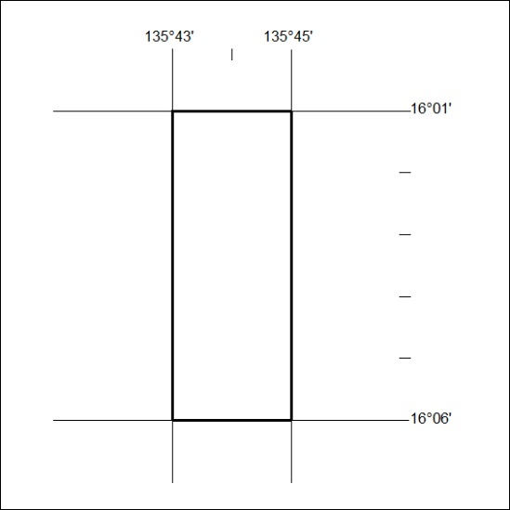

502/18
Corrigendum
Notice number 490/18 appearing in MN140/18 on 31 OCTOBER 2018 is hereby cancelled.

