Mineral Titles Act
NOTICE OF LAND CEASING TO BE A MINERAL TITLE AREA
Title Type and Number: | Exploration Licence 30669
Area Ceased on: | 12 September 2018
Area: | 10 Blocks, 29.77 km²
Locality: | UNDOOLYA
Name of Applicant(s)/Holder(s): | 100% DBL BLUES PTY LTD [ACN. 140 024 442]
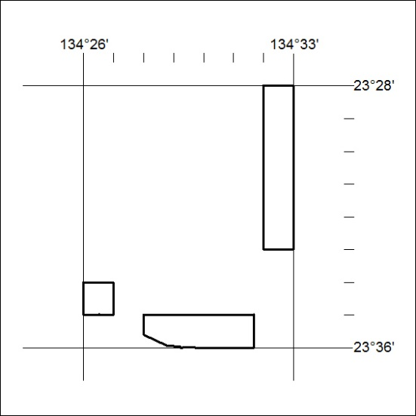

408/18

