Mineral Titles Act
NOTICE OF LAND CEASING TO BE A MINERAL TITLE AREA
Title Type and Number: | Exploration Licence 30708
Area Ceased on: | 02 September 2018
Area: | 57 Blocks, 187.13 km²
Locality: | MONTEJINNI
Name of Applicant(s)/Holder(s): | 100% ZERO GROUP MINERALS PTY LTD [ACN. 603 115 000]
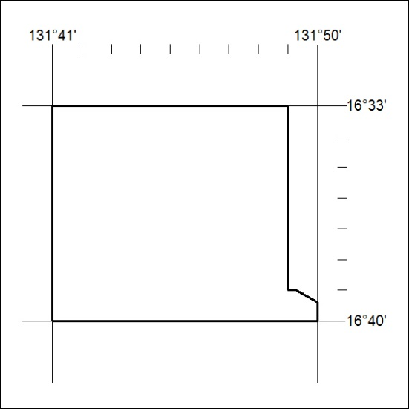

377/18

Mineral Titles Act
NOTICE OF LAND CEASING TO BE A MINERAL TITLE AREA
Title Type and Number: | Exploration Licence 31835
Area Ceased on: | 05 September 2018
Area: | 21 Blocks, 42.26 km²
Locality: | FLYNN
Name of Applicant(s)/Holder(s): | 100% GIANTS REEF EXPLORATION PTY LTD* [ACN. 009 200 346]
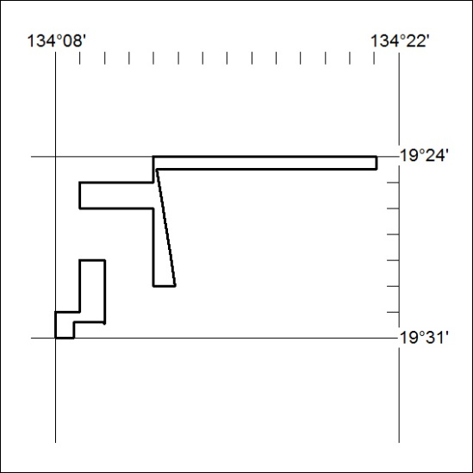

388/18

