Mineral Titles Act
NOTICE OF LAND CEASING TO BE A MINERAL TITLE AREA
Title Type and Number: | Exploration Licence 30516
Area Ceased on: | 27 August 2018
Area: | 71 Blocks, 200.21 km²
Locality: | FLYNN
Name of Applicant(s)/Holder(s): | 100% GIANTS REEF EXPLORATION PTY LTD* [ACN. 009 200 346]
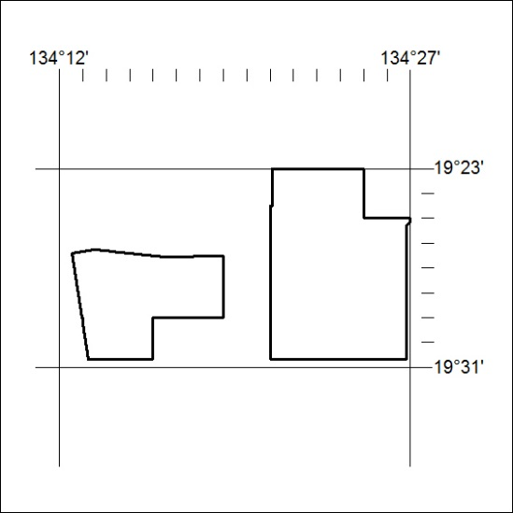

362/18

Mineral Titles Act
NOTICE OF LAND CEASING TO BE A MINERAL TITLE AREA
Title Type and Number: | Exploration Licence 31568
Area Ceased on: | 29 August 2018
Area: | 32 Blocks, 105.99 km²
Locality: | ELSEY
Name of Applicant(s)/Holder(s): | 100% FIDDLER'S CREEK MINING COMPANY PTY LTD * [ACN. 099 215 648]
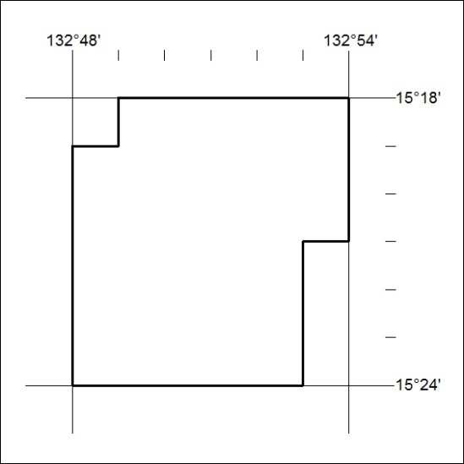

363/18

Mineral Titles Act
NOTICE OF LAND CEASING TO BE A MINERAL TITLE AREA
Title Type and Number: | Exploration Licence 31569
Area Ceased on: | 29 August 2018
Area: | 167 Blocks, 554.41 km²
Locality: | MANBULLOO
Name of Applicant(s)/Holder(s): | 100% FIDDLER'S CREEK MINING COMPANY PTY LTD * [ACN. 099 215 648]
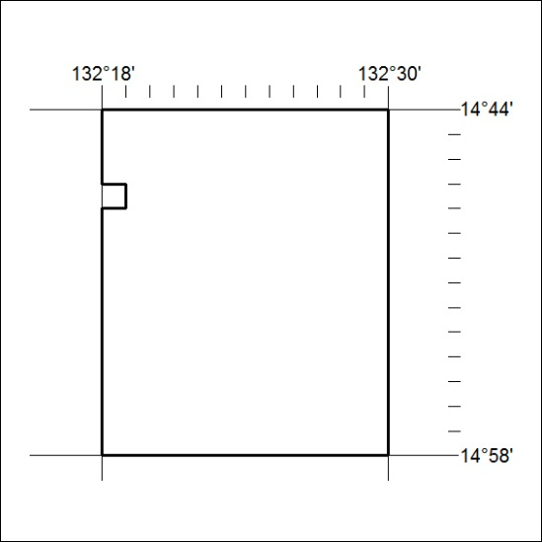

364/18

Mineral Titles Act
NOTICE OF LAND CEASING TO BE A MINERAL TITLE AREA
Title Type and Number: | Exploration Licence 31570
Area Ceased on: | 29 August 2018
Area: | 45 Blocks, 149.12 km²
Locality: | MARANBOY
Name of Applicant(s)/Holder(s): | 100% FIDDLER'S CREEK MINING COMPANY PTY LTD * [ACN. 099 215 648]
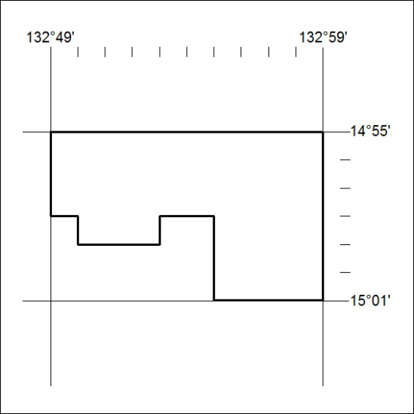

365/18

