Mineral Titles Act
NOTICE OF LAND CEASING TO BE A MINERAL TITLE AREA
Title Type and Number: | Exploration Licence 26094
Area Ceased on: | 06 May 2018
Area: | 3 Blocks, 3.67 km²
Locality: | NOONAMAH
Name of Applicant(s)/Holder(s): | 100% PODIUM MINERALS LIMITED [ACN. 009 200 079]
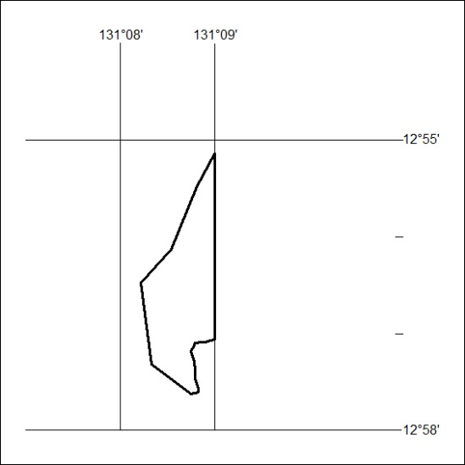

358/18

Mineral Titles Act
NOTICE OF LAND CEASING TO BE A MINERAL TITLE AREA
Title Type and Number: | Exploration Licence 27164
Area Ceased on: | 29 August 2018
Area: | 1 Block, .23 km²
Locality: | TENNANT CREEK
Name of Applicant(s)/Holder(s): | 100% GIANTS REEF EXPLORATION PTY LTD* [ACN. 009 200 346]
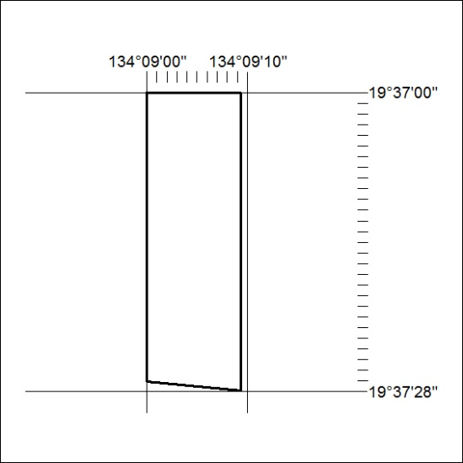

359/18

Mineral Titles Act
NOTICE OF LAND CEASING TO BE A MINERAL TITLE AREA
Title Type and Number: | Exploration Licence 31831
Area Ceased on: | 29 August 2018
Area: | 21 Blocks, 68.04 km²
Locality: | SHORT RANGE
Name of Applicant(s)/Holder(s): | 100% GIANTS REEF EXPLORATION PTY LTD* [ACN. 009 200 346]
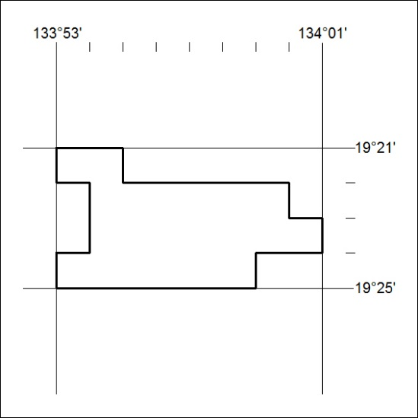

360/18

Mineral Titles Act
NOTICE OF LAND CEASING TO BE A MINERAL TITLE AREA
Title Type and Number: | Mineral Authority 27163
Area Ceased on: | 29 August 2018
Area: | Blocks, 1.05 km²
Locality: | TENNANT CREEK
Name of Applicant(s)/Holder(s): | 100% GIANTS REEF EXPLORATION PTY LTD* [ACN. 009 200 346]
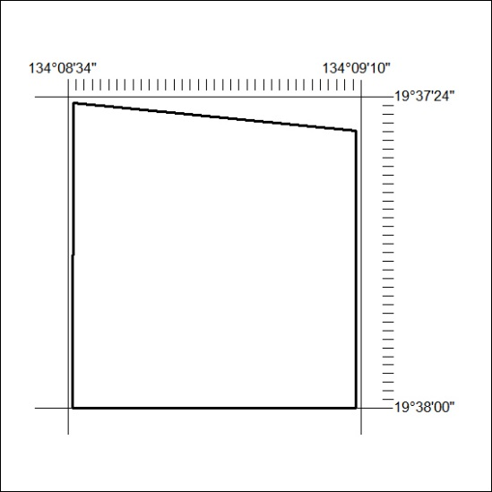

361/18

