Mineral Titles Act
NOTICE OF LAND CEASING TO BE A MINERAL TITLE AREA
Title Type and Number: | Exploration Licence 10043
Area Ceased on: | 15 June 2018
Area: | 1 Block, 3.34 km²
Locality: | PINE CREEK
Name of Applicant(s)/Holder(s): | 100% THUNDELARRA LIMITED* [ACN. 085 782 994]
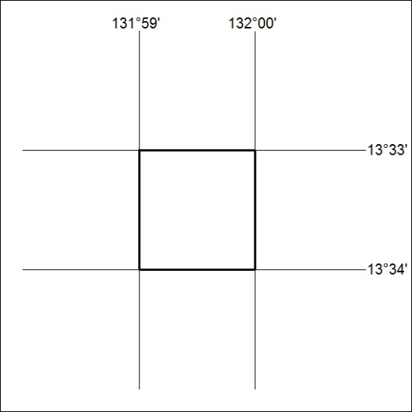

265/18

Mineral Titles Act
NOTICE OF LAND CEASING TO BE A MINERAL TITLE AREA
Title Type and Number: | Exploration Licence 24549
Area Ceased on: | 15 June 2018
Area: | 18 Blocks, 59.98 km²
Locality: | PINE CREEK
Name of Applicant(s)/Holder(s): | 100% ELEMENT 92 PTY LTD [ACN. 119 094 423]
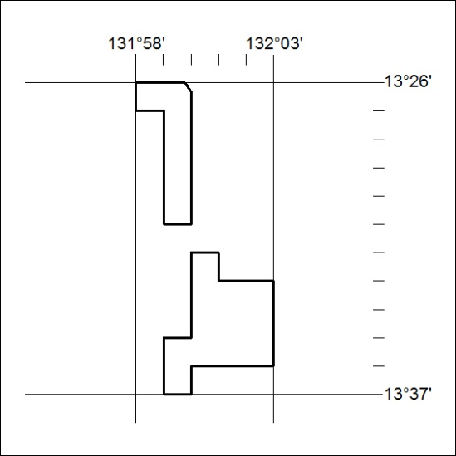

266/18

Mineral Titles Act
NOTICE OF LAND CEASING TO BE A MINERAL TITLE AREA
Title Type and Number: | Exploration Licence 25868
Area Ceased on: | 15 June 2018
Area: | 1 Block, 3.34 km²
Locality: | PINE CREEK
Name of Applicant(s)/Holder(s): | 100% ELEMENT 92 PTY LTD [ACN. 119 094 423]
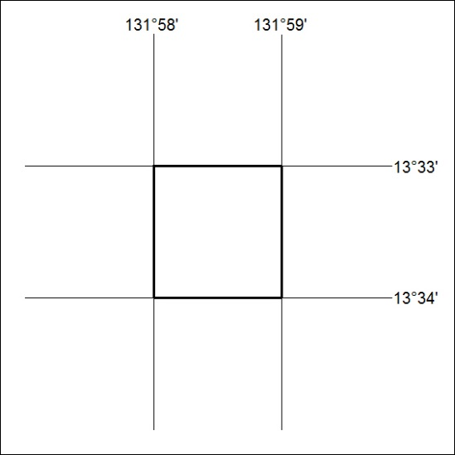

267/18

Mineral Titles Act
NOTICE OF LAND CEASING TO BE A MINERAL TITLE AREA
Title Type and Number: | Exploration Licence 28857
Area Ceased on: | 15 June 2018
Area: | 1 Block, 3.34 km²
Locality: | PINE CREEK
Name of Applicant(s)/Holder(s): | 100% ELEMENT 92 PTY LTD [ACN. 119 094 423]
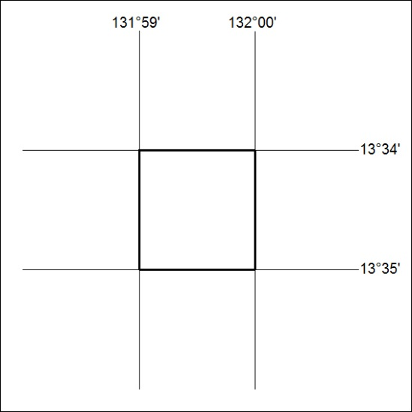

268/18

Mineral Titles Act
NOTICE OF LAND CEASING TO BE A MINERAL TITLE AREA
Title Type and Number: | Exploration Licence 31820
Area Ceased on: | 06 June 2018
Area: | 1 Block, .30 km²
Locality: | VAUGHAN
Name of Applicant(s)/Holder(s): | 100% ENERGY METALS LTD [ACN. 111 306 533]
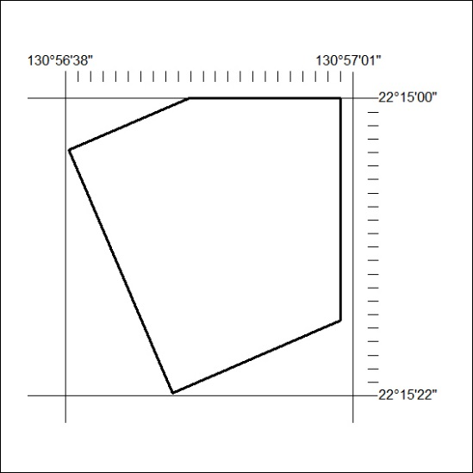

269/18

Mineral Titles Act
NOTICE OF LAND CEASING TO BE A MINERAL TITLE AREA
Title Type and Number: | Exploration Licence 31821
Area Ceased on: | 06 June 2018
Area: | 9 Blocks, 3.49 km²
Locality: | DOREEN
Name of Applicant(s)/Holder(s): | 100% ENERGY METALS LTD [ACN. 111 306 533]
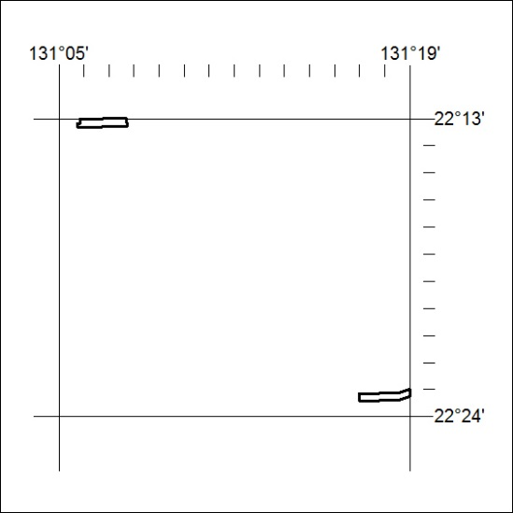

270/18

