Mineral Titles Act
NOTICE OF LAND CEASING TO BE A MINERAL TITLE AREA
Title Type and Number: | Exploration Licence 29905
Area Ceased on: | 25 May 2018
Area: | 11 Blocks, 34.83 km²
Locality: | NAPPERBY
Name of Applicant(s)/Holder(s): | 100% OZ URANIUM (NT) PTY LTD [ACN. 161 904 847]
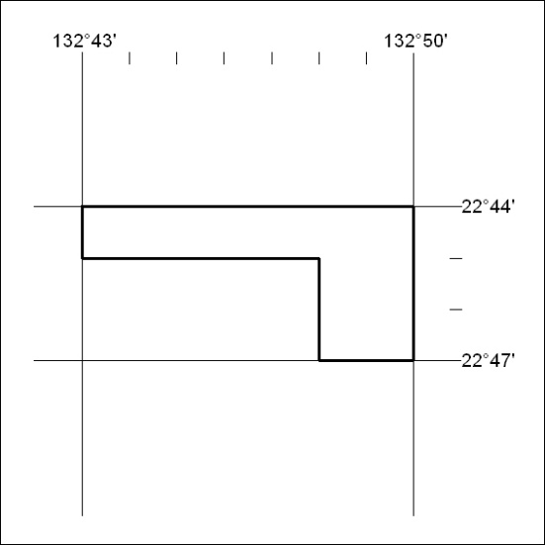

197/18

Mineral Titles Act
NOTICE OF LAND CEASING TO BE A MINERAL TITLE AREA
Title Type and Number: | Exploration Licence 29906
Area Ceased on: | 25 May 2018
Area: | 12 Blocks, 38.00 km²
Locality: | NAPPERBY
Name of Applicant(s)/Holder(s): | 100% OZ URANIUM (NT) PTY LTD [ACN. 161 904 847]
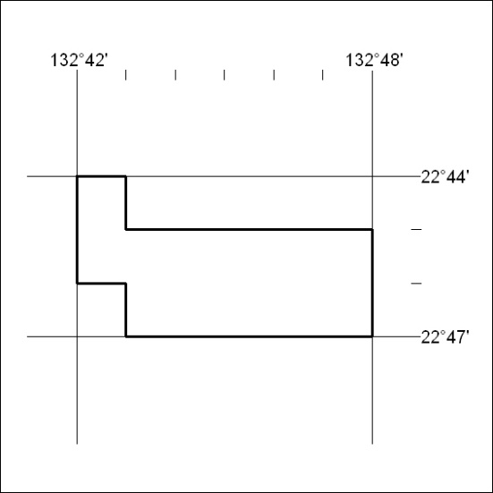

198/18

Mineral Titles Act
NOTICE OF LAND CEASING TO BE A MINERAL TITLE AREA
Title Type and Number: | Extractive Mineral Exploration Licence 30918
Area Ceased on: | 24 May 2018
Area: | 4 Blocks, 10.53 km²
Locality: | MARY RIVER
Name of Applicant(s)/Holder(s): | 100% OSTOJIC GROUP PTY LTD* [ACN. 009 629 805]
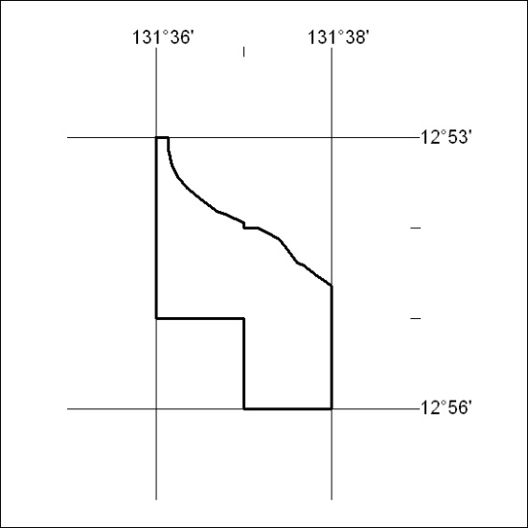

199/18

Mineral Titles Act
NOTICE OF LAND CEASING TO BE A MINERAL TITLE AREA
Title Type and Number: | Extractive Mineral Exploration Licence 30919
Area Ceased on: | 24 May 2018
Area: | 4 Blocks, 13.39 km²
Locality: | MARY RIVER
Name of Applicant(s)/Holder(s): | 100% OSTOJIC GROUP PTY LTD* [ACN. 009 629 805]
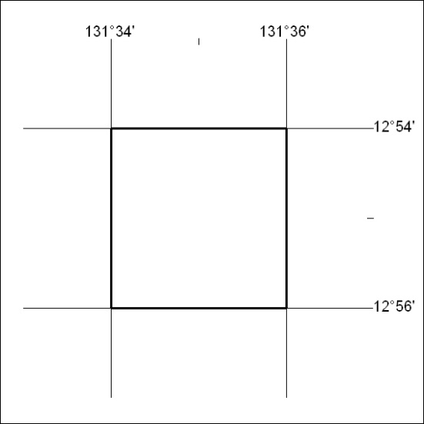

200/18

Mineral Titles Act
NOTICE OF LAND CEASING TO BE A MINERAL TITLE AREA
Title Type and Number: | Extractive Mineral Exploration Licence 30920
Area Ceased on: | 24 May 2018
Area: | 4 Blocks, 13.39 km²
Locality: | MARY RIVER
Name of Applicant(s)/Holder(s): | 100% OSTOJIC GROUP PTY LTD* [ACN. 009 629 805]
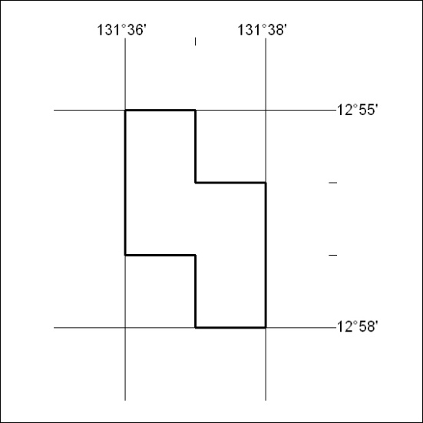

201/18

Mineral Titles Act
NOTICE OF LAND CEASING TO BE A MINERAL TITLE AREA
Title Type and Number: | Extractive Mineral Exploration Licence 30921
Area Ceased on: | 24 May 2018
Area: | 4 Blocks, 13.39 km²
Locality: | MARY RIVER
Name of Applicant(s)/Holder(s): | 100% OSTOJIC GROUP PTY LTD* [ACN. 009 629 805]
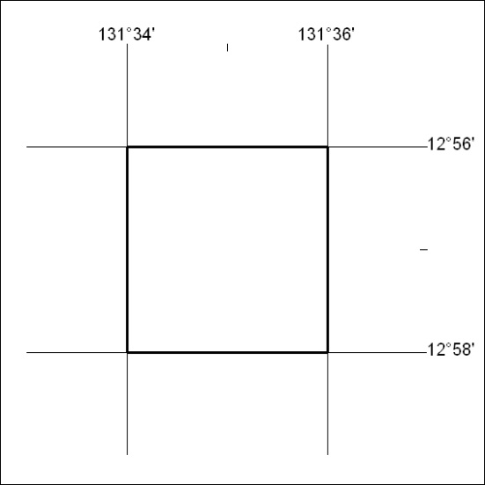

202/18

Mineral Titles Act
NOTICE OF GRANT OF A MINERAL TITLE
Title Type and Number: | Exploration Licence 31700
Granted: | 25 May 2018, for a period of 6 Years
Area: | 1 Block, 3.34 km²
Locality: | BATCHELOR
Name of Holder/s: | 100% BACCHUS RESOURCES PTY LTD [ACN. 606 340 872]
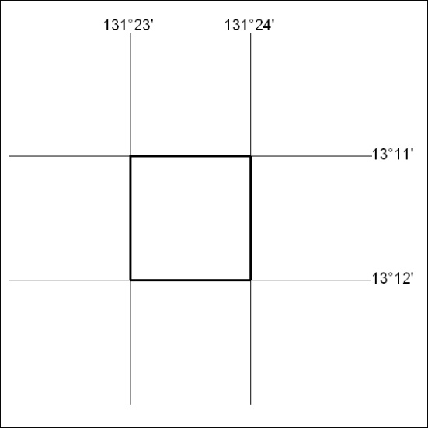
Area granted is indicated above. The titleholder is not permitted to exercise occupational rights on any land that is subject to a development title, or an application for a development title. Any land the subject of a Reserved Land gazettal under the Mineral Titles Act and all land vested in the Commonwealth of Australia is also excluded by description but not excised from the grant area.

203/18

