Mineral Titles Act
NOTICE OF LAND CEASING TO BE A MINERAL TITLE AREA
Title Type and Number: | Exploration Licence 29046
Area Ceased on: | 18 May 2018
Area: | 20 Blocks, 62.72 km²
Locality: | TODD
Name of Applicant(s)/Holder(s): | 100% GRIGM RESOURCES PTY LTD [ACN. 148 051 567]
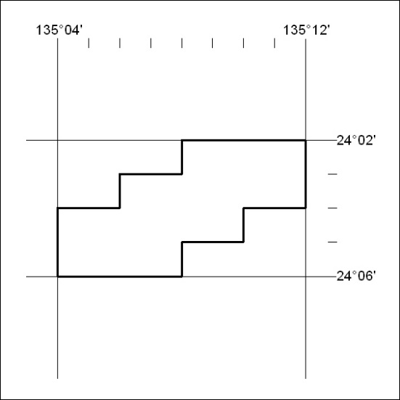

190/18

Mineral Titles Act
NOTICE OF LAND CEASING TO BE A MINERAL TITLE AREA
Title Type and Number: | Exploration Licence 29498
Area Ceased on: | 18 May 2018
Area: | 219 Blocks, 716.89 km²
Locality: | STOKES
Name of Applicant(s)/Holder(s): | 100% AUSTRALIS MINERALS PTY LTD [ACN. 131 522 257]
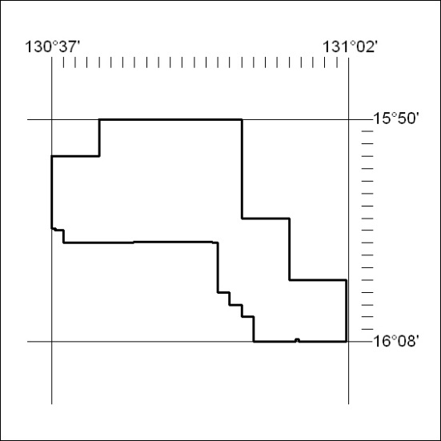

191/18

Mineral Titles Act
NOTICE OF LAND CEASING TO BE A MINERAL TITLE AREA
Title Type and Number: | Exploration Licence 31541
Area Ceased on: | 18 May 2018
Area: | 157 Blocks, 505.96 km²
Locality: | MT SANFORD
Name of Applicant(s)/Holder(s): | 100% AUSTRALIS MINERALS PTY LTD [ACN. 131 522 257]
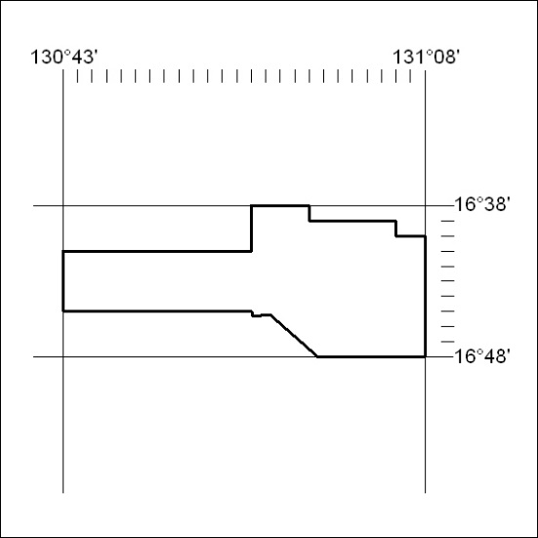

192/18

