Mineral Titles Act
NOTICE OF LAND CEASING TO BE A MINERAL TITLE AREA
Title Type and Number: | Exploration Licence 26206
Area Ceased on: | 28 March 2018
Area: | 33 Blocks, 110.00 km²
Locality: | MAINORU
Name of Applicant(s)/Holder(s): | 100% MERLIN DIAMONDS LIMITED* [ACN. 009 153 119]
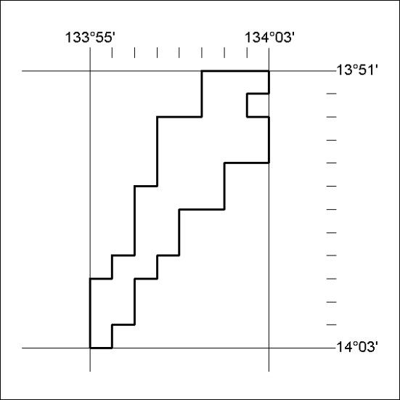

124/18

