Mineral Titles Act
NOTICE OF LAND CEASING TO BE A MINERAL TITLE
Title Type and Number: | Authorised Holdings (Northern) 98
Area ceased on: | 12 March 2018
Area: | 3.00 Hectare
Locality: | DALY RIVER
Name of Applicants(s)Holder(s): | 25% COWAN Brian William, 25% COWAN Valerie Christine, 25% COWAN Graham Gordon, 25% COWAN Jo-Anne Marree
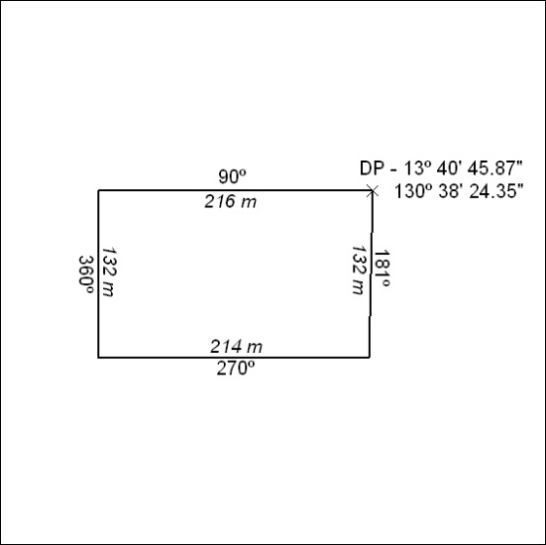

115/18

Mineral Titles Act
NOTICE OF LAND CEASING TO BE A MINERAL TITLE
Title Type and Number: | Mineral Lease 23095
Area ceased on: | 12 March 2018
Area: | 20.00 Hectare
Locality: | NOONAMAH
Name of Applicants(s)Holder(s): | 50% LANGLEY David John, 50% N.T. GOLD PTY LTD * [ACN. 009 625 870]
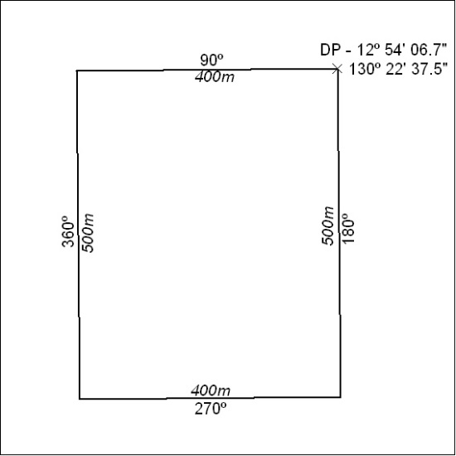

116/18

Mineral Titles Act
NOTICE OF GRANT OF A MINERAL TITLE
Title Type and Number: | Exploration Licence 31539
Granted: | 08 March 2018, for a period of 6 Years
Area: | 233 Blocks, 765.13 km²
Locality: | MONTEJINNI
Name of Holder/s: | 100% MONTEJINNI RESOURCES PTY LTD [ACN. 616 894 216]
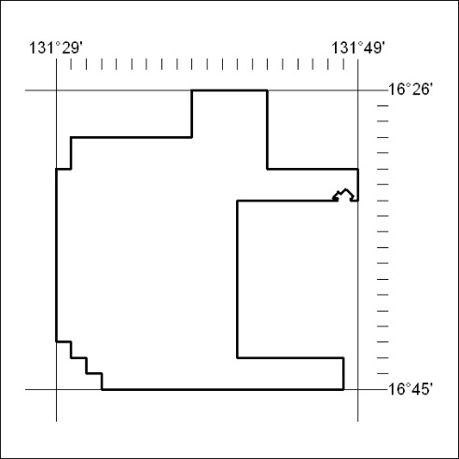
Area granted is indicated above. The titleholder is not permitted to exercise occupational rights on any land that is subject to a development title, or an application for a development title. Any land the subject of a Reserved Land gazettal under the Mineral Titles Act and all land vested in the Commonwealth of Australia is also excluded by description but not excised from the grant area.

117/18

Mineral Titles Act
NOTICE OF GRANT OF A MINERAL TITLE
Title Type and Number: | Exploration Licence 31758
Granted: | 09 March 2018, for a period of 6 Years
Area: | 150 Blocks, 487.98 km²
Locality: | KOOKABURRA
Name of Holder/s: | 100% ASIAN MINERALS PTY LTD [ACN. 099 804 467]
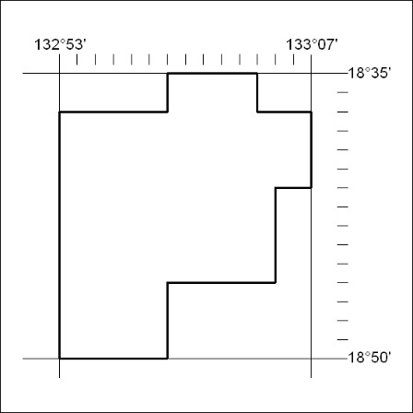
Area granted is indicated above. The titleholder is not permitted to exercise occupational rights on any land that is subject to a development title, or an application for a development title. Any land the subject of a Reserved Land gazettal under the Mineral Titles Act and all land vested in the Commonwealth of Australia is also excluded by description but not excised from the grant area.

118/18

Mineral Titles Act
NOTICE OF GRANT OF A MINERAL TITLE
Title Type and Number: | Exploration Licence 31759
Granted: | 09 March 2018, for a period of 6 Years
Area: | 236 Blocks, 769.42 km²
Locality: | RENEHAN
Name of Holder/s: | 100% ASIAN MINERALS PTY LTD [ACN. 099 804 467]
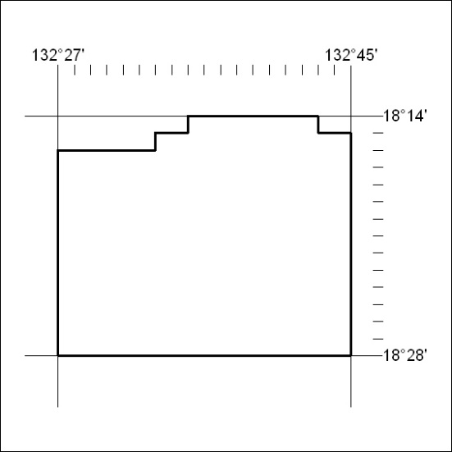
Area granted is indicated above. The titleholder is not permitted to exercise occupational rights on any land that is subject to a development title, or an application for a development title. Any land the subject of a Reserved Land gazettal under the Mineral Titles Act and all land vested in the Commonwealth of Australia is also excluded by description but not excised from the grant area.

119/18

