Mineral Titles Act
NOTICE OF LAND CEASING TO BE A MINERAL TITLE
Title Type and Number: | Mineral Lease (Northern) 276
Area ceased on: | 06 March 2018
Area: | 11.00 Hectare
Locality: | MARY RIVER
Name of Applicants(s)Holder(s): | 100% BORAL RESOURCES (QLD) PTY LIMITED [ACN. 009 671 809]
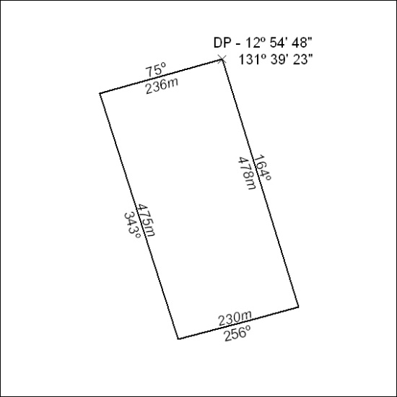

99/18

