Agnote

No: I54
July 2014

Palm Leaf Beetle
(Brontispa longissima)
T. L. Fenner* and H. Brown, Plant Industries, Darwin
* Formerly DPIF

BACKGROUND
The palm leaf beetle, Brontispa longissima, was first found in Darwin and nearby areas in December 1979. An attempted eradication campaign was unsuccessful and was abandoned in 1981. By 1989 the pest was found throughout Darwin and Palmerston, and in many nearby rural areas, including the Cox Peninsula.
Within Australia, the insect is also known from Moa Island in Torres Strait and from Cooktown to Cairns in Cape York Peninsula. Elsewhere, it ranges from Java eastward to New Caledonia and has been accidentally introduced to Tahiti, Western Samoa and American Samoa.
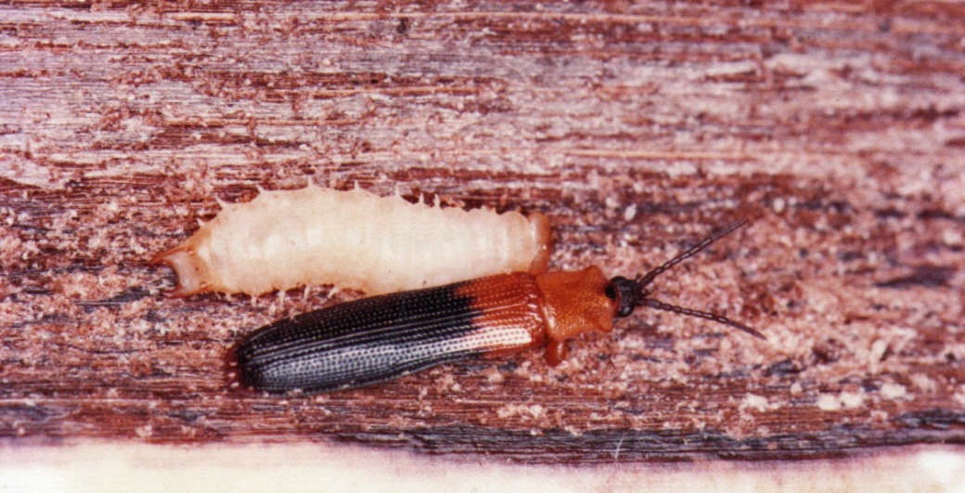
Figure 1. Palm leaf beetle adult and larva

APPEARANCE AND LIFE CYCLE
The adult is about 1 cm long and very flat, with short legs. The thorax and a third of the wing covers are orange in colour and the hind part of the wing covers is black. The larva is also flattened and has a pair of inwardly curved, immovable hook-like spines at its rear end. The pupa resembles the larva, but is larger and shows the developing wings and legs of the adult.
Female beetles lay eggs in small batches in grooves chewed in the surface of young leaflets. Eggs hatch after several days and the larva feeds for five weeks, changing its skin as it grows. When mature, the larva pupates and the adult beetle emerges five days later. It may live for up to three months, during which time a female may lay up to 100 eggs.
The adults are slow-moving and reluctant to fly during the day, but take off more readily at twilight and perhaps also fly at night. From the spread of infestation in Darwin, it seems that flights covering several hundred metres are possible.
The native palm beetle (Anadastus sp.) should not be confused with the palm leaf beetle. It is sometimes found in small numbers in the centre of palms, usually without appreciable damage being present. Compared with the palm leaf beetle, it is less flattened, has a small knob at the end of each antenna and has completely blue-black wing covers without any orange colour at the base. It is not a significant pest.

HOST RANGE
The coconut palm (Cocos nucifera) is the usual host of the palm leaf beetle.
Royal palms (Roystona regia) are sometimes severely attacked and in Darwin, moderate damage has been seen on betel nut palm (Areca catechu), Nicobar palm (Bentinckia nicobarica), Carpentaria palm (Carpentaria acuminata), fishtail palm (Caryota mitis) and bottle palm (Hyophorbe lagenicaulis). Infestation in other species, which usually causes only slight damage, has been reported locally including in Alexandra palm (Archontophoenix alexandrae), Queen palm (Syagrus romanzoffianum), Golden cane palm (Dypsis lutescens), sealing wax palm (Cyrtostachys renda), Princess palm (Dictyosperma album),Gulubia palm (Hydriastele costata), Atherton palm (Laccospadix australasica), Cairn’s fan palm (Livistona Muelleri), Date palm (Phoenix dactylifera),Fijian fantail palm (Pritchardia pacifica), Elegant palm (Ptychosperma elegans), Darwin palm (Ptychosperma macarthuri), American cotton palm (Washingtonia filifera) and Mexican fan palm (Washingtonia robusta).

DAMAGE
Palm leaf beetle attacks the youngest unopened leaves. Both adults and larvae feed on leaf tissues although most of the damage is caused by the larvae, which chew away large areas of the leaf surface. Underlying cells die and the attacked area turns brown. When the leaf opens, these brown areas shrivel and curl, producing a characteristic scorched appearance. Adult damage is seen as narrow, linear chewing marks, which are less extensive than the larval damage.
Sustained heavy attack can be fatal to palms, especially if they are young, but it is unusual for death to result directly from palm leaf beetle damage. However, trees weakened by the pests are more vulnerable to drought and disorders that could kill them. Heavy damage is usually most noticeable toward the end of the dry season, especially in palms which are not watered.
Young palms can be seriously set back during the phase of substantial damage, and in this situation the use of insecticide is recommended. This is discussed in a later section.
There are other disorders which cause palm leaves to turn brown and shrivel, but the presence of an unbroken surface layer and the absence of insect excreta distinguish these from palm leaf beetle damage.
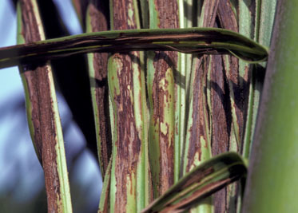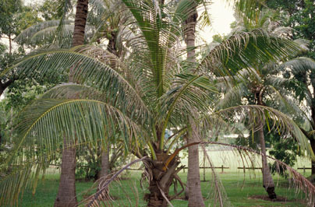
Figure 2. Damage to unopened leaves Figure 3. A mature coconut palm showing damage fronds

BIOLOGICAL CONTROL
So far, few natural enemies of the palm leaf beetle have been found in Darwin. The green muscardine fungus (Metarhizium anisopliae), can infect various stages of the beetle and cause death, especially during wet spells. Tree frogs and geckoes seem to occur more frequently on heavily-infested palms than on those which are healthy or slightly infested. They probably catch and eat adult beetles and perhaps also larvae, but are normally unable to control an infestation. Large numbers of torn, empty eggshells of palm leaf beetles have been found in a nest of an ant (Tetramorium simillimum), but its significance in controlling the pest is not known.
In some places overseas, such as New Caledonia, Tahiti and the Solomon Islands, a parasite of the palm leaf beetle, Tetrastichus brontispae is claimed to have greatly reduced damage by the pest. It is a tiny wasp about 1 mm long and black in colour. Females of the parasite lay their eggs in the pre-pupa or pupa of the beetle from which up to 20 adult wasps emerge after about 18 days.
T. brontispae was introduced into Darwin and Palmerston in 1982 and 1983 from Western Samoa but failed to establish. It was reintroduced again in 1984 from New Caledonia. This time some parasitised beetle pupae were found in the field within two weeks of the first release of adult wasps and continued to survive for about five years.
In late 1989, there was an upsurge in damage to palms in Darwin and subsequent checks suggested that the wasp parasite may have died out. New introductions were made from new stock imported from New Caledonia to the Department of Primary Industries in Brisbane, Queensland where it was reared and screened through quarantine before being sent to Berrimah Farm for mass rearing and release from 1994 to 1996. Field recoveries of the parasite were made which provided limited control of palm leaf beetles and damage to coconut palms at the release sites was reduced by 20% (Chin and Brown, 2000).
T. brontispae established better at sites that were watered by overhead sprinklers. There were no recoveries of T. brontispae from palm leaf beetle pupae collected after 1996 from any of the release sites or nearby areas. It would seem that the climate in the Top End is unsuitable for long-term establishment of the parasite (Chin and Brown, 2000).
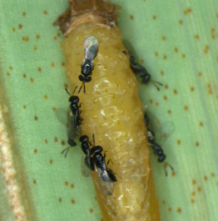 | 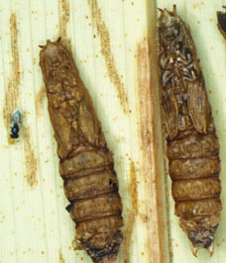
Figure 4. Tetrastichus brontispae adults parasitising palm leaf beetle pupa | Figure 5. Parasitised pupae

CHEMICAL CONTROL
The recommended insecticide is carbaryl. A few drops of an agricultural wetting agent should be added to the diluted insecticide.
Before spraying is attempted, check the stage of development of the youngest leaf. If it is still a "spear" (tightly folded along its entire length), or has only just started to open at the top, it should be slightly opened by hand to allow better penetration of the spray into the spaces between the leaflets. It can be done by grasping the spear about 60 cm above its base and steadily bending and twisting it to and fro, which causes the leaflets to separate.
This mixture can be either poured from a watering can or sprayed onto those leaves which have not completely opened. Because the insecticide works mainly by contact, it is important to completely cover both surfaces of leaves being treated and to use enough liquid to thoroughly penetrate the spaces between leaflets. Either a ladder or an extension spray lance will be needed to treat all except very young palms, as the whole length of the youngest leaf needs to be covered for best results.
Spraying must be repeated after an interval of one week, so that larvae which have hatched from eggs, or adults which have emerged from pupae since the first spraying, do not escape.
Carbaryl is lethal to bees; it should not be applied when a fresh flower spike is present. Spray must not be allowed to drift on to hives or areas in which bees are foraging. The beetle parasite is also very easily killed by insecticide.
Further information can be obtained from the Entomology Section at Berrimah Farm on 8999 2258 or email insectinfo@nt.gov.au.

References
Chin, D. and Brown, H. (2000). Biological Control of Palm Leaf Beetle, Brontispa longissima (Gestro) with the Wasp Parasitoid, Tetrastichus brontispae (Ferriere) in Darwin. Northern Territory Government. Technical Bulletin No. 277.

Please visit us at our website:
www.dpif.nt.gov.au/

© Northern Territory Government
ISSN 0157-8243
Serial No. 371
Agdex No. 620

Disclaimer: While all care has been taken to ensure that information contained in this document is true and correct at the time of publication, the Northern Territory of Australia gives no warranty or assurance, and makes no representation as to the accuracy of any information or advice contained in this publication, or that it is suitable for your intended use. No serious, business or investment decisions should be made in reliance on this information without obtaining independent and/or professional advice in relation to your particular situation.

