Overview
State final demand (SFD) declined by 0.4% in the March quarter, with stronger government consumption and investment and housing investment more than offset by weaker household consumption and business investment. The main cause of the March result was a 5.8% decline in business investment, which appears to be related to private sector engineering activity, most likely associated with work scheduling and progress for the Santos Barossa project. SFD growth in the year to March has moderated to 2.7% with household consumption being the sole detractor (Chart 1). The drop in household consumption in the year largely reflects a return to pre-pandemic interstate visitor expenditure patterns. While SFD growth is moderating, it has increased by 18.0% since the onset of COVID-19 – comfortably the strongest rebound of the jurisdictions.
Despite the quarterly decline, business investment remains elevated compared with pre-pandemic levels and Santos is reporting the Barossa project at 56% completion to the March quarter (Chart 2). For the local construction industry the pipeline of work yet to be done is strong (Chart 3) supported by non-residential works.
The Territory has reported strong increases in employment since mid-2021, with annualised growth of 5% per annum, and employment (and the unemployment rate) at levels last seen at the peak of activity for Inpex’s Ichthys LNG project. Employment is being supported by construction activity and the return of tourism (Chart 4).
Indicator | Most recent | Measure | Period change¹ | Annual change² | Year on Year³ | COVID period change⁴
Economic Growth |  | $B
State final demand (NT) (sa) | Mar-23 | 7.084 | -0.4% | 1.3% | 2.7% | 18.0%
Consumption |  | 5.348 | 0.2% | -0.6% | 0.8% | 10.4%
Investment |  | 1.736 | -2.3% | 7.8% | 9.5% | 43.7%
Domestic final demand (Aus) (sa) | Mar-23 | 539.863 | 0.6% | 2.2% | 4.1% | 9.5%
Consumption |  | 414.163 | 0.2% | 2.4% | 5.2% | 9.4%
Investment |  | 125.700 | 1.8% | 1.5% | 0.6% | 10.0%
Gross state product (NT) | 2021-22 | 26.058 | na | na | 4.7% | na
Gross domestic product (Aus) | 2021-22 | 2,156.802 | na | na | 3.7% | na
Partial Indicators |  | $B
Nominal retail sales (NT) (sa) | May-23 | 0.321 | 1.6% | 5.3% | 4.3% | 23.0%
Nominal retail sales (Aus) (sa) | May-23 | 35.525 | 0.7% | 4.2% | 9.8% | 28.0%
Construction work done (NT) (sa) | Mar-23 | 0.727 | -4.0% | 5.0% | 5.0% | 51.6%
Construction work done (Aus) (sa) | Mar-23 | 57.687 | 1.8% | 5.1% | 2.4% | 8.1%
Residential building activity (NT) | Dec-22 | 0.082 | -12.5% | -4.3% | -7.0% | -0.4%
Residential building activity (Aus) | Dec-22 | 18.467 | -1.6% | -2.2% | -3.6% | -1.1%
Nominal goods exports (NT) | May-23 | 1.347 | 29.3% | -4.4% | -2.3% | 22.7%
Nominal goods exports (Aus) (sa) | May-23 | 48.906 | 5.0% | -7.6% | 16.6% | 52.2%
Prices |  | Annual Δ²
Inflation (Darwin) | Mar-23 | 6.2% | -0.9 ppt | 0.7 ppt | na | 5.8 ppt
Inflation (8 Capitals) | Mar-23 | 7.0% | -0.8 ppt | 1.9 ppt | na | 5.2 ppt
WPI growth (NT) | Mar-23 | 2.9% | 0.4 ppt | 1.0 ppt | na | 0.4 ppt
WPI growth (Aus) | Mar-23 | 3.6% | 0.2 ppt | 1.2 ppt | na | 1.4 ppt
Employment |  | #M
Employment (NT) (sa) | May-23 | 0.142 | -1.2% | 2.6% | 4.0% | 4.7%
Employment (Aus) (sa) | May-23 | 14.012 | 0.5% | 3.4% | 4.3% | 8.1%
Unemployment |  | Rate
Unemployment rate (NT) (sa) | May-23 | 3.1% | -0.2 ppt | -1.0 ppt | na | -1.9 ppt
Unemployment rate (Aus) (sa) | May-23 | 3.6% | -0.1 ppt | -0.4 ppt | na | -1.5 ppt
Population |  | #M
Population (NT) | Dec-22 | 0.250 | -0.1% | 0.8% | na | 1.6%
Population (Aus) | Dec-22 | 26.268 | 0.5% | 1.9% | na | 2.9%
1. Monthly change for retail sales, goods exports, employment and unemployment; quarterly change for all other variables.
2. Compares the latest period with the same period last year.
3. Compares the 12 months up to and including the latest period with the previous 12-month period using original data.
4. Percentage change from December 2019 to most recent data.
Chart 1: Changes in private investment are a major factor impacting changes in SFD in the Territory, and can be ‘lumpy’ compared with other jurisdictions due to the scale of investment associated with major projects. It is observable when construction phase work starts/stops or is delayed/expedited. Since 2014, private investment’s share of Territory SFD has ranged from 13% to 43%, and nationally from 18% to 23% of final demand. | Chart 2: Engineering construction activity has been elevated since the March quarter 2021, impacted by works for the US$4.2 billion Barossa gas field and Darwin LNG life extension projects. The quarterly value of work done has plateaued at an elevated level since December 2021 and is expected to remain so until the end of 2024, with any changes in construction rates for these two projects likely to have a marked impact on reported quarterly data.
State Final Demand – NT  Components, moving annual total ($B)  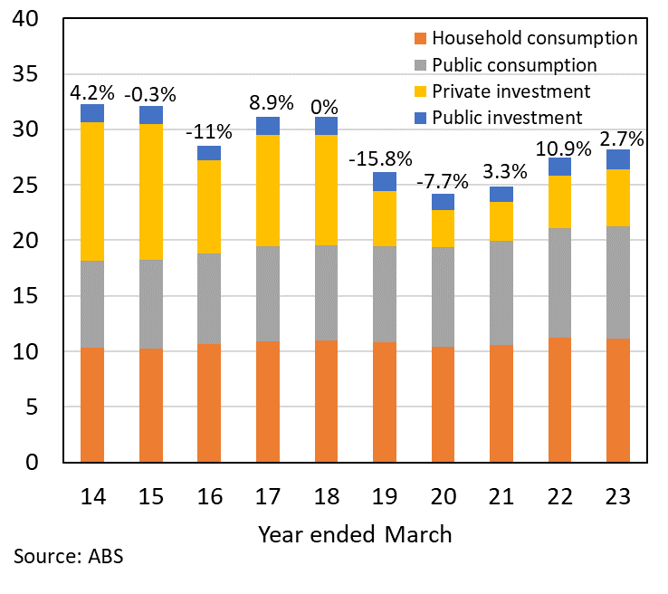 | Engineering Work Done – NT  Chain volume measure, quarterly ($M)  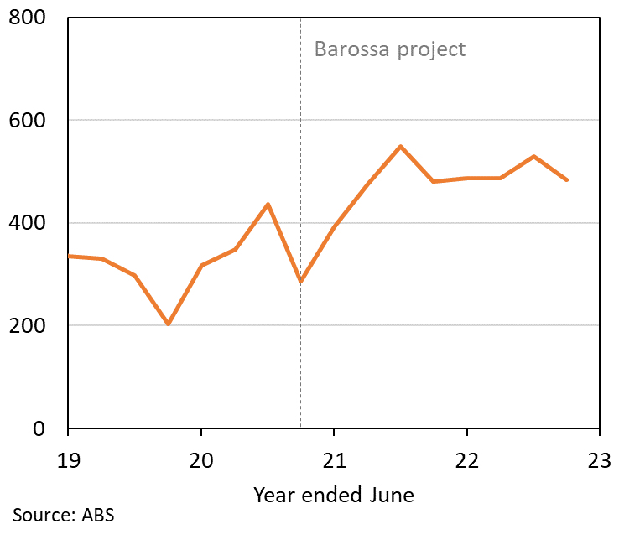
Chart 3: Building activity (residential and non-residential) increased by 1.2% in the December quarter 2022. Work ‘yet to be done’ – a forward indicator of construction sector activity – is around $1 billion, having increased by $600 million (or 150%) since mid-2020. The strength of the building pipeline reflects non-residential activity related to defence commitments and work for Charles Darwin University’s city campus. | Chart 4: For the year ending March 2023, visitors to the Territory increased by 35% compared with the year ending March 2022. Visitation for the March quarter 2023 increased 20% compared to the same period in 2022. Domestic visitation is at around 95% of 2019 levels, while international visitation is at around 40%. A total of 1.7 million visitors spent $3.1 billion in the year at an average spend of $1,821 per visitor.
Building Work Yet to be Done – NT  Current prices ($M)  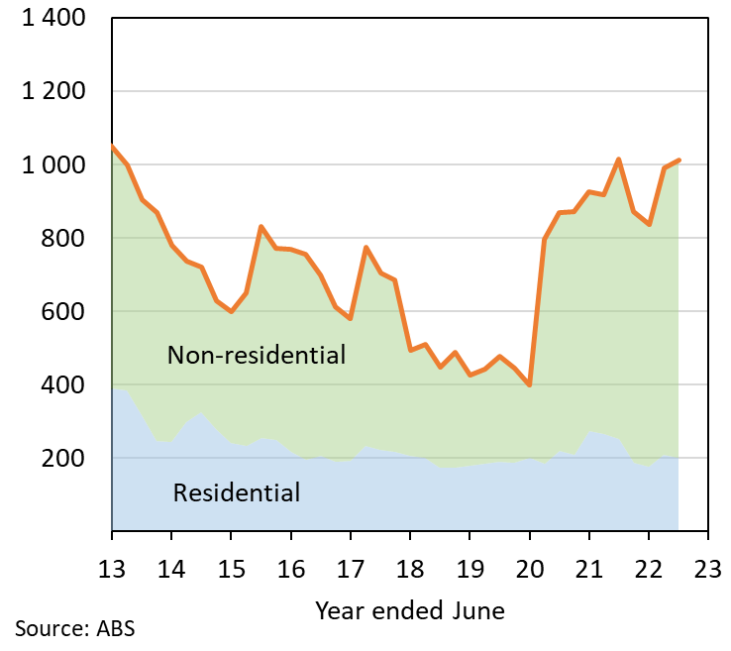 | Tourism Visitor Statistics – NT  Visitor numbers (000); average spend per person ($)  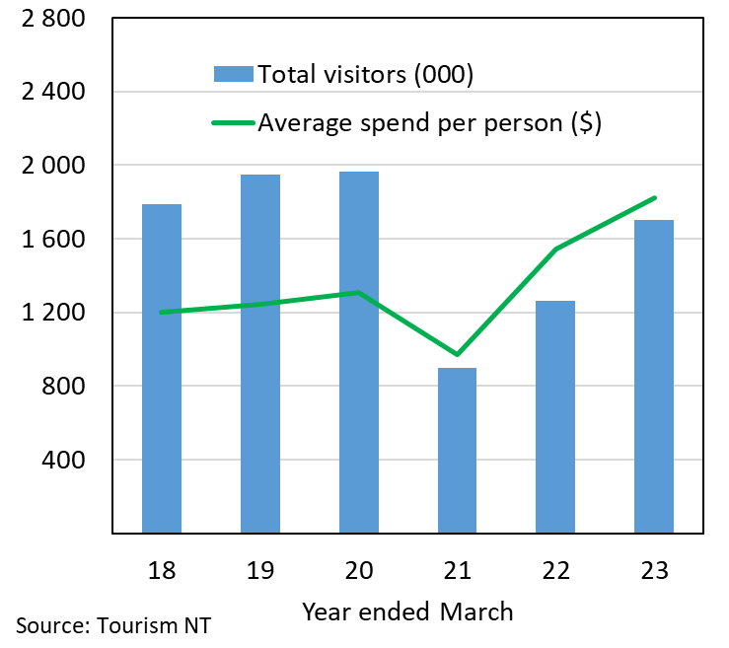
The Northern Territory of Australia exercised due care and skill to ensure that at the time of publication the information contained in this publication is true and correct. However, it is not intended to be relied on as professional advice or used for commercial purposes. The Territory gives no warranty or assurances as to the accuracy of the information contained in the publication and to the maximum extent permitted by law accepts no direct or indirect liability for reliance on its content.

