Mineral Titles Act 2010
NOTICE OF LAND CEASING TO BE A MINERAL TITLE AREA
Title Type and Number: | Exploration Licence 24177
Area Ceased on: | 21 August 2022
Area: | 62 Blocks, 200.11 km²
Locality: | PARGEE
Name of Applicant(s)/Holder(s): | 100% NORTHERN MINERALS LIMITED * [ACN. 119 966 353]
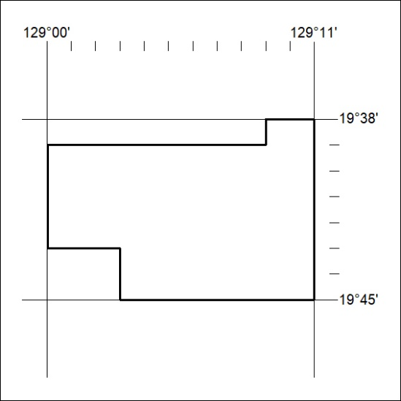

292/22

Mineral Titles Act 2010
NOTICE OF LAND CEASING TO BE A MINERAL TITLE AREA
Title Type and Number: | Exploration Licence 26498
Area Ceased on: | 21 August 2022
Area: | 10 Blocks, 32.49 km²
Locality: | WARE
Name of Applicant(s)/Holder(s): | 100% NORTHERN MINERALS LIMITED * [ACN. 119 966 353]
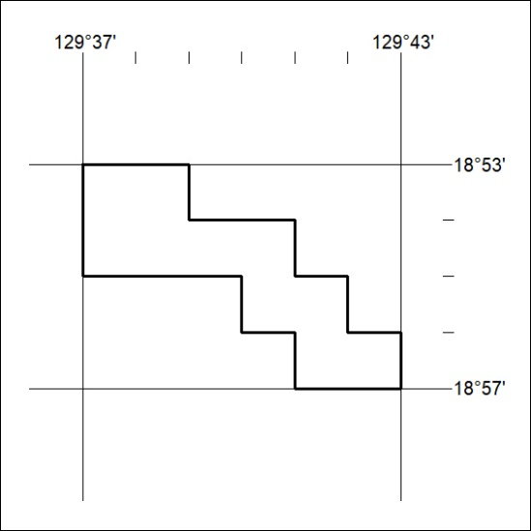

293/22

Mineral Titles Act 2010
NOTICE OF LAND CEASING TO BE A MINERAL TITLE AREA
Title Type and Number: | Exploration Licence 27367
Area Ceased on: | 21 August 2022
Area: | 51 Blocks, 165.41 km²
Locality: | MALLEE
Name of Applicant(s)/Holder(s): | 100% NORTHERN MINERALS LIMITED * [ACN. 119 966 353]
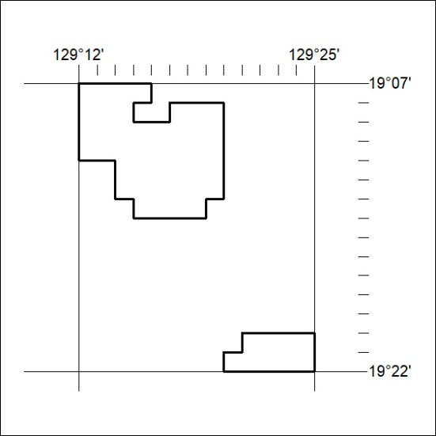

294/22

Mineral Titles Act 2010
NOTICE OF LAND CEASING TO BE A MINERAL TITLE AREA
Title Type and Number: | Exploration Licence 29595
Area Ceased on: | 21 August 2022
Area: | 29 Blocks, 93.78 km²
Locality: | PARGEE
Name of Applicant(s)/Holder(s): | 100% NORTHERN MINERALS LIMITED * [ACN. 119 966 353]
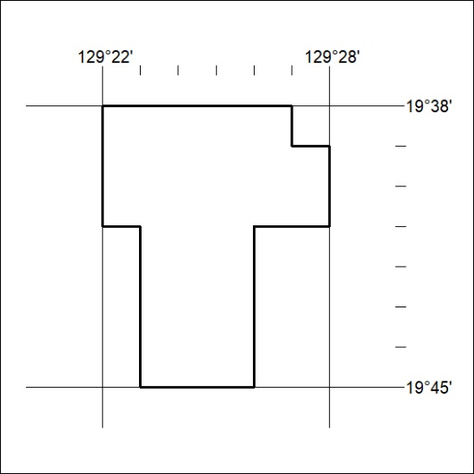

295/22

Mineral Titles Act
NOTICE OF GRANT OF A MINERAL TITLE
Title Type and Number: | Mineral Authority 33124
Granted: | 19 August 2022, for a period of 5 Years
Area: | 27.00 Hectares
Locality: | GOVE
Name of Holder/s: | 100% GULKULA MINING COMPANY PTY LTD [ACN. 153 861 806]
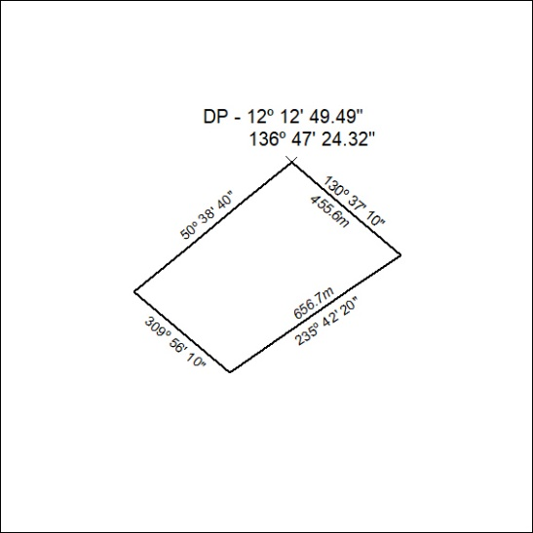

296/22

Mineral Titles Act
NOTICE OF GRANT OF A MINERAL TITLE
Title Type and Number: | Extractive Mineral Exploration Licence 33147
Granted: | 19 August 2022, for a period of 2 Years
Area: | 1 Block, 2.58 km²
Locality: | BYNOE
Name of Holder/s: | 100% KING Allan Ronald
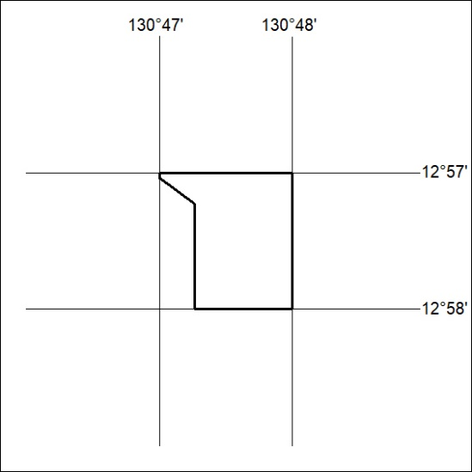
Area granted is indicated above. The titleholder is not permitted to exercise occupational rights on any land that is subject to a development title, or an application for a development title. Any land the subject of a Reserved Land gazettal under the Mineral Titles Act and all land vested in the Commonwealth of Australia is also excluded by description but not excised from the grant area.

297/22

