Mineral Titles Act 2010
NOTICE OF LAND CEASING TO BE A MINERAL TITLE AREA
Title Type and Number: | Exploration Licence 31013
Area Ceased on: | 17 August 2022
Area: | 18 Blocks, 59.05 km²
Locality: | LANCEWOOD
Name of Applicant(s)/Holder(s): | 100% SCRIVEN EXPLORATION PTY LTD [ACN. 006 264 615]
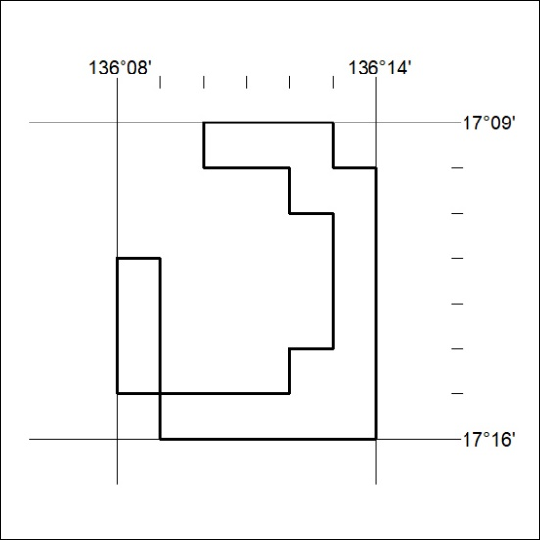

287/22

Mineral Titles Act
NOTICE OF GRANT OF A MINERAL TITLE
Title Type and Number: | Exploration Licence 33018
Granted: | 18 August 2022, for a period of 6 Years
Area: | 204 Blocks, 640.40 km²
Locality: | GLEN HELEN
Name of Holder/s: | 100% GS METALS PTY LTD [ACN. 654 797 878]
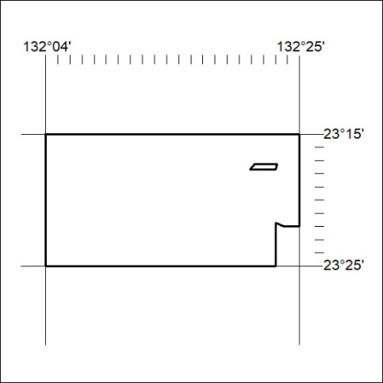
Area granted is indicated above. The titleholder is not permitted to exercise occupational rights on any land that is subject to a development title, or an application for a development title. Any land the subject of a Reserved Land gazettal under the Mineral Titles Act and all land vested in the Commonwealth of Australia is also excluded by description but not excised from the grant area.

288/22

Mineral Titles Act
NOTICE OF GRANT OF A MINERAL TITLE
Title Type and Number: | Exploration Licence 33019
Granted: | 18 August 2022, for a period of 6 Years
Area: | 82 Blocks, 250.92 km²
Locality: | ALICE SPRINGS
Name of Holder/s: | 100% GS METALS PTY LTD [ACN. 654 797 878]
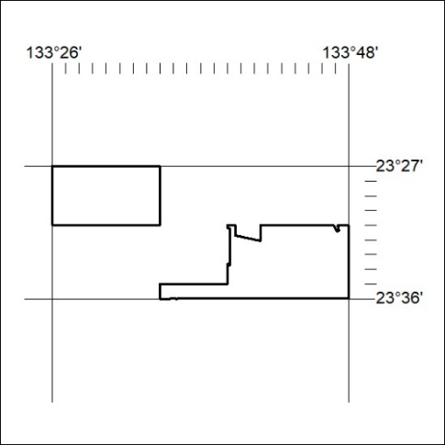
Area granted is indicated above. The titleholder is not permitted to exercise occupational rights on any land that is subject to a development title, or an application for a development title. Any land the subject of a Reserved Land gazettal under the Mineral Titles Act and all land vested in the Commonwealth of Australia is also excluded by description but not excised from the grant area.

289/22

Mineral Titles Act
NOTICE OF GRANT OF A MINERAL TITLE
Title Type and Number: | Exploration Licence 33057
Granted: | 18 August 2022, for a period of 6 Years
Area: | 50 Blocks, 132.94 km²
Locality: | HERMANNSBURG
Name of Holder/s: | 100% GS METALS PTY LTD [ACN. 654 797 878]
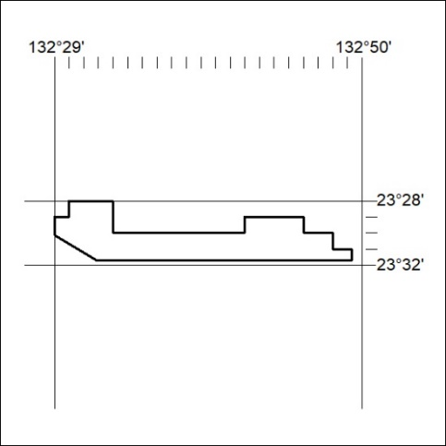
Area granted is indicated above. The titleholder is not permitted to exercise occupational rights on any land that is subject to a development title, or an application for a development title. Any land the subject of a Reserved Land gazettal under the Mineral Titles Act and all land vested in the Commonwealth of Australia is also excluded by description but not excised from the grant area.

290/22

Mineral Titles Act
NOTICE OF GRANT OF A MINERAL TITLE
Title Type and Number: | Exploration Licence 33058
Granted: | 18 August 2022, for a period of 6 Years
Area: | 250 Blocks, 788.13 km²
Locality: | ANBURLA
Name of Holder/s: | 100% GS METALS PTY LTD [ACN. 654 797 878]
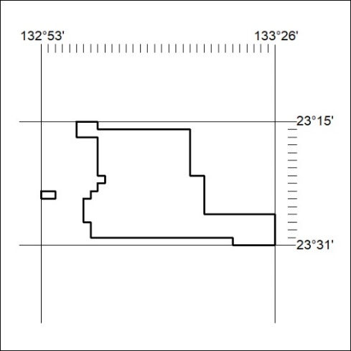
Area granted is indicated above. The titleholder is not permitted to exercise occupational rights on any land that is subject to a development title, or an application for a development title. Any land the subject of a Reserved Land gazettal under the Mineral Titles Act and all land vested in the Commonwealth of Australia is also excluded by description but not excised from the grant area.

291/22

